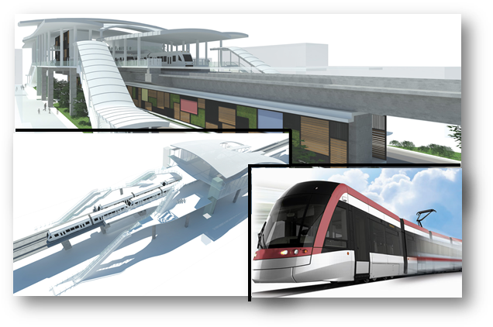

**PT WijayaKarya (Persero), Tbk.**

**JAKARTA LRT PROJECT – CORRIDOR 1 (PHASE 1):**

**KELAPA GADING–VELODROME – PACKAGE P102**

**MAIN WORKS**

**SCADA**

**DETAIL DESIGN OF HMI**

**Doc. No. WIKA-P102-ALL-440-DSR-0002**

2017

**Validation Sheet**

**SCADA**

**DETAIL DESIGN OF HMI**

**Doc. No. WIKA-P102-ALL-440-DSR-0002**

PROJECT NAME : CONSTRUCTION OF LRT CORRIDOR 1 (PHASE1): KELAPA GADING – VELODROME

PACKAGE NO.102: MAIN WORKS (P102)

DATE : JULY2017

CONTRACTOR : PT WIJAYA KARYA (PERSERO), Tbk.

This document is issued to those who commissioned and for a specific purpose related to the above projects alone. This document should not be relied upon by any other party or used for other purposes.

We are not responsible for the consequences of this documentserve as a reference by the other party, or used for other purposes, or contain errors or omissions caused by errors or *omissions* in the data provided to us by other parties.

This document contains confidential information and intellectual property. This document may not be disclosed to other parties without consent from us and from the party which commissioned it.

|  |  |  |  |  |  |
| --- | --- | --- | --- | --- | --- |
|  |  | **PT WIJAYA KARYA (PERSERO), TBK.** | | | |
| Acknowledge: | Verified by: | Acknowledge: | Reviewed by: | Checked by: | Author/Designer: ***PT. Len*** |
| Name | Name  **Zulkifli Y.** | Name  **Sonny Setiawan** | Name  **Iden Ho** | Name  **SJ. Hong** | Name  **M. Taufik** |
| Position | Position  **Project Manager** | Position  **Project Director** | Position  **Senior Design Manager** | Position  **System Design & Cons. Manager** | Position  **SCADA Engineer** |
| Date: | Date: | Date: | Date: | Date: | Date:  04 September 2017 |

Revision history

|  |  |  |  |  |  |  |
| --- | --- | --- | --- | --- | --- | --- |
| **Rev** | **Date** | **Reason of Issue** | **Author** | **Checked** | **Approved**  **WIKA ICE** | |
| A | September 04, 2017 | First Submission | M. Taufik |  |  |  |
| B | November 01, 2017 | Second Submission |  |  |  |  |
|  |  |  |  |  |  |  |

LIST OF CONTENTS

Validation Sheet i

LIST OFCONTENTS III

LIST OF TABLES VI

LIST OF FIGURES VII

ABBREVIATION X

1 Introduction 5

1.1 Overview 5

1.2 Objective 5

1.3 Scope of Work 5

1.4 Structure of Document 6

1.5 References 7

1.5.1 Document References 7

1.5.2 Standard References 8

2 System Description 10

2.1 SCADA System Overview 16

2.1.1 Functional Role 16

2.1.2 Interdependencies 17

2.1.3 External Interaction 17

2.2 External System Device Overview 25

2.2.1 Network Switch 25

2.2.2 Time Management 25

3 Hardware Descriptions 26

3.1 OCC SCADA Server PC 26

3.1.1 OCC SCADA Server 26

3.1.2 OCC HMI Workstation PC 27

3.1.3 HMI Workstation Monitor 28

3.1.4 Color Printer 29

3.1.5 Black and White Printer 31

3.2 Typical Station 32

3.2.1 Local SCADA PC 33

3.2.2 Workstation Monitor 34

3.2.3 Schematic Drawing for SCADA 35

3.2.4 Installation Drawing for SCADA 37

4 Software Functionality 38

4.1 Zenon Product Family 38

4.2 Zenon Editor 40

4.3 Zenon Runtime 41

4.4 Zenon HMI Feature 41

4.4.1 Historian 42

4.4.2 Chronological Event List 44

4.4.3 Automatic Line Coloring (ALC) 45

4.4.4 Alarm Administration 46

4.4.5 User administration 47

4.5 SCADA System Functionality 47

4.5.1 Archive 47

4.5.2 Alarms 50

5 Supplementary Functions 52

5.1 Redundancy 52

5.2 SIL 2 Safety Application 54

5.3 Signalling Driver 55

5.4 ONVIF Driver 57

5.5 PA/ PIS Driver 58

6 Project Specific Configuration 62

6.1 General 62

6.2 Control Philosophy 63

6.2.1 BMS and Traction Power Substation 64

6.2.2 PA/PID system 70

6.2.3 CCTV System 71

6.3 SCADA Operating Console – Monitor Concept 71

6.3.1 OCC Operating Console - Monitor Concept 71

6.3.2 Local Operating Console – Monitor Concept 72

6.3.3 Video Wall Display – monitor concept 72

6.4 User Authorization 73

6.5 Alarm Management 74

6.6 I/O List 75

6.7 SCADA Screen Design and Functionality 76

6.7.1 General Screen Design and Functionality 76

6.7.2 SCADA - Signalling Screen Design and Funtionality 79

6.7.3 SCADA – Traction Power Substation Screen Design and Functionality 82

6.7.4 SCADA – BMS Screen Design and Funtionality 88

6.7.5 SCADA – PA/PID/VoIP/PHP Screen Design and functionality 90

6.7.6 SCADA AMS/CCTV Screen Design and Funtionality 96

6.7.7 SCADA – Other System Screen Design and Funtionality 97

6.7.8 SCADA – Wall Display Screen Design and Funtionality 99

6.8 MI SCADA Sytem BoQ 101

6.9 Cabling System 105

6.9.1 CAT 6 Cable 105

6.9.2 AC Power Cable 4 Core 105

6.9.3 Earthing Cable 106

6.10 Earthing System 107

6.10.1 Introduction 107

6.10.2 Grounding of SCADA Equipment 108

7 Electromagnetic compatibility 109

8 RAMS Model 111

9 Appendix 114

Appendix A: Compliance List Matrix 114

Appendix B: List of Drawings 114

Appendix C: SIL 2 Certificate 114

Appendix D: Technical Spesification of SCADA 114

Appendix E: IO List (not confirm) 114

# LIST OF TABLES

Table 1 – Document References 7

Table 2 - Standard Reference 9

Table 3 - SCADA Functional Device Type 16

Table 4 - SCADA System Bandwidth Utilization 19

Table 5 - Technical Spesification HPE ProLiant DL 380 Gen 9 26

Table 6 - Technical Spesification HP Z440 Workstation 27

Table 7 – Technical Specification HP N240 27-inch 28

Table 8 – Technical Specification HP Color Laserjet Pro M177fw 30

Table 9 - HP Pro 3610 Black and White E 31

Table 10 - HP Z440 Workstation 33

Table 11 - HP N240 27-inch 34

Table 13 - Priority of Operation Authorization 68

Table 14 - SCADA – PA Authorization Level 70

Table 15 – User Authorization 74

Table 16 – Alarm Priority Level 75

Table 17 – Alarm State 75

Table 18 - SCADA IO List 76

Table 19 – Train Journey Schedule 81

Table 20 - individual train schedule 82

Table 21 - BMS and SCADA Controlling and Monitoring List 89

Table 22 - SCADA Interface with other Party 98

Table 23 – SCADA BoQ 104

Table 24 - CAT 6 Cable's Spesification 105

Table 25 - Tehnical Cable's Spesification for AC Power 106

Table 26 - Technical Cable's Spesification for Power and Chassis Grounding 107

Table 27 – Hardware Compatibility 110

Table 28 - Equipment MTBF, MTTR and Availability Summary 111

# LIST OF FIGURES

Figure 1 – SCADA System Overview 15

Figure 2 – HPE ProLiant DL 380 Gen 9 26

Figure 3 - HP Z440 Workstation 27

Figure 4 - HP N240 27-inch 28

Figure 5 - HP Color Laserjet Pro M177fw 29

Figure 6 - HP Pro 3610 Black and White E 31

Figure 7 - Station Arcitecture Diagram 32

Figure 8 - HP Z440 Workstation 33

Figure 9 - HP N240 27-inch 34

*Figure*  10 *– SCADA Schematic Drawing* 36

*Figure*  11 *– SCADA Installation Drawing* 37

Figure 12 – Zenon Editor Interface 40

Table 13 – Zenon Editor Interface Element 41

Figure 14 – Zenon Report Generator Feature 43

Figure 15 – Zenon Report Viewer Feature 43

*Figure*  16 *– Chronogical Event List Screen* 45

Figure 17 – Zenon ALC Example 45

*Figure*  18 *– Alarm Message List Screen* 46

*Figure*  19 *– Storage of Form in SCADA Server* 49

*Figure*  20 *– SCADA System Alarm List Display* 51

Figure 21 – Zenon Software Redundancy Example 53

Figure 22 – Signalling Driver Block Diagram 55

Figure 23 – CTC – SCADA Data Flow Control 56

*Figure*  24 *– Signalling driver architecture diagram* 57

*Figure*  25 *– ONVIF architecture diagram* 58

*Figure*  26 *– SCADA PA architecture handle public announcement* 59

Figure 27 - Remote/Local Permissive mechanism 65

*Figure*  28 *– Control Permission Change Diagram from Local Workstation to SCADA OCC Workstation* 66

Figure 29 - Control permission transfer diagram when there is some communication breakdown 69

Figure 30 - SCADA HMI Main Display 77

Figure 31 – SCADA HMI Alarm Display 78

Figure 32 - SCADA and Signalling System Connection diagram 79

Figure 33 - SCADA and Signalling System Operational Concept 80

Figure 34 - SCADA Traction Power Substation Connection Diagram 83

Figure 35 – Traction Power Substation Display sample 84

Figure 36 – Traction Power Control Display Sample 85

Figure 37 - SCADA System and Traction Power System Operational Concept 85

Figure 38 - Emergency trip button 87

Figure 39 - SCADA System and Building Management System Connection Diagram 88

Figure 40 – BMS Ligthing HMI Display Sample 90

Figure 41 – Building equipment HMI Display sample 90

Figure 42 - SCADA and PA/PID/VoIP/PHP System Connection Diagram 91

Figure 43 – Public Announcement HMI Display Sample 93

Figure 44 – PID HMI Display sample 94

Figure 45 - SCADA System and PHP system Operational Concept 95

Figure 46 - SCADA – AMS/CCTV System Connection Diagram 96

Figure 47 – CCTV Monitoring HMI Display Sample 97

Figure 48 - SCADA Connection with Other Party 98

Figure 49 – PSD Monitoring HMI Display Sample 99

Figure 50 - SCADA Wall Display Design Interface Diagram 100

ABBREVIATION

| Term | MEANING |
| --- | --- |
| SCADA | Supervisory Control and Data Acquisition |
| LRT | Light Rail Transit |
| SIL | Safety Integrity Level |
| TPSS | Traction Power SubStation |
| APSS | Auxiliary Power SubStation |
| BMS | Building Management System |
| PA | Public Address |
| PID | Passenger Information Display |
| PHP | Passenger Help Point |
| CCTV | Closed-Circuit Television |
| AMS | Access Management System |
| OCC | Operation Control Center |
| HMI | Human Machine Interface |
| RTU | Remote Terminal Unit |
| IO | Input/Output |
| M&E | Mechanic and Electric |
| NTP | Network Time Protocol |
| OA | Open Access Sdn. Bhd. |
| GUI | Graphic user Interface |
| UDP | User Datagram Protocol |
| QoS | Quality of Service |
| SAT | Site Acceptance Test |
| SDK | Software Development Kit |
| Zenon | SIL 2 Certified SCADA HMI Software by Copadata |
| Zone | Audio Zone – a number of audio outputs which can be controlled (audio content, volume level, ANC) as a group |
| SNI | Standard National Indonesia |

# Introduction

## Overview

PT Len Industri has been engaged to deliver the SCADA system for the Jakarta LRT Project which will be SIL 2 certified based on IEC61508. This system is an integrated SCADA system for both monitoring and control (some system) for the following railway systems :

* Power System including TPSS, APSS, and 3rd Rail
* Automatic Fare Collection (AFC)
* Building Management System (BMS)
* Telco equipment, PA, PID, PHP, Radio Tetra, CCTV and AMS
* Signaling System
* Platform Screen Door (PSD)

The fixed infrastructure project comprises 6 stations and a Depot which includes the OCC and BCC.

## Objective

This document is intended to capture and describe all system requirements and required behaviour relating to the SCADA System to be supplied for the Jakarta LRT project, focusing on the HMI design. This document focused on the Design and Functionality of the system.

## Scope of Work

PT Len is the leader for SCADA system in this project. PT Len is overall responsible of the  
design with the engineering process assisted by Vendor.

The scope of supply includes:

* Supply of OCC SCADA Server (also redundant server) hardware and software
* Supply of OCC SCADA HMI workstation hardware and software
* Supply of OCC color printer
* Supply of OCC black and white printer
* Supply of Local SCADA HMI Workstation hardware and software
* Supply of Redundant Local RTU
* Design of software functional additions
* Project Management related to supply and integration

## Structure of Document

The document divided into 9 Section

Section 1. Introduction

Section 2. System Description

Section 3. Hardware Description

Section 4. Software Functionality

Section 5. Supplementary Functions

Section 6. Project Specific Configuration

Section 7. Electromagnetic Compatibility

Section 8. RAMS Model

Section 9. Appendix

## References

### Document References

|  |  |  |  |
| --- | --- | --- | --- |
| **#** | **Document ID** | **Document** | **Source** |
| 1 | 362748-MMI-MVI1-XX-SP-000-0010 dated 05.09.2016 | Technical Specification | Tender Document |
| 2 | 362748-MMI-MVI1-XX-SP-000-0001 dated 20.05.2016 | Design Criteria | Tender Document |
| 3 | 362748-MMI-MVI1-XX-RP-760-0001 | Interface Matrix | Tender Document |
| 4 | 362748-MMI-MVI1-XX-RP-781-0001 | Safety Hazard Log | Tender Document |
| 5 | 362748-MMI-MVI1-XX-DR-000-0004 | Preliminary Design Report Volume 3 Drawings | Tender Document |
| 6 | Zenon manual: alarm administration v.760 | Zenon Manual | Copa Data |

Table 1 – Document References

### Standard References

|  |  |  |
| --- | --- | --- |
| **#** | **Standard** | **Description** |
| 1 | BS 7430 | Requirements for electrical installations, lET Wiring Regulations. 17th edition |
| 2 | BS 7671 | Railway applications. Electromagnetic compatibility |
| 3 | BS EN 50121 | Railway applications. Fixed installations. Electrical safety, earthing and the return |
| 4 | BS EN 50122 | Circuit |
| 5 | BS EN 50125 | Railway applications. Environmental conditions for equipment |
| 6 | BS EN 50126 | Railway applications. The specification and demonstration of reliability, |
| 7 | BS EN 50128 | Railway applications. Communication, signalling and processing systems.Software for railway control and protection systems |
| 8 | BS EN 50129 | Railway applications. Communication, signalling and processing systems |
| 9 | BS EN 50174 | Information Technology. Cabling installation |
| 10 | BS EN 50288-7 | Multi-element metallic cables used in analogue and digital communication andcontrol |
| 11 | BS EN 50310 | Application of equipotential bonding and earthing in buildings with informationtechnology equipment |
| 12 | BS EN 60073 | Basic and safety principles for man-machine interface, marking and identification. Coding principles for indication devices and actuators |
| 13 | BS EN 60529 | Degrees of protection provided by enclosures (IP code) |
| 14 | BS EN 60617 | Graphical symbols for diagrams |
| 15 | BS EN 60870 | Tele-control equipment and systems |
| 16 | BS EN 60950 | Information Technology Equipment. Safety |
| 17 | BS EN 61000 | Electromagnetic compatibility (EMC) |
| 18 | BS EN 61131 | Programmable controllers |
| 19 | BS EN 61508 | Functional Safety of Electrical/Electronic/programmable electronic safety-relatedsystems |
| 20 | BS EN 62305 | Protection against lightning |
| 21 | BS EN 62491 | Industrial systems, Installations and equipment and industrial products — labellingof cables and cores |
| 22 | ISO 11801:2012 | Information technology - Generic cabling for customer premises - Amendment 2 |
| 23 |  | All Indonesia National and Municipal Codes, Acts and Regulations that are related  to the SCADA system |

Table 2 - Standard Reference

# System Description

The SCADA system scope in The Jakarta LRT Project include provision of a centralised control function with appropriate SCADA facilities to provide the Operators with an efficient means of real-time monitoring and controlling the M&E plant and subsystems throughout the stations through the SCADA workstations.

The core of the SCADA system will comprise a pair of redundant servers, configured in a hot-standby configuration to provide resilience and secondary recovery control positions. The primary server is installed in the common equipment room (CER) of OCC, while the back up server is installed in the emergency recovery centre i.e BCC. The SCADA servers is configured in a hot-standby arrangement so that either server can immediately assume system mastership in the event of one server failure. It is possible to remove one server for maintenance without interrupting system operation and, upon its reinstatement, re-synchronize the database without interruption to system operations. The Operator is able to designate either server as the primary or secondary server through the SCADA workstations.

Each server is designed to have two communication links to interconnect with two different network switches for receiving or transmitting I/O status from or to the fields RTUs, SCADA workstations or subsystems.

The SCADA system is designed to continuously monitor the status of M&E plant and subsystems at the following locations:

* All stations
* Depot
* Traction Power Substations

Equipment failures of M&E plant and subsystems shall generate alarms to the SCADA workstations which shall be automatically recorded and printed.

The SCADA servers is capable, in terms of processor and memory, to meet the performance requirements, including operator interface, database management, alarming and communication interfaces. The primary server/ master server in common equipment room (CER) is designed to handle communications with the RTUs, maintain the primary system database and interface with the SCADA workstations through the LAN in OCC or Fibre Optic Transmission System for those SCADA workstations that installed throughout the stations. Meanwhile the secondary server/ slave server standby and will replace the master server in case there is failure condition of SCADA systems.

The SCADA servers is designed to utilise the LAN connection to monitor and control of other subsystems including CCTV System, Public Address (PA) System, Help Points System, Passenger Information Display (PID) System, etc. through the IP protocol.

The secondary server is designed to provide identical functions as primary server, including data storage and data printing. Furthermore, the secondary server can take over the primary server’s function immediately without re-booting when a primary server failure occurs. The secondary server shall update the primary server’s database and handover the supervisory and control function back to the primary server once it has recovered.

Two SCADA workstation at OCC is designed to accommodate with four monitors. One monitor shall be dedicated to display CCTV images (spot monitor), and three monitors shall be used to display GUI graphics for overview stations display, overview traction power substations display and alarm status display for control and monitoring.

Each station is installed with a Local SCADA workstation that has the same basic system operations and functionality of the OCC SCADA system. Each Local SCADA workstation is designed to accommodate with three monitors. Three monitors shall be used to display GUI graphics for overview station display and alarm status display of the particular station.

All SCADA servers and workstations is configured with password access levels so that access to the operating control level is available only to Operator with the appropriate access rights.

OCC HMI Workstations is comprised of colour monitors with a minimum size of 27”, diagonal non-glare flat LED screens and have a minimum resolution of 1920 X 1080 pixels. The SCADA workstations is designed to display with colour GUI diagrams the current status of the M&E plant and subsystems.

Two black ink laser printers is provided in OCC room. One printer shall be assigned for printing of recording alarms or event transactions, and the other printer shall be configured as standby. A colour laser printer that supports GUI graphics shall be provided and shall be assigned for printing of system reports and trending.

The SCADA system using the Remote Terminal Units (RTUs) to gather I/O status of traction power. TPSS in each station and APSS shall consist of redundant RTUs device. Each set of RTU is powered from dual power supply units to achieve system availability. Each set of RTU is designed to comprise dual communication modules to interconnect with different network switches (diverse LAN route) for transmitting the received I/Os to the SCADA system. The Fibre Optic Transmission System is used to link the RTUs at various station back to the SCADA servers at OCC and BCC. The RTUs for the substations is linked via a dedicated fibre optic cable to the nearby station for retransmission of I/Os back to the SCADA servers.

The below provides an overview of the system.

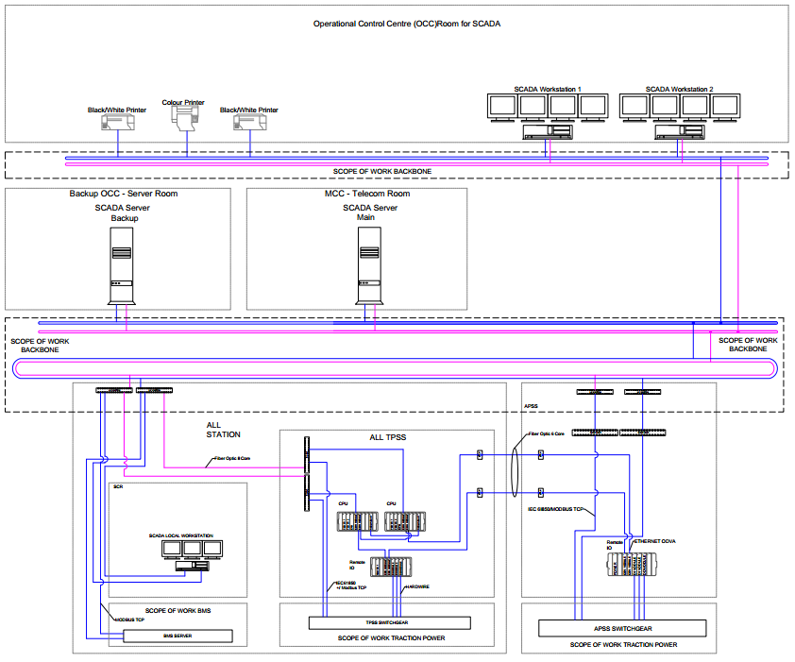

Figure 1 – SCADA System Overview

## SCADA System Overview

### Functional Role

The following functional types of devices will be used as part of the SCADA system for the Jakarta LRTProject as identified in table below

|  |  |  |  |
| --- | --- | --- | --- |
| **No** | **Functional Device Type** | **Qty** | **Model** |
| **1** | OCC SCADA Server | 2 | HPE ProLiant DL 380 Gen 9 |
| **2** | OCC and BCC HMI Workstation | 3 | HP Z8440 Workstation |
| **3** | OCC HMI Monitor | 30 | HP V272 27-inch |
| **4** | Color Printer | 1 | HP Colour Laserjet Pro M177fw |
| **5** | Black/White Printer | 2 | HP OfficeJet Pro 8210 |
| **6** | Station HMI Workstation | 6 | HP Z440 Workstation |
| **7** | RTU Controller | 12 | Allen Bradley 1756 L71 |
| **8** | Remote I/O | 6 | Allen Bradley 1715 Redundant I/O |

Table 3 - SCADA Functional Device Type

1. OCC SCADA Server responsibility are including operator interface, database management, alarming and communication interfaces. The primary server responsibility also to handle communications with the local RTU Controller, maintain the primary system database and interface with the SCADA workstations through the LAN in OCC or Fibre Optic Transmission System for those SCADA workstations that installed throughout the stations.
2. Two SCADA workstation at OCC is designed to accommodate with four monitors. On the first workstation shall be display telecom, BMS and alarm status display for control and monitoring. On the second workstation shall be display power and alarm status display for control and monitoring
3. Black/White Printer assigned for printing of recording alarms or event transactions, and the other printer shall be configured as standby. A colour laser printer that supports GUI graphics shall be provided and shall be assigned for printing of system reports and trending.
4. RTU controller responsibility to handle communications with OCC SCADA Server and interface with the SCADA workstations in each station.
5. RTU main function to gather I/O status of TPSS and APSS and send it to OCC server and station workstation.

### Interdependencies

When operating in a networked configuration, all SCADA system equipment are managed and communicate with OCC SCADA Server. In this operation mode, all the station HMI Workstation display only mimicking the SCADA HMI Workstation.

RTU controller are also capable of operating in a degraded mode (“standalone” mode) when there is no network connectivity to the OCC SCADA servers. In this mode, RTU controller will independently manage the communication with station workstation to control equipment in station. All local level logic and control will be at this local level server.

OCC SCADA Server will be supplied for the Jakarta LRT Project. The two servers provide a fault tolerant configuration where system operation will be coordinated by the secondary server in the event of a fault, power input, or network connectivity to the primary server. The servers will be installed in two separate locations. The primary SCADA server shall be installed in the Common Equipment Room, while the secondary SCADA server shall be installed in the BCC Equipment room. Command from the OCC server will be send to all or individual RTU controller before begin to send to field locally.

### External Interaction

The SCADA system supports operating in a networked configuration. It is intended to configure the system from the outset with the expectation of a network being provided. Each equipment (Servers, Workstations and RTUs) requires an IP connection for transfer of control and media content information. Furthermore, via the network system, external interactions with Fiber Optic Transmision / Backbone System can also be accomplished as further described below:

#### Backbone System

SCADA System requires the following information to be determined for each device:

* UDP and TCP/IP Networking
* Addressing assignment method (DHCP, Auto or Static)
* IPv4 Address and network subnet (for Static / Auto)
* Default Gateway Address Details (for Static / Auto)
* NTP Server Adresses

Communication protocol will transfer the data from device to driver and will be received by Zenon software variable, then alarm will be showed.

#### Network Requirements

The network is recommended to have the following features and protocols:

* UDP and TCP/IP Networking
* 802.1Q VLAN Support
* Provision of an NTP time source
* DHCP Option 82 (if DHCP is used for SCADA devices)
* SNMP
* ModBus TCP
* IEC-61850
* ODVA
* OPC UA
* Open Access SDK
* DAEATI Signalling Protocol

#### Routing and Subnets

A networked system requires the following network topology and structure to be provided:

* OCC SCADA Server network path should be the same path used by OCC HMI Workstation.
* RTU Controller network path should be the same path used by station HMI Workstation.
* Firewalls are not recommended to be installed between SCADA subsystem unless carefully configured.
* A contiguous range of UDP ports is required for RTP audio streams.

#### Bandwidth Utilization

The following table shows estimated bandwidth utilised for communication between different SCADA equipment in the LRT Jakarta SCADA system:

| **Transport Method** | **Bandwidth** |
| --- | --- |
| OCC SCADA Server – OCC HMI Workstation | 100 Mbps |
| OCC SCADA Server – BMS RTU | 100 Mbps |
| OCC SCADA Server – APSS RTU | 100 Mbps |
| OCC SCADA Server – APSS Protection Relay | 100 Mbps |
| OCC SCADA Server – PABX Server | 100 Mbps |
| OCC SCADA Server – AFC Server | 100 Mbps |
| OCC SCADA Server – Radio Sysem Server | 100 Mbps |
| OCC SCADA Server – Backbone and Access Server | 100 Mbps |
| OCC SCADA Server – PA, PID and PHP Server | 100 Mbps |
| OCC SCADA Server – CTC/Signalling Server | 100 Mbps |
| OCC SCADA Server – NTP Server | 100 Mbps |
| OCC SCADA Server – CCTV and Secutiry Server | 100 Mbps |
| OCC SCADA Server – Local SCADA Server | 100 Mbps |
| Local SCADA Server – Local HMI Workstation | 100 Mbps |
| Local SCADA Server – BMS RTU | 100 Mbps |
| Local SCADA Server – TPSS RTU | 100 Mbps |

Table 4 - SCADA System Bandwidth Utilization

#### Public Adress System

For the Jakarta LRT project, it is required for the SCADA system to be able to monitor and control the PA system. This shall be achieved by allowing the SCADA system access to the open access SDK, with which a relevant GUI shall be creates within SCADA system to allow for specific monitoring and control of the PA system.

Among the control that shall be available to the SCADA operators :

* Control of the initiation and end of a Live PA stream including zone, priority and location selection
* Control of the initiation and end of a DVA stream including zone, priority and location selection
* Control the trigger of the automatic DVA announcement based on train locations/arrival/departure
* Control the trigger of automatic DVA announcement based on schedules
* Managing system operational configuration and settings (such as volume control)

Among the monitoring capabilities that shall be available to the SCADA operators:

* Monitoring of PA system alarms and faults
* Monitoring of PA system health status
* Monitoring of PA system speaker health
* Monitoring of PA zones status

#### Passanger Information Display

For the Jakarta LRT project, it is required for the SCADA system to be able to control and monitoring PID system. This shall be achieved by allowing the SCADA system access to the open access SDK, with which a relevant GUI shall be creates within SCADA system to allow for specific monitoring and control of the PID system.

Among the control shall be available to the SCADA operators :

* Control the initiation and end of broadcast live message to any PIS unit.
* Control the trigger of broadcast live message to any PIS unit.
* Control the automatic trigger of broadcast message based on train location/arrival/departure
* Managing system operational configuration and settings (such as text display color)

Among the monitoring capabilities that shall be available to the SCADA operators :

* Monitoring of PID system alarms and status
* Monitoring of PID health status
* Monitoring of PID display monitor health
* Monitoring of PID zones status

#### VoiP Telephone

For the Jakarta LRT project, it is required for the SCADA system to be able to monitoring Voice Telephony system. This shall be achieved by allowing the SCADA system access to the open access SDK, with which a relevant GUI shall be creates within SCADA system to allow for specific monitoring of the VoiP system.

Among the monitoring capabilities that shall be available to the SCADA operators :

* Monitoring of VoiP system alarms and status
* Monitoring of VoiP health status
* Monitoring of VoiP device health

#### Radio System

For the Jakarta LRT project, it is required for the SCADA system to be able to monitoring Radio system. This shall be achieved by allowing the SCADA system access by SNMP protocol, with which a relevant GUI shall be creates within SCADA system to allow for specific monitoring of the VoiP system.

Among the monitoring capabilities that shall be available to the SCADA operators :

* Monitoring of Radio system alarms and status
* Monitoring of Radio health status
* Monitoring of Radio device health

#### Automatic Fare Collection

For the Jakarta LRT project, it is required for the SCADA system to be able to monitoring Automatic Fare Collection system. This shall be achieved by allowing the SCADA system access by SNMP protocol, with which a relevant GUI shall be creates within SCADA system to allow for specific monitoring of the AFC system.

Among the monitoring capabilities that shall be available to the SCADA operators :

* Monitoring of AFC gateline operation
* Monitoring of AFC health and status
* Monitoring of AFC display monitor health

#### Platform Screen Door

For the Jakarta LRT project, it is required for the SCADA system to be able to monitoringPlatform Screen Door system. This shall be achieved by allowing the SCADA system access by Modbus TCP communication, with which a relevant GUI shall be creates within SCADA system to allow for specific monitoring of the PSD system.

Among the monitoring capabilities that shall be available to the SCADA operators :

* Monitoring of PSD alarms status
* Monitoring of PSD devices status
* Monitoring of emergency door status

#### Signalling

For the Jakarta LRT project, it is required for the SCADA system to be able to control and monitoring Signalling system. This shall be achieved by allowing the SCADA system access by custom interface, with which a relevant GUI shall be creates within SCADA system to allow for specific monitoring of the Signalling system.

Among the control shall be available to the SCADA operators :

* Control of Signalling indication
* Control of Signalling status Traction Power

Among the monitoring capabilities that shall be available to the SCADA operators :

* Monitoring of Signalling alarms and status
* Monitoring of Signalling SCADA records
* Monitoring of Signalling display

#### BMS System

For the Jakarta LRT project, it is required for the SCADA system to be able to control and monitoring BMS system. This shall be achieved by allowing the SCADA system access by TCP/IP Modbus communication, with which a relevant GUI shall be creates within SCADA system to allow for specific monitoring of the BMS system.

Among the control shall be available to the SCADA operators :

* Control of on and off lamp in BMS system

Among the monitoring capabilities that shall be available to the SCADA operators :

* Monitoring of Subsystem lamp status
* Monitoring of Subsystem alarm status
* Monitoring of Subsystem escalator
* Monitoring of Subsystem escavator
* Monitoring of Subsystem elevator
* Monitoring of Subsystem fire status
* Monitoring of Subsystem pump
* Monitoring of Subsystem Sprinkler

#### Passenger Help Point

For the Jakarta LRT project, it is required for the SCADA system to be able to monitor and control the PHP system. This shall be achieved by allowing the SCADA system access to the open access SDK, with which a relevant GUI shall be creates within SCADA system to allow for specific monitoring and control of the PHP system.

Among the monitoring capabilities that shall be available to the SCADA operators:

* Monitoring of PHP system alarms and faults
* Monitoring of PHP system health status
* Monitoring of PHP zones status

#### Master Clock

For the Jakarta LRT project, it is required for the SCADA system to be able to monitor the master clock system. This shall be achieved by allowing the SCADA system access by SNMP, with which a relevant GUI shall be creates within SCADA system to allow for specific monitoring and control of the PHP system.

Among the monitoring capabilities that shall be available to the SCADA operators:

* Monitoring of Master Clock Alarms
* Monitoring of Master Clock Events
* Monitoring of Master Clock Requests
* Monitoring of Master Clock Response

#### Wireless Area Network

For the Jakarta LRT project, it is required for the SCADA system to be able to monitor the WAN system. This shall be achieved by allowing the SCADA system access by SNMP, with which a relevant GUI shall be creates within SCADA system to allow for specific monitoring and control of the PHP system.

Among the monitoring capabilities that shall be available to the SCADA operators :

* Monitoring of Master Clock Alarms
* Monitoring of Master Clock Events
* Monitoring of Master Clock Requests
* Monitoring of Master Clock Response

#### AMS

For the Jakarta LRT project, it is required for the SCADA system to be able to monitor the AMS system. This shall be achieved by allowing the SCADA system access by OPC UA, with which a relevant GUI shall be creates within SCADA system to allow for specific monitoring and control of the PHP system.

Among the monitoring capabilities that shall be available to the SCADA operators :

* Monitoring of AMS system alarms and faults
* Monitoring of AMS system health status
* Monitoring of AMS zones status

#### CCTV

For the Jakarta LRT project, it is required for the SCADA system to be able to monitoring and control the CCTV system. This shall be achieved by allowing the SCADA system access by OPC UA, with which a relevant GUI shall be creates within SCADA system to allow for specific monitoring and control of the PHP system.

Among the control that shall be available to the SCADA operators :

* Control of a Live CCTV view
* Control of the PTZ view including zone, priority and location selection
* Managing system operational configuration and setting

Among the monitoring capabilities that shall be available to the SCADA operators:

* Monitoring of CCTV system alarms and faults
* Monitoring of CCTV system health status
* Monitoring of CCTV zones status

## External System Device Overview

### Network Switch

The Customer will provide Ethernet switches required for the fixed infrastructure network.

### Time Management

The SCADA system requires access to a NTP timeserver for reliable time synchronization. It is recommended that the SCADA System networking infrastructure for all operations and all network management is consistent.

The SCADA system are configured to act as Stratum 3 or higher NTP server and are recommended to be configured so that they interface to an NTP server in the network. All announcement and system events are logged with timestamps at the SCADA Server. NTP ensures there is a synchronized time throughout the whole system in order to provide accurate audit records. No specialised, high precision backup / hold over clocks are provided on the SCADA System therefore drifting and time synchronisation is reliant on NTP.

SCADA WPC is to supply all NTP server details e.g. NTP IP addresses upon commencement of the project. It is expected there will be at least one (1) NTP time source for this project as indicated. In the event the NTP time sources are unavailable, the SCADA servers will continue to act as time servers for higher stratum SCADA equipment during the holdover period. The holdover period is configurable and by default set to at least 1 day.

# Hardware Descriptions

## OCC SCADA

### OCC SCADA Server

The proposed hardware for the server in OCC is HPE Proliant DL380 Gen 9 as detailed below. We chose commercially available hardware from reputable company to enssure the support anad evallibility for the hardware for the life cycle of the project. This is also in line with standarization of the HP brand across all the system vendors.



Figure 2 – HPE ProLiant DL 380 Gen 9

|  |  |
| --- | --- |
| **Operating System** | Windows Server 2016 x64 |
| **Processor** | Intel® Xeon® E5-2637v4, 3.50 GHz, 15M Cache, 4cores CPU |
| **Memory** | 32 GB (2x HPE 16GB 1Rx4 PC4-2400T-R Kit) |
| **Storage** | HP Smart Array P440ar/2G FIO Controller  2x HPE 300GB SAS 10k SFF SC HDD  12x HPE 600GB SAS 15K SFF SC HDD |
| **FBWC** | 2 GB DDR3-1,866 MHz, 72-bit wide bus at 14.9 GB/s on P440ar |
| **Battery** | HPE DL/ML/SL 96 W Smart Storage Battery optional |
| **HPE SmartDrives** | 24 + 2 SFF/12 + 3 LFF max, HDD/SSD, M.2 enabled and optional 6 NVMe PCIe SSD support |
| **Networking** | HP Embedded 1Gb Ethernet 4-port 331i Adapter |
| **VGA/serial/USB/SD ports** | Front VGA opt, rear VGA, and serial standard, 5 USB 3.0, 2 USB 2.0 optional, Dual microSD optional |
| **Power and cooling** | 2x HPE 800W FS Plat Hot Plug Power Supply Kit |
| **Industry compliance** | ASHRAE A3 and A4,6 lower idle power, and ENERGY STAR |
| **Form factor/Chassis depth** | Rack (2U), 26.75" (SFF) |
| **Serviceability—easy install rails** | Standard |
| **Operating Environment** | Operating temperature: 10 to 35°C  Operating humidity: 8 to 90% RH |

Table 5 - Technical Spesification HPE ProLiant DL 380 Gen 9

### OCC HMI Workstation PC

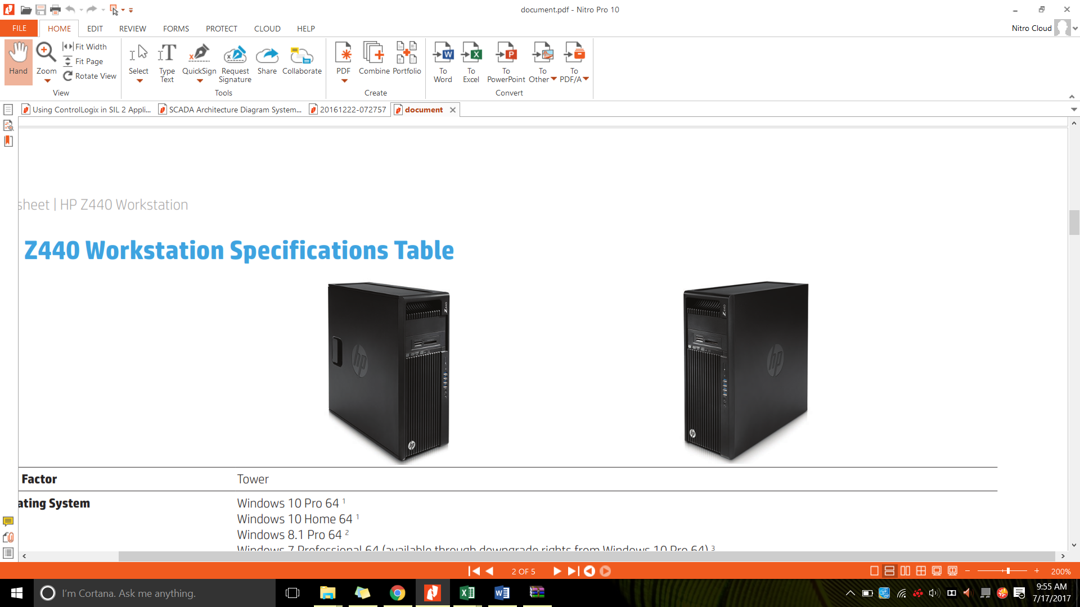

Figure 3 - HP Z8440 Workstation

A workstation specification shall be adequate and the proposed hardware is HP Z8440 Workstation. The technical specification for HP Z8440 is as detailed below.

|  |  |
| --- | --- |
| **Operating System** | Windows 10 Pro 64 |
| **Processor** | Intel® Xeon® E5-2620 v4 2.1 GHz up tp 3 GHz |
| **Memory** | 16GB DDR4-2400 (2x8GB) 1 CPU Registered RAM |
| **Storage** | 1 TB 7200 RPM SATA HDD  1 TB 7200 RPM SATA 2nd HDD  1 TB 7200 RPM SATA 3rd HDD  RAID 5 Parity Array Configuration |
| **Drive Controllers** | Integrated SATA 6.0 Gb/s |
| **VGA** | NVIDIA Quadro M4000 8GB 4xDP |
| **Networking** | HP X520 10GbE Dual Port Adapter |
| **Ports and Connectors** | Front: 4 USB 3.0; 1 microphone; 1 headset  Back: 4 USB 3.0; 2 USB 2.0; 2 PS/2; 1 RJ-45; 1 audio line in; 1 audio line out  Internal: 1 USB 2.0; 1 USB 3.0 |
| **Power** | 700 W 90% efficient chasis |
| **Dimensions (W x D x H)** | 6.65 x 17.5 x 17 in / 16.9 x 44.5 x 43.2 cm |
| **Weight** | 24.3 lb / 11 kg |

Table 6 - Technical Spesification HP Z440 Workstation

### HMI Workstation Monitor

Large 27-inch diagonal screen, with wide range of viewing angles, full HD resolution and 10M:1 dynamic contrast ratio, seamless multi-monitor set-up with this bezel-less display suitable to be SCADA workstation monitor.



Figure 4 – HP V272 27-inch

|  |  |
| --- | --- |
| **Display Type** | IPS w/LED backlight |
| **Panel Active Area** | 59.79 x 33.63 cm |
| **Viewing angle** | 178° horizontal, 178° vertical |
| **Brightness** | 250 cd/m² |
| **Contrast Ratio** | 1000:1 static, 10000000:1 dynamic |
| **Response Ratio** | 7 ms gray to gray |
| **Aspect Ratio** | 16:9 |
| **Native Resolution** | 1920 x 1080 (Full HD) @60 Hz |
| **Input Signal** | 1 DVI-D (with HDCP support); 1 VGA; 1 HDMI (with HDCP support) |
| **Input Power** | Input voltage: 100 to 240 VAC |
| **Power Consumption** | 36 W (maximum), 24 W (typical), 0.45 W (standby) |
| **Dimensions with Stand** | (W x D x H) 24.5 x 7.87 x 17.09 in ;  62.23 x 20 x 43.42 cm |
| **Total weight** | 5.3 kg with stand |
| **Ergonomic Features** | Tilt: -5 to +220 |
| **Energy efficiency** | ENERGY STAR® certified |
| **Operating Environment** | Operating temperature: 5 to 35°C  Operating humidity: 20 to 80% RH |
| **Environmental** | Arsenic-free display glass  Mercury-free display backlights  Low halogen |

*Table*  7  *– Technical Specification HP N240 27-inch*

### Color Printer

HP Color Laser Jet Pro MFP brings vibrant, colour printing in-house, and boosts, productivity with Ethernet connectivity. This printer suitable to be SCADA syetem color printer.



Figure 5 - HP Color Laserjet Pro M177fw

|  |  |
| --- | --- |
| Print resolution | Black (best): Up to 600 x 600 dpi quality (2400 dpi effective output with ImageREt 2400); Colour (best): Up to 600 x 600 dpi quality (2400 dpi effective output with ImageREt 2400); Technology: HP ImageREt 2400 |
| Print speed | Black (A4, normal): Up to 16 ppm; Colour (A4, normal): Up to 4 ppm |
| Scanner specifications | Scanner type: Flatbed, ADF Scan technology: Contact Image Sensor (CIS); Scan input modes: Scanning via HP LaserJet scan application or TWAIN—or WIA-compliant application software; Twain version: Version 1.9; Duplex ADF scanning: No; Scan size maximum (flatbed, ADF): 216 x 297 mm; Optical scan resolution: Up to 1200 dpi |
| Scannable area | Maximum media size (flatbed): 216 x 297 mm; Minimum media size (ADF): 152 x 114 mm; Maximum media size (ADF): 216 x 356 mm |
| Bit depth/ Grey scale levels | 24-bit / 256 |
| Fax specifications | Fax resolution: Standard: 203 x 98 dpi; Fine: 203 x 196 dpi, 256 levels of grey; Superfine: 300 x 300 dpi, 256 levels of grey; Quick dialing: Up to 100 numbers; Telecom compliance: Wireless telecommunications: EU (R&TTE Directive 1999/5/EC, EN 301 489-1 V1.8.1:2008-04, EN 301 489-17 V2.1.1:2009-05, EN 300 328 V1.7.1:2006-10. Fax Telecom: ES 203 021; R&TTE Directive 1999/5/EC (Annex II) with CE Marking (Europe); FCC Part 68; other Telecom approvals as required by individual countries |
| Wireless | Yes, built-in WiFi 802.11b/g/n |
| Network capabilities | Yes, via built-in Fast Ethernet; Wireless 802.11b/g/n |
| Media weight | Tray 1: Paper: 60 to 120 g/m²; envelopes: 60 to 90 g/m²; postcards: 135 to 176 g/m²; HP glossy media: 130 to 220 g/m²; ADF: Tray 1: Paper: 60 to 120 g/m²; envelopes: 60 to 90 g/m²; postcards: 135 to 176 g/m²; HP glossy media: 130 to 220 g/m² |
| Input capacity | Tray 1: sheets: 150; envelopes: 10 Maximum: Up to 150 sheets ADF: Standard, 35 sheets |
| Output capacity | Standard: Up to 50 sheets Envelopes: Up to 10 envelopes Transparencies: Up to 15 sheets Maximum: Up to 50 sheets |
| Printer dimensions (W x D x H) | Minimum 432 x 425 x 335 mm; Maximum 423 x 484 x 335 mm |
| Printer weight | 16 kg |
| Operating environment | Temperature: 15 to 30ºC; Humidity: 30 to 70% RH |
| Acoustics | Acoustic power emissions: 6.2 B(A) Acoustic pressure emissions: 49 dB(A) |
| Power | Requirements: Input voltage: 220 to 240 VAC (+/- 10%), 50/60 Hz (+/- 2 Hz) Consumption: 290 watts (Printing), 200 watts (Copying), 9.2 watts (Ready), 1.3 watts (Sleep/Auto-Off), 0.2 watts (Manual Off); Typical Electricity Consumption (TEC): 0.713 kWh/Week; Power supply type: Built-in power supply |

*Table*  8 *– Technical Specification* HP Color Laserjet Pro M177fw

### Black and White Printer

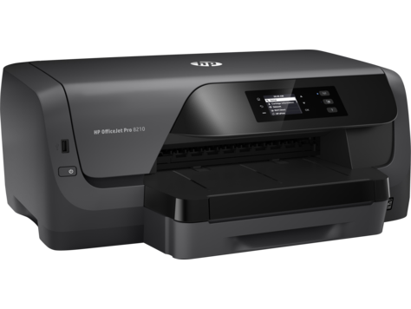

Figure 6 - HP Officejet Pro 8210

|  |  |
| --- | --- |
| **Connectivity** | Hi-Speed USB 2.0; Built-in wired Ethernet 10/100Base-TX (RJ45) networking; Built-in wireless 802.11b/g/n networking; Wi-Fi Direct |
| **Media Size** | A4 (210 x 297 mm) |
| **Minimum dimensions (W x D x H)** | 496 x 420 x 203 mm |
| **Weight** | 8.25 kg |
| **Power** | Input voltage 100 to 240 VAC, 50/60 Hz |
| **Power consumption** | 23 watts maximum (printing), 0.3 watts (Manual-Off), 3.03 watts (Standby), 1.45 watts (Sleep) |
| **Energy efficiency** | ENERGY STAR® qualified |
| **Operating temperature range** | 15 to 30°C |
| **Operating Humidity Rang** | 20 – 80% RH |
| **Print technology** | HP Thermal Inkjet |
| **Print Speed** | Black: Up to 34 ppm (draft, A4); Up to 22 ppm (ISO, laser-comparable); Duplex (A4): Up to 12 ppm; |

*Table*  9 *- HP Pro 3610 Black and White E*

## Typical Station

All local station in Jakarta LRT consist of Telkom room, SCR and Traction Power. To manage all communication in and out to SCADA master and workstation this station need hight tech hardware which is;

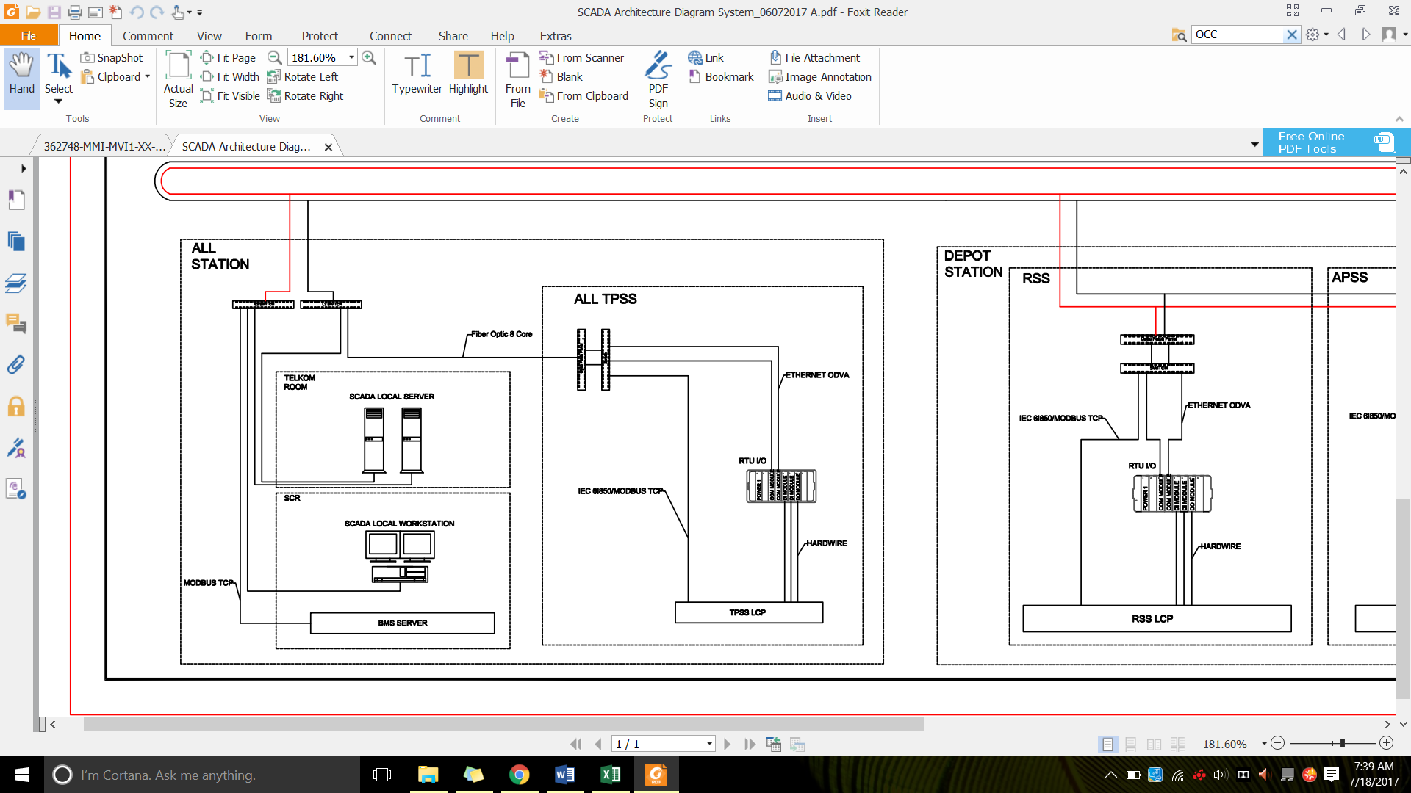

Figure 7 - Station Arcitecture Diagram

### Local SCADA PC



Figure - HP Z8440 Workstation

A workstation specification shall be adequate and the proposed hardware is HP Z8440 Workstation. The technical specification for HP Z8440 is as detailed below.

|  |  |
| --- | --- |
| **Operating System** | Windows 10 Pro 64 |
| **Processor** | Intel® Xeon® E5-2620 v4 2.1 GHz up tp 3 GHz |
| **Memory** | 16GB DDR4-2400 (2x8GB) 1 CPU Registered RAM |
| **Storage** | 1 TB 7200 RPM SATA HDD  1 TB 7200 RPM SATA 2nd HDD  1 TB 7200 RPM SATA 3rd HDD  RAID 5 Parity Array Configuration |
| **Drive Controllers** | Integrated SATA 6.0 Gb/s |
| **VGA** | NVIDIA Quadro M4000 8GB 4xDP |
| **Networking** | HP X520 10GbE Dual Port Adapter |
| **Ports and Connectors** | Front: 4 USB 3.0; 1 microphone; 1 headset  Back: 4 USB 3.0; 2 USB 2.0; 2 PS/2; 1 RJ-45; 1 audio line in; 1 audio line out  Internal: 1 USB 2.0; 1 USB 3.0 |
| **Power** | 700 W 90% efficient chasis |
| **Dimensions (W x D x H)** | 6.65 x 17.5 x 17 in / 16.9 x 44.5 x 43.2 cm |
| **Weight** | 24.3 lb / 11 kg |

*Table*  10 *-* HP Z8440 Workstation

### Workstation Monitor

Large 27-inch diagonal screen, with wide range of viewing angles, full HD resolution and 10M:1 dynamic contrast ratio, seamless multi-monitor set-up with this bezel-less display suitable to be SCADA workstation monitor.



Figure – HP V272 27-inch

|  |  |
| --- | --- |
| **Display Type** | IPS w/LED backlight |
| **Panel Active Area** | 59.79 x 33.63 cm |
| **Viewing angle** | 178° horizontal, 178° vertical |
| **Brightness** | 250 cd/m² |
| **Contrast Ratio** | 1000:1 static, 10000000:1 dynamic |
| **Response Ratio** | 7 ms gray to gray |
| **Aspect Ratio** | 16:9 |
| **Native Resolution** | 1920 x 1080 (Full HD) @60 Hz |
| **Input Signal** | 1 DVI-D (with HDCP support); 1 VGA; 1 HDMI (with HDCP support) |
| **Input Power** | Input voltage: 100 to 240 VAC |
| **Power Consumption** | 36 W (maximum), 24 W (typical), 0.45 W (standby) |
| **Dimensions with Stand** | (W x D x H) 24.5 x 7.87 x 17.09 in ;  62.23 x 20 x 43.42 cm |
| **Total weight** | 5.3 kg with stand |
| **Ergonomic Features** | Tilt: -5 to +220 |
| **Energy efficiency** | ENERGY STAR® certified |
| **Operating Environment** | Operating temperature: 5 to 35°C  Operating humidity: 20 to 80% RH |
| **Environmental** | Arsenic-free display glass  Mercury-free display backlights  Low halogen |

*Table*  11 *-* HP V272 27-inch

### Schematic Drawing for SCADA

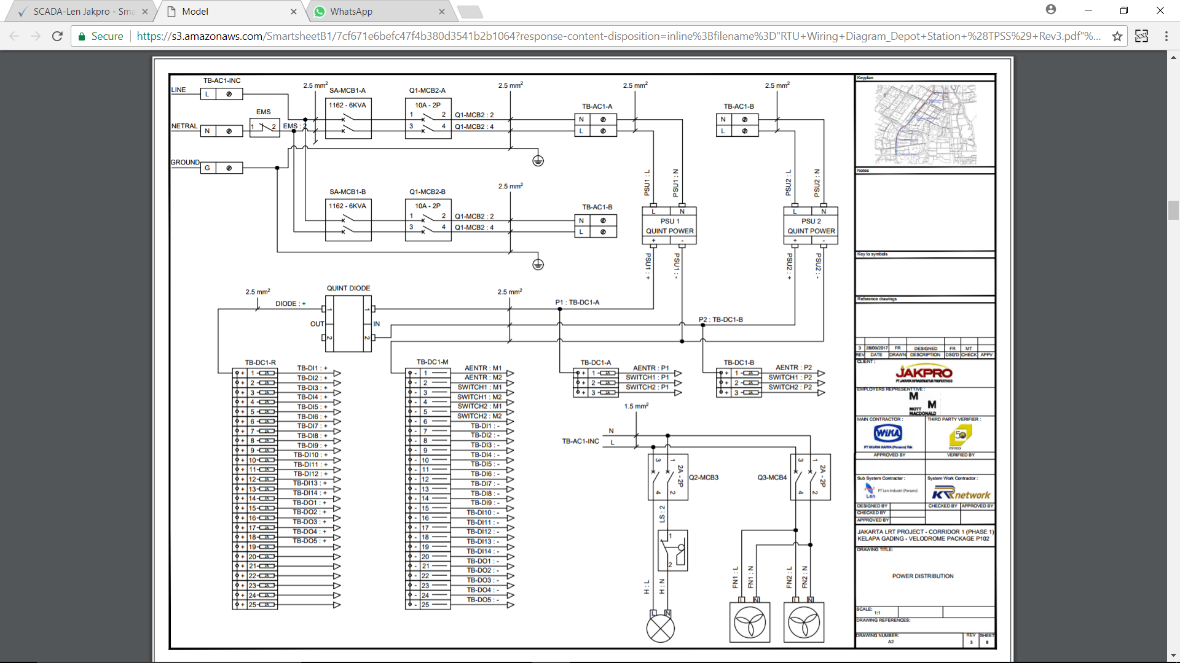

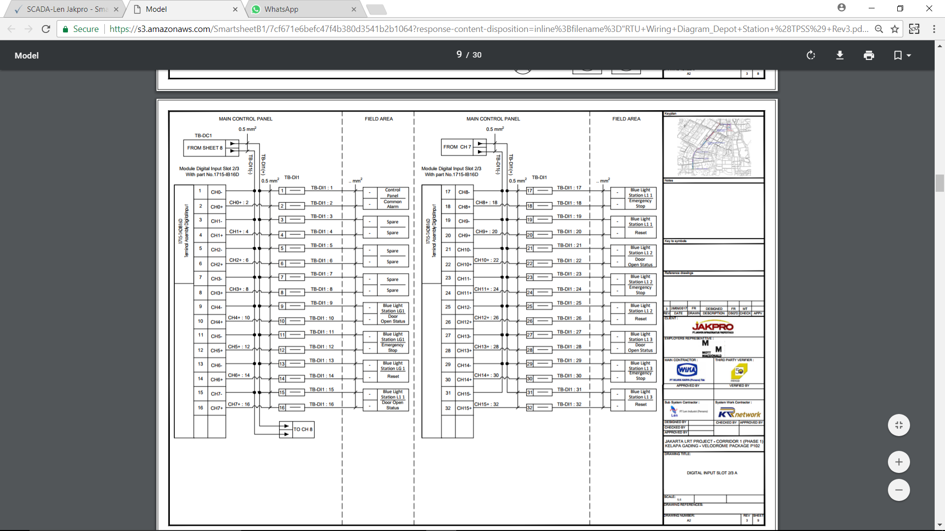

*Figure*  10 *– SCADA Schematic Drawing*

### Installation Drawing for SCADA

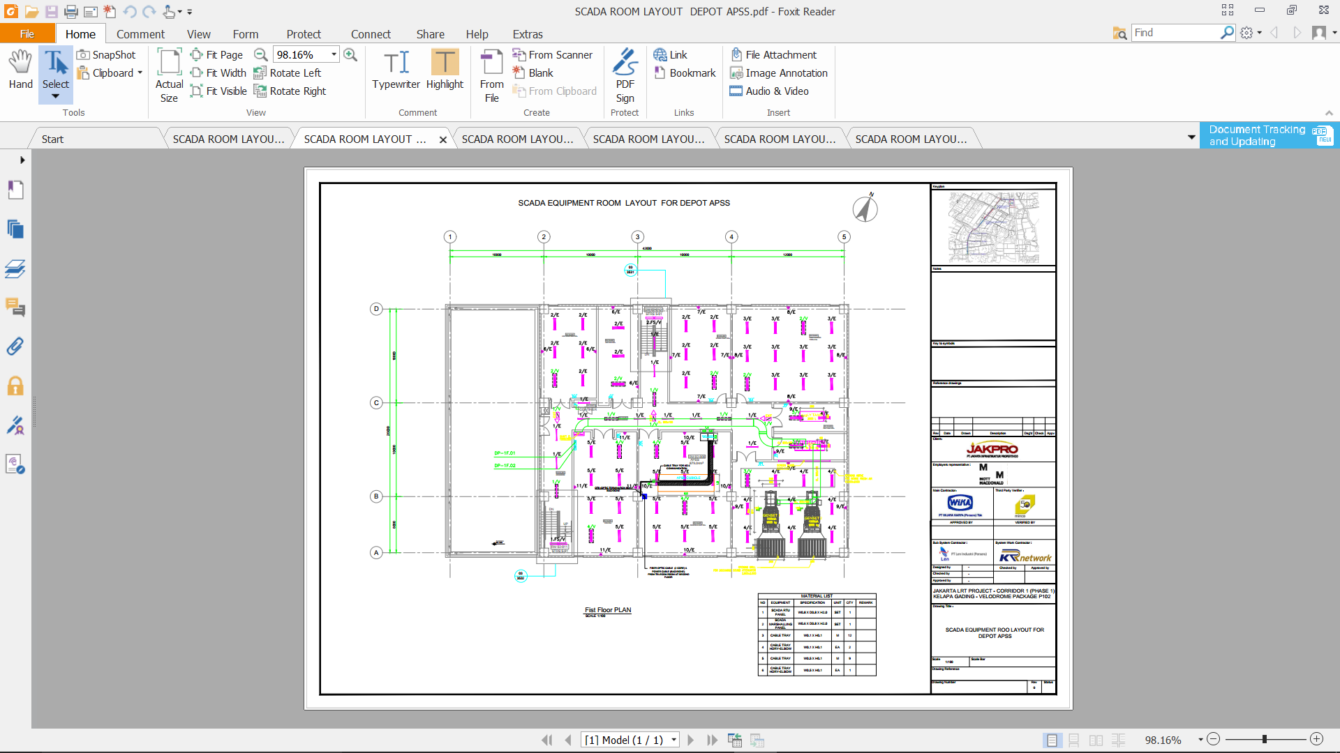

*Figure*  11 *– SCADA Installation Drawing*

# Software Functionality

## Zenon Product Family

As [automation](mk:@MSITStore:C:\Program%20Files%20(x86)\COPA-DATA\zenon%207.60%20SP0\Help\english\main.chm::/29612.htm#o168846) software for HMI, [SCADA](mk:@MSITStore:C:\Program%20Files%20(x86)\COPA-DATA\zenon%207.60%20SP0\Help\english\main.chm::/29648.htm#o168781) and reporting zenon provides a plethora of integrated functions for engineering and Runtime platform-independent.

Zenon has been used for over 25 years by many companies worldwide and in various industries. Zenon is firmly positioned in automation, particularly in the Automotive, Railway, Food & Beverage, Energy and Pharmaceutical industries.

With zenon function is:

* Create, distribute, edit and execute automation projects
* use integrated Soft-SPS zenon Logic
* Collect and evaluate [equipment](mk:@MSITStore:C:\Program%20Files%20(x86)\COPA-DATA\zenon%207.60%20SP0\Help\english\main.chm::/29620.htm#o168856)-spanning data from a plethora of sources

HMI/SCADA software from zenon by COPA-DATA is used for developing automation software for HMI in this project.

Zenon Energy Edition (EE) is used for this project, for both server and client. Zenon Energy Edition is the industry specific SCADAsolution from COPA-DATA especially for power plant automationand substation automation, grid control technology andwind park management.

The drivers availablein Zenon guaranteeadherence to international standards such as IEC 61850/EC 61400-25, IEC 60870 and DNP3.Furthermore, COPA-DATA is SIL 2 certified, thus enablingthe implementation of zenon for process visualization andcontrol in safety-critical applications.

Zenon security features including:

* IEC 61850 authentication
* DNP 3 secure authentication v2 and v5
* Encrypted network communication
* Data encryption with password and hash encryption
* Certified for Windows 10 – supporting all its sophisticated security features
* Active Directory
* No data stored in plain text
* Signed files
* Password protected SQL database access
* Each action can be locked/attributed to user rights
* Change history logging
* Chronological Event List (CEL) logging security incidents
* For NERC/CIP we provide information and documentation for parts CIP-002 through CIP-009
* Webserver offers HTTP Tunneling
* Webserver available solely for monitoring withoutoperational functions

With its native drivers and communication protocols, Zenon Energy Edition is perfectly suited for all communication tasks,whether with various IEDs or to remote systems. Zenon Energy Edition drivers and protocols including:

* IEC 61850 Client/Server and GOOSE
* TÜV SÜD certificate for IEC 61850 Edition 2
* IEC 61400-25
* IEC 60870-5 (101/103/104)
* DNP3
* IEC 62056-21
* OPC UA
* Modbus
* IEEE C37.118 (Synchrophasor)
* IEC 61850-90-5
* Slave/Server Side with the zenon Process Gateway for ICCP/ TASE.2/ IEC 60870-6, IEC 60870-5, DNP3, OPC UA, Modbus
* Integrated SCL Editor for IEC 61850 documents

## Zenon Editor

Zenon consists of two main components; Editor and Runtime. Projects are created in the Editor, operation and monitoring is done in the Runtime.

Zenon Editor´s user interface consists of different areas:

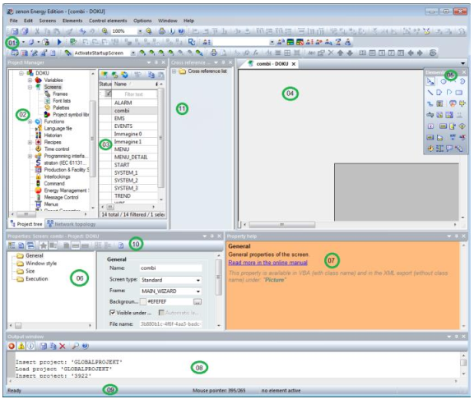

Figure 12 – Zenon Editor Interface

|  |  |
| --- | --- |
| **Element** | **Contents** |
| 01 - Toolbars: | A collection of [Toolbars](mk:@MSITStore:C:\Program%20Files%20(x86)\COPA-DATA\zenon%207.60%20SP0\Help\english\main.chm::/138937.htm) for the Editor and its modules. They are available for:   * [Dockable](mk:@MSITStore:C:\Program%20Files%20(x86)\COPA-DATA\zenon%207.60%20SP0\Help\english\main.chm::/138938.htm) windows * [Alignment](mk:@MSITStore:C:\Program%20Files%20(x86)\COPA-DATA\zenon%207.60%20SP0\Help\english\main.chm::/138939.htm) * [Screens](mk:@MSITStore:C:\Program%20Files%20(x86)\COPA-DATA\zenon%207.60%20SP0\Help\english\main.chm::/138940.htm) / [Symbols](mk:@MSITStore:C:\Program%20Files%20(x86)\COPA-DATA\zenon%207.60%20SP0\Help\english\main.chm::/138941.htm) * [Editor profiles](mk:@MSITStore:C:\Program%20Files%20(x86)\COPA-DATA\zenon%207.60%20SP0\Help\english\main.chm::/138942.htm) * [Elements](mk:@MSITStore:C:\Program%20Files%20(x86)\COPA-DATA\zenon%207.60%20SP0\Help\english\main.chm::/138943.htm) * [Menu bar](mk:@MSITStore:C:\Program%20Files%20(x86)\COPA-DATA\zenon%207.60%20SP0\Help\english\main.chm::/138941.htm) * [Production & Facility Scheduler](mk:@MSITStore:C:\Program%20Files%20(x86)\COPA-DATA\zenon%207.60%20SP0\Help\english\main.chm::/138944.htm) * [Remote Transport](mk:@MSITStore:C:\Program%20Files%20(x86)\COPA-DATA\zenon%207.60%20SP0\Help\english\main.chm::/138945.htm) * [Report Generator](mk:@MSITStore:C:\Program%20Files%20(x86)\COPA-DATA\zenon%207.60%20SP0\Help\english\main.chm::/138946.htm) * [Runtime Files](mk:@MSITStore:C:\Program%20Files%20(x86)\COPA-DATA\zenon%207.60%20SP0\Help\english\main.chm::/138947.htm) * [Visibility levels](mk:@MSITStore:C:\Program%20Files%20(x86)\COPA-DATA\zenon%207.60%20SP0\Help\english\main.chm::/138948.htm) * [VBA macros](mk:@MSITStore:C:\Program%20Files%20(x86)\COPA-DATA\zenon%207.60%20SP0\Help\english\main.chm::/138949.htm) |
| 02 - Project Manager: | Tree view of the Project Manager. |
| 03 - Detail view of the Project Manager: | Details for the module selected in the Project Manager. |
| 04 - Main [window](mk:@MSITStore:C:\Program%20Files%20(x86)\COPA-DATA\zenon%207.60%20SP0\Help\english\main.chm::/29658.htm#o168899): | Main work space; here documents such as screens or reports are displayed. |
| 05 - [Toolbar](mk:@MSITStore:C:\Program%20Files%20(x86)\COPA-DATA\zenon%207.60%20SP0\Help\english\main.chm::/29652.htm#o168901) elements: | Toolbar for [screen](mk:@MSITStore:C:\Program%20Files%20(x86)\COPA-DATA\zenon%207.60%20SP0\Help\english\main.chm::/29648.htm#o168516) elements - vector elements and dynamic elements. |
| 06 – Properties | Displays the properties of a selected object. Three modes are available and can be selected from the [Properties toolbar](mk:@MSITStore:C:\Program%20Files%20(x86)\COPA-DATA\zenon%207.60%20SP0\Help\english\main.chm::/138951.htm). |
| 07 - Properties help: | Displays short help messages for properties of screens, variables, functions and other elements which can be engineered. |
| 08 - Output window | Messages are displayed here if projects are compiled and sent to Runtime. |
| 09 - Status bar: | Shows status information for Editor readiness and screens. |
| 10 - Toolbar properties: | Defines display and sorting options of the properties, shows [Properties help](mk:@MSITStore:C:\Program%20Files%20(x86)\COPA-DATA\zenon%207.60%20SP0\Help\english\main.chm::/139020.htm). |
| 11 - Cross-reference list: |  |

Table 13 – Zenon Editor Interface Element

## Zenon Runtime

Zenon Runtime is software that supports graphic display possibilities for HMI/[SCADA](mk:@MSITStore:C:\Program%20Files%20(x86)\COPA-DATA\zenon%207.60%20SP0\Help\english\main.chm::/29648.htm#o168781) projects.Zenon Runtime offers:

* Process display
* Archiving of data such as messages and process values
* Integrated alarm message list
* Recipes
* Multi-Touch,etc.

## Zenon HMI Feature

Zenon Energy Edition include several features which useful for development of HMI SCADA in this project, that is:

* Historian
* Chronological Event List (CEL)
* Automatic Line Coloring (ALC)
* Alarm administration
* User administration
* Logic Control - Straton

### Historian

In zenon, the Historian takes on the saving of process data as well as the export of the archived data.The data is thus available for subsequent processing and evaluation - even outside of zenon.

Historian in zenon including some features like:

* Data logging: cyclic, event-triggered, on change
* Cascaded data aggregation (aggregated archives)
* Event recording
* RDA archiving
* SQL evacuation
* User-defined start/stop of recording
* Function execution when starting and closing the archive
* Automatic data evacuation
* Automatic creation of substitute archives
* Data export via a function (to XML for example)
* Manual revision of archive data

Data from archiving can be reused in zenon for reporting purposes:

* Report Generator.

The Report Generator works on a cell-orientated basis. Each of these cells can be assigned certain formats and functions. A report is configured as its own screen as a Report Generator screen. The data is calculated, output and displayed using pre-defined report functions. These can be entered into the respective cells using a dialog or manually. To be able todisplay reports in Runtime, they must be configured in the Editor.

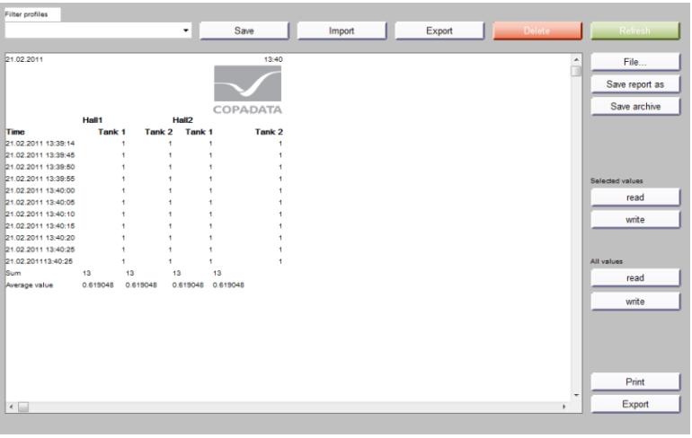

Figure 14 – Zenon Report Generator Feature

* Report Viewer

The Report Viewer also allows archive data to be prepared for the user. However, in contrast to theReport Generator, these cannot longer be modified. For this, the Report Viewer offers extensive graphicpossibilities for display, such as diagrams. In addition, two time ranges for incoming analyses can becompared with one another.

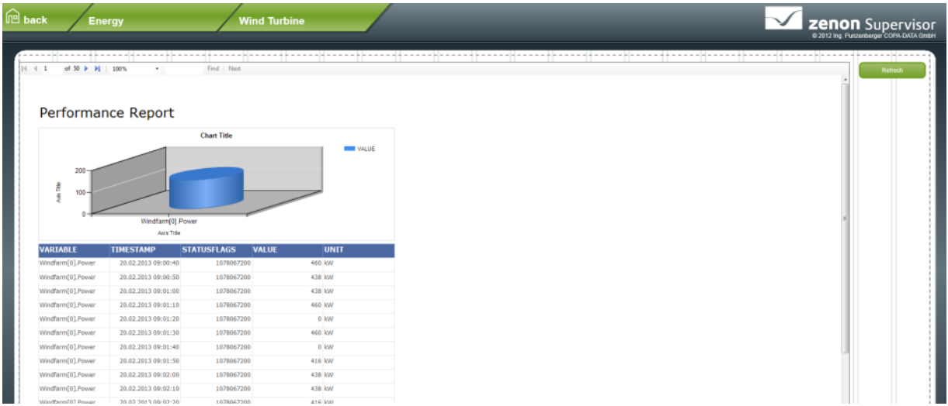

Figure 15 – Zenon Report Viewer Feature

To be able to create reports using the Report Viewer, software from third-party providers will also berequired. Microsoft Report Designer is therefore also installed when zenon is installed. This opens assoon as you create a new report. There is a separate screen type for display in Runtime.

* Extended Trend

Extended Trend provides online values and archive values from variables as curves. In contrast to the trend dynamic element, it is possible to zoom, browse, query and scale online values and values from archives. As with the Report Generator and the Report Viewer, there is also a separate screen type for Extended Trend.

### Chronological Event List

In the Chronological Event List (CEL) system events and user inputs can be logged, e.g.:

* Alarm acknowledgement
* Delete alarms
* Set value
* Send recipes
* Change recipe
* Archive data
* User action
* Network action

A Chronological Event List screen makes it possible to log and display system events and useroperations in the Runtime. Which entries are displayed is defined via the engineering. The display canbe changed by filters in the engineering and in the Runtime. Functions make it possible toexport and print the displayed events.

CEL Exports can be carried out in different formats. Which columns are exported, and how, depends on thesource (AML/CEL) and the export format is listed below:

* CSV
* dBase
* SQL
* XML

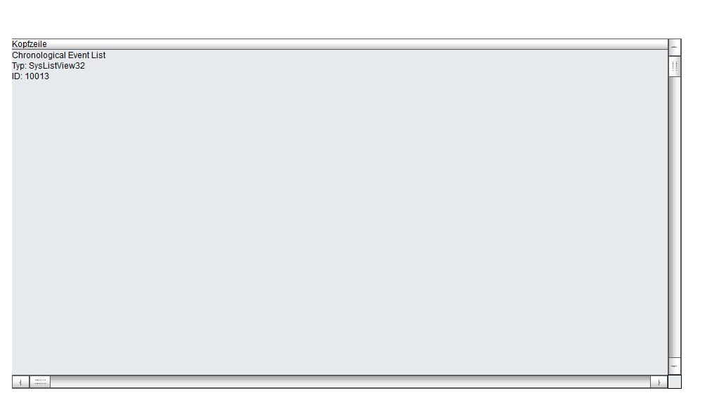

*Figure*  16 *– Chronogical Event List Screen*

### Automatic Line Coloring (ALC)

Automatic Line Coloring (ALC) makes it possible to color lines depending on the process status. Thecombined element is used as the process element. Automatic line coloring allows easy automaticdynamizing of tubes in technology (for media) as well as in the topological networks (for electricity).

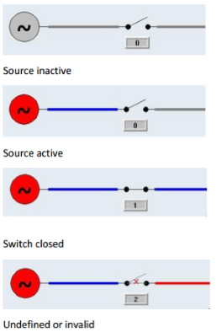

Figure 17 – Zenon ALC Example

### Alarm Administration

Alarm administration informs faults that occur such as limit values being exceeded. It comprises:

1. Alarm status line

Information line that is always shown in the foreground in Runtime and contains, depending onthe configuration, the most recent or oldest unacknowledged alarms.

1. Alarm Message List (AML)

Administers the alarms in a list in Runtime. The AML:

* Displays alarms and their causes in an unfiltered or filtered list
* Enables localization of the cause of the alarm
* Enables acknowledgment of alarms
* Enables deletion of alarms.
* Enables printing and saving of alarms

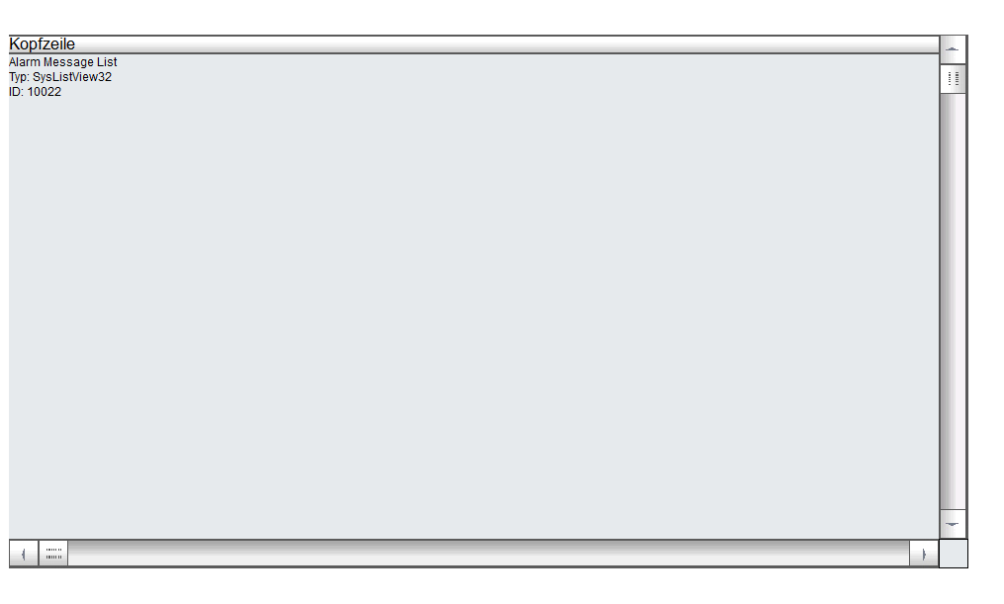

*Figure*  18 *– Alarm Message List Screen*

Alarms can be exported in different formats:

* dBase
* CSV
* XML
* SQL

### User administration

Zenon supports user administration for the Editor and for online operation Runtime. The concept of zenon user administration assumes that different users have different operating rights(authorization levels and function authorizations). Administrators also have different rights, but haveadditional administrative rights, such as the administration of users. Users can be administered viazenon and the Windows Active Directory.

Each user can be assigned several different authorizations. A maximum of 128 (0 to 127) authorizationscan be configured. Users can be assigned to the individual authorization levels and the attendantproject-specific password design in relation to this can be created completely freely. Each user can haveany level allocated. Thus e.g. user 1 can have levels 0, 1, 5 and 6 assigned and user 2 can have levels 0, 1,6, 8 and 10 assigned. Authorizations can only be issued if the administrator has those rights himself.

The user is logged in in Runtime using the login function and a login screen. If the user isto be logged in automatically based on an event (e.g. position of a key known to the system). The SCADA workstations shall display the name of the operator who is currently logged in. The Loginwithout password function is used. This function is projected with a limit value or a Remaof the variable in the variable management, respectively. With multi-project administration, users canautomatically be logged in to subprojects with automatic login.

If during a defined period of time there is no operation, an automatic time-triggered logout can be engineered. Users can log off from the system at any time using the logout function. The user SYSTEM is thus logged in.

## SCADA System Functionality

### Archive

All Health status, data, and alarm from all system equipment that will be connected to SCADA System will be stored in the form of Archive in SCADA Server. The Archive will only store the data only if there is a data changing or if a value is passing of desired level of data.

The archive will store the information of but shall not be limited to the following:

* Time of data stored
* Text status of the data
* Measure unit use
* Value of the data
* Etc.

Following shown below the drawing example of the Archive in SCADA System



*Figure*  19 *– Storage of Form in SCADA Server*

### Alarms

When the alarm from a system that connected to SCADA System is arise, beside stored the data to the archive, SCADA System will also display the data on the alarm list to show the operator that there is an alarm to the system. SCADA System alarm list will grouped the alarm into three group

* Urgent Alarm – Assigned to important alarm.
* Alert Alarm - assigned to alarm which have lower priority
* Cleared - means that the alarm condition has been cleared.

Each alarm that will be displayed on the alarm list will have four states, which are :

* Active State - alarm is present and has not been acknowledged
* Acknowledged state - alarm is present and has been acknowledged
* Reset state - alarm has not been acknowledged and cleared.
* Cleared state – alarm has been acknowledged and cleared

When the alarm present and has not been acknowledged, the alarm list will display the particular alarm to be flashing. The data that will be show on the alarm list are as follows:

* Alarm State
* Alarm time received
* Alarm time cleared
* Alarm time acknowledged
* Variable name
* Value of the data
* Measurement unit
* Text status
* Etc.

Following show the example of SCADA System alarm list from Zenon alarm dialog template

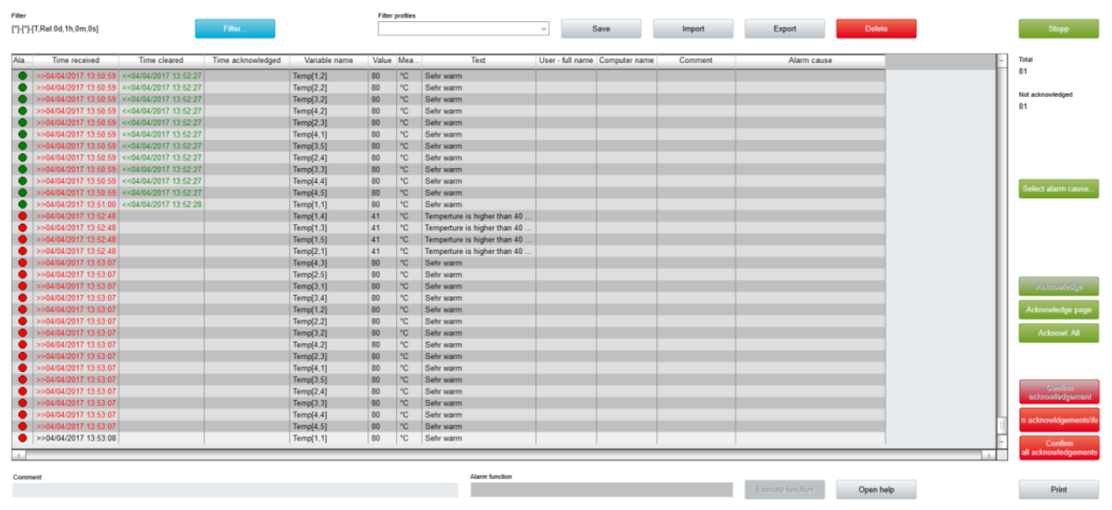

*Figure*  20 *– SCADA System Alarm List Display*

# Supplementary Functions

## Redundancy

Redundancy in zenon ensures that processes are not interrupted even in the event of a failure of the Primary Server and that no data is lost. Seamless redundancy in zenon means that the time period between the failure of the Primary Server and detection of the failure is protected from data loss. This is implemented as follows:

1. The Standby Server buffers all data.
2. The Standby Server detects the failure of the Primary Server and automatically takes on the complete functionality thereof.
3. The standby server adds the data from the buffer to the corresponding modules (AML, CEL, archives).

Project changes need only be entered on the Primary Server; the standby server and the connected clients automatically synchronize online data. This ensures that the project status is the same on all computers.

There are two kind of redundancy systems in zenon, that is:

1. Software redundancy

The primary server communicates with the controller on a two-way basis; the standby server is read only

1. Hardware redundancy

Both servers communicate on a two-way basis with the respective connected controller. This kind of redndancy is usually applied in conjunction with controllers connected in series.

For this project, software redundancy system is used.

In normal operation, both computers communicate with the controller; in doing so:

* The Primary Server communicates with the controller in two directions (read and write)
* The Standby communicates with the controller as read only
* Both computers keep the controller’s data current and synchronous database

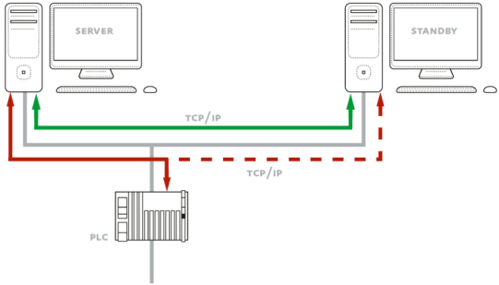

Figure 21 – Zenon Software Redundancy Example

In the event of a failure of the Primary Server:

* The Standby Server becomes the new Primary Server
* The Seamless redundancy ensures that all data is complete without omissions, including data from the time between the failure and the switch
* The new Primary Server communicates with the PLC both ways

For software redundancy type, there are three differentredundancy modes available. The distribution of roles (Primary Server or Standby Server) duringoperation and after the re-availability of a server that failed beforehand depends on the selected redundancy mode.

* Dominant

1. The Primary Server fails.
2. The original Primary Server goes online again.In doing so:

a) It connects to the current Primary Server

b) It synchronizes all data

c) It becomes the Primary Server itself again

1. The original Standby Server becomes the Standby Server again.
2. All Clients connect to the new Primary Server.

* Non-dominant

1. The Primary Server fails.
2. The original Primary Server goes online again.In doing so:

a) It connects to the current Primary Server

b) It synchronizes all data

c) It becomes the Standby Server itself

1. The current Primary Server remains the Priimary Server.
2. All Clients retain the connection to this.

* Rated

With rated redundancy, the roles of Primary Server and Standby Server are given on the basis of anevaluation matrix.In doing so:

1. Both computers each carry out a rating calculation on the basis of configured rating criteria.
2. The computer that has the higher rating becomes the Primary Server
3. No change of roles is carried out if both computers have the same rating
4. Alarms and CEL entries are written by the Primary Server
5. The clients connect to the Primary Server

In this project, Dominant redundancy mode is used. Main server will act as Primary Server, and whenever Main server fails, Backup server will replace Main server as Primary Server. When Main server back to normal again, it will be act as Primary Server again, not Backup server.

## SIL 2 Safety Application

There are plants that need to correspond to particular safetystandards. The IEC 61508 standard helps to ensure safetywith the Safety Integrity Levels (SIL). COPA-DATA is SIL2 certified, thus enabling the implementation of zenon forprocess visualization and control in safety-critical applications.

The Safety Integrity Levels (SIL) are defined in the IEC61508 standard. The SILs relate to electrical, electronic orprogrammable electronic systems (E/E/PE systems), thatcould cause damage. Companies that operate such safetycritical equipment can make standardized safety precautionswith the help of SIL certification and minimize the dangerof malfunctions. The safety levels range from 1 to 4 anddenote how signifcant any damage to be expected is andthe probability with which this may occur. The greater thedamage that can arise and the greater the risk that thisdamage may occur, the higher the required level of safety.

The level of the safety risk and the attendant SIL that isrequired is established using analyses of scenarios. The basisof this analysis is an estimation of the areas in which damagecan occur in a company. Based on this, a calculation is madeto determine how probable this damage is and how seriousthe consequences of this are if it occurs.

Software planning and development according to IEC 61508-3 forces manufacturers to clearly defne their processes andprocedures. Work steps need to be precisely documented andchecked. The principle of dual control applies to every step of the process. COPADATA is certifed to SIL 2 in accordance with the requirementsof the IEC 61508 standard.

Zenon can be implemented in safety-critical applications forprocess visualization and control. Numerous safety relevantfunctionalities support our customers in developing highlyreliable applications. Furthermore, the TÜV Süd certifcationoffers the necessary framework for a safety conformimplementation.

## Signalling Driver

The requirement of the project is to interface with signaling system to get the relevant information for the train timetable, alarms and send some information of 3rd rails energization to the signaling system. The signallng system WPC provided the protocol document for this interface. Nline with this, the special driver in developed for the signaling protocol interfaces.

This driver consists some functions such as establishing connection, making communication for data exchange, auto reconnection, closing connection and sending heartbeat.

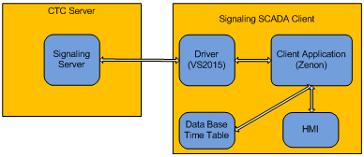

Figure 22 – Signalling Driver Block Diagram

The driver will start communication with CTC server using TCP/IP Client-Server method through the port server. The CTC server will provide all of signaling data includes the data which are needed by SCADA client. The functionality provided by the driver will be embedded into the Client Application for the user or operator to be able to use the function in HMI.

There are many types of data transferred between the CTC Server and the SCADA Client, that is:

* 3rd rail status (SCADA to CTC Server)
* Total schedule information
* Today’s running schedule ID
* Modified schedule
* Train position
* Alarm

One of data types is data schedule of train. The data schedule of train operation is sent to SCADA Client and saved in certain data base of time table. Every change of schedule must be sent to SCADA Client through the driver. So the Client Application always get updated schedule. It’s important to be used in HMI functions.

The driver is very important thing here. If the driver is not working well so the client application can’t get update data from CTC server and send 3rd rail data. The driver must be designed robust and safe. Data base is needed to save time table or schedule of train temporary until newer time table comes. When communication is lost, the client application still can use time table in data base for meanwhile.

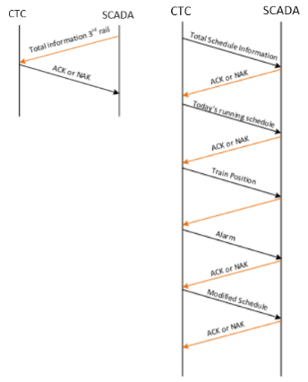

Figure 23 – CTC – SCADA Data Flow Control

With the driver, the client application can get signaling data (such as train schedules, train locations, alarms) and also send back 3rd status to CTC server. The CTC server and the client application communicate periodically in 3 seconds. This communication process is handled by the driver. The driver also handles about flow control of communication between server and client such as establishing connection, making communication for data exchanges, auto reconnection, closing connection and sending heartbeat must be handled by the driver.

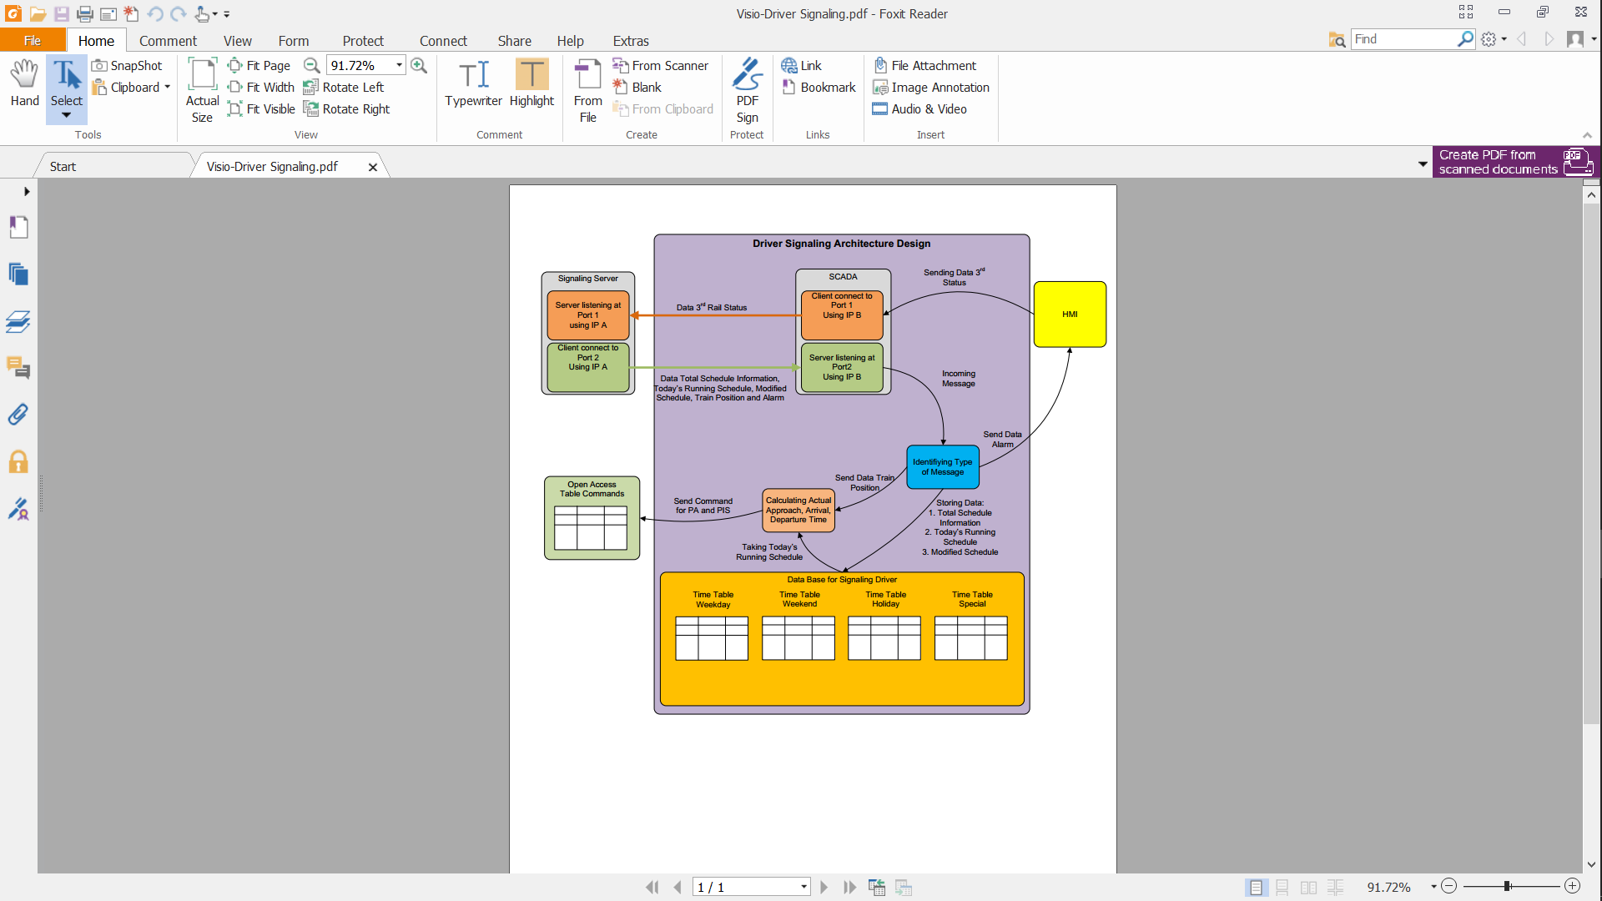

*Figure*  24 *– Signalling driver architecture diagram*

## ONVIF Driver

The requirement of the tender is for SCADA to interface to CCTV system. This will be done base on open protocol i.e ONVIF. Via this protocol only the live view (which is relevant to operation) for the CCTV workstation. ONVIF has various profiles with on the standart. Profiles will be implemented for this interface. Profile-S driver will be added and implemented for this interface.

An ONVIF device compliant to the Profile S is an ONVIF device that sends video data over an IPnetwork to a client. The Profile S also includes support for PTZ, audio and metadata streaming, andrelay outputs if those features are present on the device. For example, a device compliant to theProfile S may be an IP network camera or an encoder device.

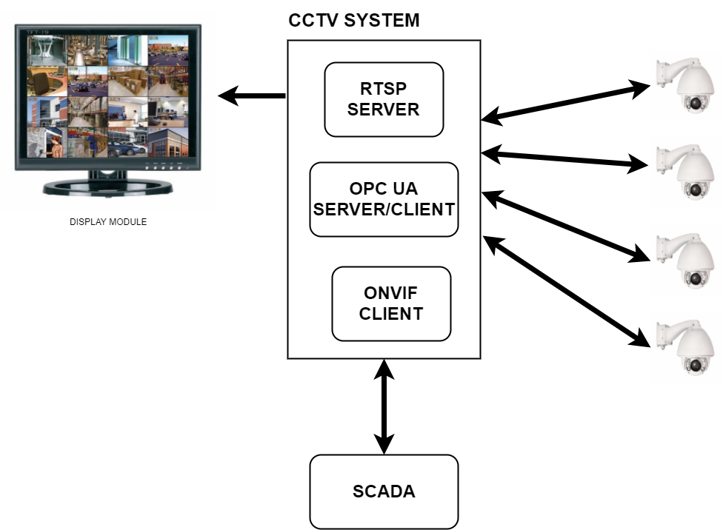CCTV systems that will develop are like this architecture below :

*Figure*  25 *– ONVIF architecture diagram*

* Onvif client will take the status of CCTV cameras. this status will be used by SCADA to display in HMI SCADA. Communication will use OPC UA
* after getting the rtsp URL obtained from the onvif client, the video feed will be displayed to the display module
* if an alarm occurs in the SCADA system such as damage to the electrical instrument then SCADA will send commands to the CCTV system to direct the nearest camera to where the alarm occurred

## PA/ PIS Driver

SCADA PA system architecture to handle public announcement and special text display as below:



*Figure*  26 *– SCADA PA architecture handle public announcement*

SCADA PA system will be divided into two modules Zenon Open access driver and user interface running on runtime.

Zenon Open Access driver will implement features as below:

* Live Announcement : Trigger RLLPA to CXS server
* DVA Announcement : Trigger ALLPA and DVS to CXS server
* PSI Text Message : Send Text message for PIS via CXS
* Device Status : Get and set status for PA /PIS devices via CXS
* Call Management : Initiate and manage call such as phone number directory , call escalation , see call status
* Audio File Management : Update audio file for CXS servers and to NAC devices
* Call Management : Initiate and manage call such as phone number directory , call escalation , see call status
* Audio File Management : Update audio file for CXS servers and to NAC devices

Live announcement can be performed by two ways either operator from IP Mic by speaking at IP MIC or selecting a pre-recorded Media file from user interface. Live announcement design can be realized by Zenon driver module and PA view configuration.

Zenon driver will have implementation to attach IP Mic with NAC zone in order to initiate RLLPA by software trigger via netspire SDK. In order to make announcement user interface need to provide details about IP mic id and list of zones to which ip mic will be attached. When IP Mic is attached to zone software trigger id will be returned by SDK and this id will be used to initiate annocement from IP mic.

Public announcement user interface will be programmed and configured in Zenon editor where station can be grouped as section. Each section station can be again grouped as announcement group. Another section called pre-recorded announcement which will provide list of pre-recorded announcement. Announcement zone section will list zone available in selected station. There PA Log which will show current log for PA related activity.

Algorithm to make RLLPA

1. In Zenon runtime click on menu for PA Announcement
2. Open Section 1 by default listing all station in section 1.
3. Read PA device statues from Zenon IO point variable mapped.
4. Set colour of station to red if PA device is offline, Set colour to green if PA device is online. Set colour to yellow if announcement in progress and colour set colour to gray if station PA device is deactivated
5. Select station to make announcement. When station is selected its colour will change to indicate selection. Or Click group to select station in group.
6. Click on zone where announcement need to make.
7. Click on Live Announcement button
8. Write all selection details to Zenon variable
9. Publish Zenon variable
10. Zenon OA driver reads publish variable and send details to connect Live Announcment function
11. ConnectLiveAnnoucment function attaches ip mic to zone
12. Creates software trigger and activate announcement with software trigger id
13. Write details to Zenon variable that announcement started
14. A window screen popup to show details of live announcement and allow user to finish announcement
15. Once Announcement is finished user clicks to stop announcement button
16. This information is set into Zenon variable to publish
17. Zenon driver subscribe updated variable and execute function disconnectlive annoucment
18. Disconnect live announcement deactivate software trigger and then detach all zones from ip mic.

Automatic DVA announcement are announcement triggered on following situations:

* when train is approaching
* when train occupied platform
* when train departing
* special announcement on any of above situation example “salamat hari raya” on Arrival

Zenon signalling driver will have implementation to monitor train journey. In event of train is approaching station or arriving etc., an announcement order and PIS text message order will be created in JMRT_SCADA. This order will contain all details such as media files to be played, zones,

Zenon Open access driver will always read new orders created for processing. Once new order is found driver will trigger function to execute play DVA or trigger PIS Display Content where play DVA will send trigger announcement to be played and trigger PIS Display Content will trigger PIS content to display devices on station.

Algorithm to make DVA

1. Same till point 6 of RLLPA
2. Select pre-recorded announcement one or many
3. Click on DVA Announcement button
4. Write all selection details to Zenon variable
5. Publish Zenon variable
6. Zenon OA driver reads publish variable and send details to play DVA function
7. Play DVA function play media items on selected zones

# Project Specific Configuration

## General

For the Jakarta LRT operational purposes, SCADA System will be comprise of the following major equipment, that are:

* SCADA OCC Server
* SCADA OCC Workstation
* SCADA Station Workstation
* SCADA RTU (Remote Terminal Unit)

SCADA Server will be responsible to interface with various of other subsystem to form data exchange for monitoring and controlling purposes. Whereas SCADA Workstations both in OCC and local will be the client of SCADA Server respectfully and will also act as an operator interface. SCADA RTU will be used as interface with the workstation in the OCC and station Sercer.

SCADA system will be connected and interface with the following subsystem:

* Traction Power Substation
  + Interface via RTU I/O, IEC 61850 for protection relay and Modbus for Power Meter
  + Monitoring and Control
* Building Management System
  + Interface via Modbus Protocol
  + Monitoring and Control
* Signalling System
  + Interface via Signalling Driver developed.
  + Train descrier data from signalling for Automation trigger for PA and PIDS
  + 3rd Rail power states send to signalling via the signalling driver
  + No Signalling control from SCADA
* Public Announcement (PA)
  + Interface via Open Acces SDK driver developed
  + Monitoring and Control
* Public Information Display (PID)
  + Interface via Open Acces SDK driver developed
  + Monitoring and Control
* Passanger Help point (PHP)
  + Interface via Open Acces SDK driver developed
  + Monitoring, and control via Open acces IPPA
* CCTV System
  + Interface via ONVIF driver developed
  + Monitoring and Control (PTZ Control only). Playback will be at CCTV Workstation
* Access Management System (AMS)
  + Interface via OPC UA protocol
  + Monitoring for status and alarm only
  + No Control
* Radio Tetra
  + Interface via SNMP Protocol
  + Monitoring for status and alarm only
  + No Control
* Fiber Optic Transmission System
  + Interface via SNMP
  + Monitoring for status and alarm only
  + No Control
* Master Clock
  + Interface via SNMP Protocol
  + Monitoring for status and alarm only
* Wide Area Network (WAN)
  + Interface via SNMP Protocol
  + Monitoring for status and alarm only
* Automatic Fare Collection (AFC)
  + Interface via SNMP Protocol
  + Monitoring for status and alarm only
* Platform Screed Door (PSD)
  + Interface via Modbus TCP Protocol
  + Monitoring for status and alarm only

## Control Philosophy

On LRT Jakarta, SCADA System will be used to monitor and control various of system centralize at OCC. Interface between SCADA System and other system will be done on two ways, which are:

* SCADA Server to Another Server Connection at OCC
* SCADA Server at OCC to Another server or controller at local station (i.e BMS, PSD etc.)
* SCADA RTU to Other Controller or Equipment at Station

All this data will be gathered and coordinated by SCADA Server, and operated by operator through SCADA Workstation. SCADA System will have two types of workstation, one type will be used to control and monitor all station at OCC, and the other will be used and installed locally on each station.

Operator interface will be also supplied for each of subsystem individually which control and monitor their own’s system, beside SCADA Workstation. To avoid confussion for operation, priority control authorization mechanism between SCADA workstation and other system workstation are mandatory.

This control authorization will be applied to control operation between operator interface of SCADA system and other system, and will be limited to only for system which allowed SCADA System to do or send command control to the particular system. System which will allowed for SCADA system to send command control and grouped by the similarity of the system are as follows:

* BMS and Traction Power Substation system
* PA/PID system
* CCTV System

### BMS and Traction Power Substation

BMS and Traction Power Substation have similar system for control mechanism. Although traction power substation does not have any local workstation panel like BMS, but it have the ability to be operate locally through circuit breaker. This in turn will need a clear control mechanism for locally or remotely through SCADA OCC Workstation.

#### Control Authorization

As mentioned above, SCADA System purpose is to centralize process monitoring and control of various system which connected to SCADA System. Usually, the system which connected to SCADA system also have their own local control and workstation that can be operated by operator. Not to mention that SCADA System also have two types of workstation, which will be installed at occ and locally at each station. So, clear definition of which workstation will have authority to send command control to the equipment is required.

To Solve the problem, Remote/Local Permissive mechanism will be introduced to determine which workstation that have authority to send command control. The Remote/Local mechanism can be shown on the following diagram.

Remote

Remote Permisive Command

Local Permisive Status

Remote Permisive Status

Local Permisive Command

Local

Figure 27 - Remote/Local Permissive mechanism

From the diagram above we can see that each remote or local will have following bits:

* Permissive Command
* Permissive Status (from other side permissive command)

Permissive command is a permission for the particular workstation to be allowed to give command to the system. Value of Permissive command 1 means that the particular workstation is taken over the control command. Value of permissive command 0 means that the particular workstation is releasing the right to give command to the system. Permisive status is a status of the permissive command from the other side of workstation. For example, for remote and local workstation, the remote workstation will have following bit:

* Remote permissive command (used for remote workstation to take or release the permission to give control command).
* Local Permissive status (is status of local permissive command from local workstation)

And vice versa for local workstation bit authority command.

Before, for example, remote workstation is decided to take the authority to give command control, remote workstation first need to check the status of local permissive status bit. If the value of local permissive status is 0, then remote workstation can procced the process to take the authority for command control. And if the value of local permissive status is 1, then remote workstation will not be allowed to take the authority for command control. And vice versa for local workstation.

This Authorization for control command right will be used between SCADA System workstation and Another system workstation. And also, between SCADA System OCC Workstation and SCADA System Local workstation. Following drawing show example control permission change diagram from station workstation to SCADA OCC workstation



*Figure*  28 *– Control Permission Change Diagram from Station Workstation to SCADA OCC Workstation*

From the drawing above, describe the step of control permission change from local workstation to SCADA OCC workstation are as follows:

1. Initial state assumption which control command for the particular system will be sended from station workstation and the L/R indication show L in green which indicate that current state is local mode
2. Station operator releases the station control permission from station workstation, the L/R indication will display red on both L and R which indicate that no workstation is having permission or control permission is floating.
3. SCADA OCC workstation will also detect that the control permission for the particular system are floating. L/R indicator will display both red for L and R which means the control permission is floating.
4. SCADA OCC operator press remote control permission button which in turn, will make control permission change from local workstation to SCADA OCC Workstation. The L/R indicator will display red for L and green for R which mean control permission will be on SCADA OCC Workstation.
5. SCADA OCC operator then can control the particular system.

#### Operation Hierarchy

The Operation of SCADA System will consist of but shall not be limited to the following situation or condition, which are:

* Normal and Maintenance / Service Operation
* Starting Up Operation
* Loss communication Operation
  1. **Normal and Maintenance/Service Operation**

SCADA System will only use to operate for normal operation only. Under normal operation, all control to the system will be operated centralize and taken over by the SCADA OCC Workstation.

When there is some equipment that needed to run in maintenance or services, SCADA system will release the authority for command control and will be taken over by correspond local workstation. Because operate under service or maintenance will need for the operator and technician to be near the equipment being sevices or running under emergency mode. This way, local operator and technician will have full control of equipment being services, and also be able to organize safety procedure easier.

After the equipment able to run normally, the correspond local workstation will release their authority for command control and will be taken over by SCADA System to be able to operate normally. Table below show SCADA control permission recommendation for normal and emergency mode

|  |  |  |  |  |
| --- | --- | --- | --- | --- |
| No | Operation | Control Recommendation | | |
| SCADA OCC Workstation | SCADA Local Workstation | Other system local workstation |
| 1 | Normal Operation | 1 | 2 | 3 |
| 2 | Maintenance / Services Operation | 3 | 2 | 1 |

*Table*  13 *- Priority of Operation Authorization*

*\*note: 1 is the highest priority and 3 is the lowest priority*

For the table above, the priority for normal operation will recommend utilizing SCADA OCC workstation for centralize operation. And for Maintenance / Services operation will recommend utilizing station workstation to operate the system locally.

* 1. **Starting Up Operation**

For Starting up, which system to be starting first between SCADA system and another system that connected to SCADA system is not important. So, any system can be starting up first. When SCADA System starting up for the first time, SCADA System will not take the authority for command control. Instead, command control will be done locally through the local control system.

This way, All the system which will be connected to the SCADA System can be started independently from SCADA System. Each system than can do consistency testing through their own local workstation. After finishing testing, each system will release command permissive from their own’s local workstation to be taken over by SCADA Workstation.

* 1. **Loss Communication Operation**

When there are some major failure or communication breakdown within SCADA system, all corresponding local workstation should be able to detect communication failure to the SCADA System, which in turn, will automatically release the permission for command control. So, this way, the corresponding local workstation can take over for command control permission. Following show the diagram of permission control transfer.



Figure 29 - Control permission transfer diagram when there is some communication breakdown

Following are the step of control permission transfer when there are some failure or communication breakdown

1. First, when everything is normal, the command control to the various system will be handle by SCADA OCC workstation.
2. The first scenario, the communication breakdown happens between OCC and Station. SCADA station workstation will detect this communication breakdown and so do the other system local workstation. But the communication between SCADA local worksation and Other system local workstation will still be established. SCADA station workstation will then release the control permission from SCADA OCC Workstation, and take the permission for control. SCADA station workstation then be able to send command control to the corresponding system.
3. The second scenario, the communication breakdown happens at telecommunication device of station. Other station worskstation will detect the communication breakdown to SCADA OCC and Local workstation. In turn, this other system local workstation will take the control permission to be able to send command control to the corresponding system.

### PA/PID system

#### Control Authorization

Control Authorization mechanism between SCADA and PA/PID workstation will be controlled by PA/PID server using priority level. The priority level will be determined by considering the type of message and the source which trigger the message. Following are the priority table from PA/PID server

|  |  |
| --- | --- |
| Type of PA | Priority Level |
| Emergency Live PA from Station Controller IPPA | Highest |
| Emergency DVA from Station Controller | Second |
| Emergency Live PA from OCC Controller | Third |
| Emergency DVA from OCC Controller | Fourth |
| Live PA from Station Controller | Fifth |
| Live PA from OCC Controller | Sixth |
| DVA from Station Controller | Seventh |
| DVA from OCC Controller | Lowest |

Table 14 - SCADA – PA Authorization Level

From the table above, can be concluded that for message priority level from the highest to the lowest will be:

* Emergency Live
* Emergency DVA
* Live message
* DVA message

And for the source priority level from the highest to the lowest will be:

* Station Controller
* OCC Controller

#### Operation Hierarchy

There will be no strict hierarchy of operation between SCADA system and PA/PID system, and also, no need to determine which system to be start first. Both system can be starting up independently. When SCADA system are starting up, SCADA system will try to connect to PA/PID system before it can make an announcement.

After the connection is establish between SCADA system and PA/PID system, both system can be operated independently to make live or DVA message, and normal or emergency message. Because PA/PID system utilize priority level above to control which announcement to be publish first.

Only for train automatic announcement that will be triggered by SCADA system based on train schedule from signaling system. Because SCADA system will be interfaced with signaling system to get train schedule and information.

### CCTV System

#### Control Authorization

SCADA system will access directly to CCTV camera device to show live view image and change the direction of some PTZ camera based on some trigger event or operator input. Before SCADA system to be able to access CCTV camera, SCADA system should pass the authentication process first from CCTV camera by supplying correct authorization data. After that SCADA can access CCTV camera to get live image and to send command control.

#### Operation hierarchy

There will be no hierarchy of operation between SCADA system and CCTV system. Both SCADA system and CCTV system will be allowed to access camera CCTV directly.

## SCADA Operating Console – Monitor Concept

### OCC Operating Console - Monitor Concept

SCADA OCC Workstation will be used as operator interface for normal operation on LRT Jakarta. There will be 2 SCADA OCC Workstation which will be installed on OCC room. The first SCADA OCC workstation will be intended to be more focuses on Traction Power Monitoring and Control, and the other SCADA OCC Workstation will be intended to be more focuses on Building and utility monitoring and control. Although both SCADA OCC Workstation can be use to operate both system (Traction Power, and Building and utility).

SCADA OCC Workstation will be equipped with four monitors. The individual function of each monitor can be described on the following:

* First monitor use as Overview of the System
* Second monitor use as Workspace to control and monitor
* Third monitor use as Alarm and Chronological Event List (CEL)
* Fourth monitor use as CCTV Spot Monitor

### Local Operating Console – Monitor Concept

SCADA Local Workstation will be limited to only focuses on monitoring and control of system which will be connected locally to SCADA system. This Workstation will be intended only for maintenance / services operation, so all normal operation will be done on SCADA OCC Workstation.

SCADA Local workstation will be equipped with two monitors, which are:

* First Monitor use as Overview of the system and in emergency will be used for alarm and CEL.
* Second monitor use as workspace and for control and monitor

There will be no monitor that will be use as CCTV display at SCADA Local Workstation. Instead, a 3rd monitor will be fitted next to the 2 SCADA monitor which will be local CCTV client workstation monitor working a CCTV spot monitor. This 3rd monitor can also then work for playback when required.

### Video Wall Display – monitor concept

SCADA system will have a display workstation computer that will be functioning to display SCADA overview. Display workstation will be connected to OCC matrix display in the form of VGA connection which is part of the OCC system. So, the OCC matrix display will be responsible to organize all the display to Wall Display System including SCADA Overview Display.

Display workstation will be designed to show the overview of the following system:

* Traction Power Substation overview
* Building and Utility overview

## User Authorization

SCADA LRT Jakarta will be designed to have six hierarchical levels of Login Access, each with its own password. The Login Authorization Level consist of:

1. Operation Operator
2. Operation Supervisor
3. Operation Manager
4. Engineer
5. Maintainer
6. Administrator

SCADA LRT Jakarta will also be designed to support two types of operation for control and monitoring, which are:

1. Building and utility operation (included telecommunication system)
2. Traction Power Substation operation

These two types of operation above will have their own login access for operator and supervisor. And the operation manager login will have both access of Building and utility operation, and Traction power operation. For more detail about user authorization level, refer to the following table

|  |  |  |  |  |  |  |  |  |
| --- | --- | --- | --- | --- | --- | --- | --- | --- |
| **Priveledge** | **Permission** | | | | | | | |
| **Bdg**  **Op** | **Bdg**  **Spv** | **Pwr**  **Op** | **Pwr**  **Spv** | **Op.**  **Mgr** | **Eng** | **Main** | **Adm** |
| View graphics status of Building and Utility | v | v |  |  | v | v | v | v |
| Operate and Control of Building and Utility System | v | v |  |  | v |  |  | v |
| Acknowledged Building and Utility Alarms |  | v |  |  | v |  |  | v |
| View graphics status of Traction Power Substation |  |  | v | v | v | v | v | v |
| Control of Traction Power Substation |  |  | v | v | v |  |  | v |
| Acknowledged Traction Power Substation Alarms |  |  |  | v | v |  |  | v |
| Edit graphics and IO setting |  |  |  |  |  | v |  | v |
| Print |  |  |  |  | v |  | v | v |
| Install Software Updates |  |  |  |  |  |  |  | v |

Table 15 – User Authorization

The SCADA Operator Interface will also provide for anonymous user which only be able for viewing only of building and utility, or traction power substation GUI. Also, the system will provide for auto-log off the current user after a configurable time of user inactivity has elapsed.

## Alarm Management

The purpose of an alarm system is to indicating malfunction equipment or abnormal condition to the operator. It provides essential support to the operator by warning him of situations that need his attention. Hence it has an important role in preventing, controlling, and mitigating the effects of abnormal situations.

Alarm management will manage the design an alarm system to increase its usability and its efficiency. Good alarm management helps the operator to maintain the system within a safe operating envelope and to correct potentially dangerous and costly situations before the emergency shutdown system is forced to intervene.

In SCADA LRT Jakarta, Alarm system will be grouped into three group based on its priority as shown in the following table. The priority in the operator interface is a critical way to designate the importance of the alarm. Depending on how the alarm effect the system and how much time is there t react.

|  |  |  |
| --- | --- | --- |
| Priority | Alarm Group | Description |
| 1st | Urgent Alarm | Assigned to important alarms.  Primarily associated with life safety, environment damage, and the availability operation of the system issues. Alarms with this priority may require rapid operator response and resolution. |
| 2nd | Alert/Warning Alarm | Alert/Warning alarm have lower priority.  Primarily associated with condition outside above issues which have minor impact to the availability operation of the system. |
| 3rd | Record | This classification covers routine events that are treated as status which do not require acknowledgment. |

Table 16 – Alarm Priority Level

The alarm which are raised in the system will be designed to have several states based on the operator response to the corresponding alarm. Following table show the state of alarm which will be designed.

|  |  |
| --- | --- |
| State | Description |
| Active | The condition generating the alarm is present and the alarm has not been acknowledged |
| Acknowledge | The condition generating the alarm is still present but the Operators have acknowledged the alarm |
| Reset | The condition generating the alarm no longer exist and the alarm has not yet been acknowledged |
| Cleared | The condition generating the alarm no longer exist and the alarm has been acknowledged. |

Table 17 – Alarm State

## I/O List

The SCADA system provides an overview of the Rail System in OCC and it is interfaced to various system as described in chapter 2 above.

The IO list is derived and consolidated via various prorocol as shown in the table below:

|  |  |  |  |
| --- | --- | --- | --- |
| No | Protocol | Subsystem | Remark |
| 1 | SNMP | PABX Server |  |
| AFC Server |  |
| Radio System Server |  |
| Backbone and Access Server |  |
| NTP Server |  |
| 2 | OPC UA | CCTV and Security Server |  |
| 3 | ModBus TCP | BMS RTU |  |
| APSS Protection Device | Assumption |
| 4 | ODVA | Allen Bradley TPSS RTU |  |
| 5 | Open Acces SDK | PA, PID, PHP Server |  |
| 6 | DAEATI Signalling Protocol | Signalling Server |  |
| 7 | IEC 61850 | TPSS Protection Relay | Assumption |

Table 18 - SCADA IO List

The complete I/O list is depicted in document appendix B.

## SCADA Screen Design and Functionality

### General Screen Design and Functionality

SCADA screen design will be grouped into three subsystems, which are:

1. General Main Display Screen
2. Building and Utility Screen
3. Traction Power Substation screen

Here, Building and utility screen, and Traction Power Substation screen will be differentiated into different group. Because SCADA operator who will be operated Building and Utility Screen, or Traction Power Substation Screen are required to have different set of knowledge and skill between both system.

General Main display will consist of display that will be used by Building and Utility Screen, and Traction Power Substation Screen, which are:

* Main Screen or display for login
* Archive and Alarm Screen
* CCTV realtime image screen

CCTV realtime image screen will be discuss more on CCTV screen design and functionality sub chapter.

#### Main display

SCADA main display screen is the first screen that will be show by scada workstation when Starting up. The main display will show login window as user authorization to determine which system the user is authorize to whether Building and utility system, or Traction power substations system.

Following show the screen sample of main display in SCADA LRT Jakarta.

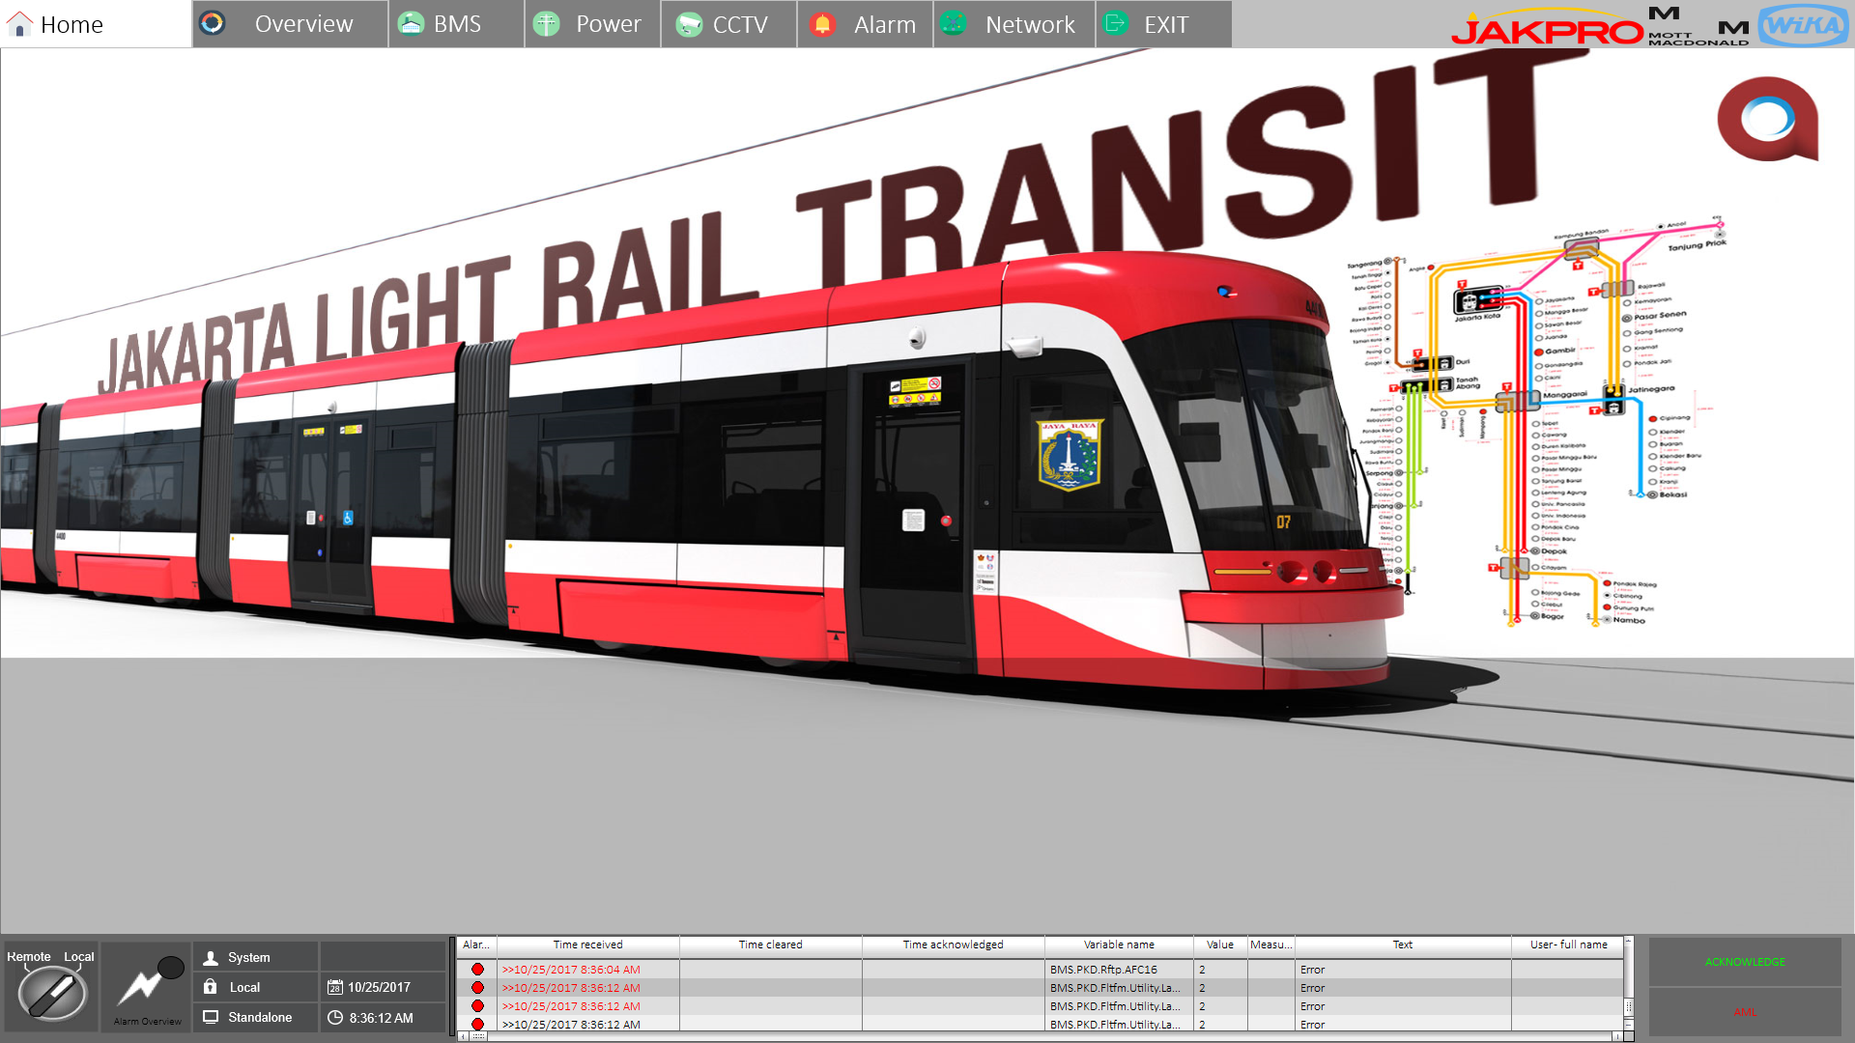

Figure 30 - SCADA HMI Main Display

#### Archive and Alarm

SCADA LRT will be equipped with archive and alarm display. All Health status, data, and alarm from all system equipment that will be connected to SCADA System will be stored in the form of Archive in SCADA Server. The Archive will only store the data only if there is a data changing or if a value is passing of desired level of data. The archive will be able to store all the data minimum in the range of 6 month, based on SCADA LRT Jakarta requirement.

When the alarm from a system that connected to SCADA System is arise, beside stored the data to the archive, SCADA System will also display the data on the alarm list to show the operator that there is an alarm to the system. Following show the sample of Alarm user interface of SCADA LRT Jakarta.

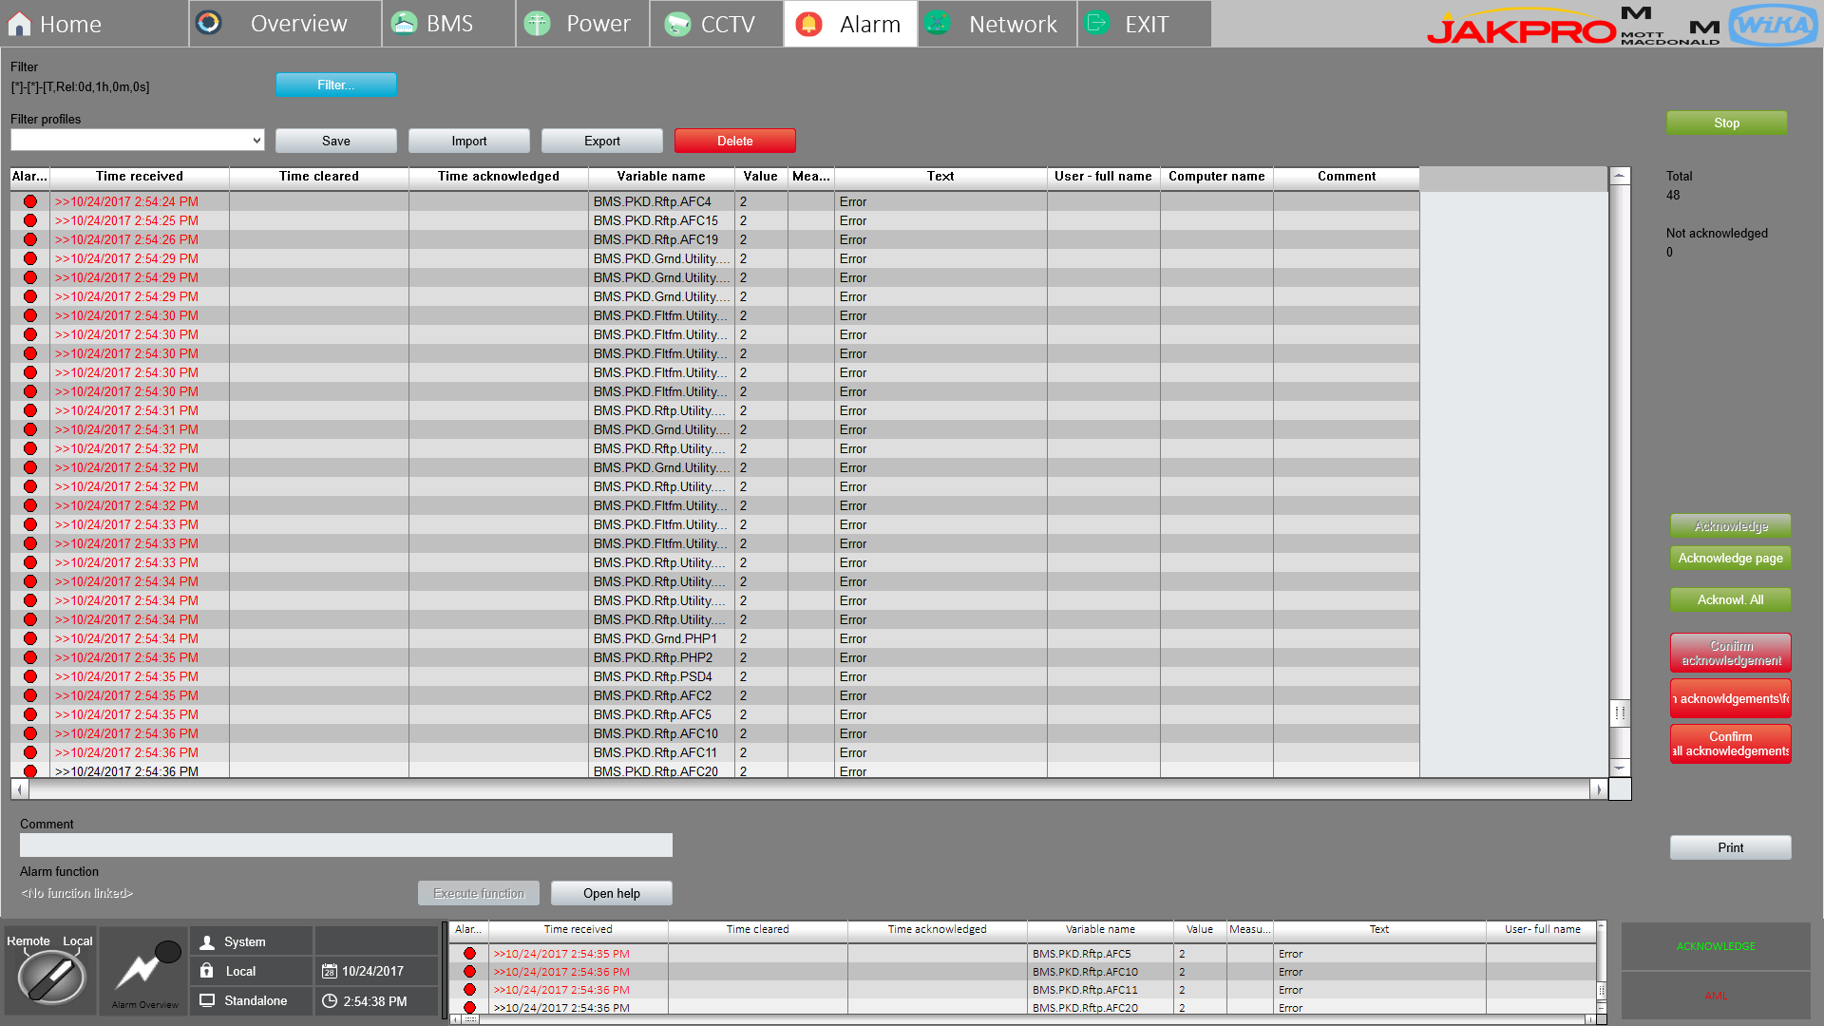

Figure 31 – SCADA HMI Alarm Display

### SCADA - Signalling Screen Design and Funtionality

Following shown drawing of SCADA System and Signalling System Connection diagram



Signalling

SCADA

Figure 32 - SCADA and Signalling System Connection diagram

SCADA System will be connecting with the Signalling sistem through server to server at the OCC. The connection will use ethernet communication with redundancy configuration.

Following shown block diagram of SCADA System and Signalling System operational concept.



Figure 33 - SCADA and Signalling System Operational Concept

* 1. SCADA system will need data from signalling system for monitoring status and alarm of signaling system. So, SCADA System will need but not limited to following data from signalling system:
* Signalling Equipment status and alarm
* Train Schedule
* Train position or other data that can be used to determine train approaching or departing or etc.
  1. SCADA system will provide data and controlling PA system
  2. SCADA system will provide data and controlling PID system
  3. TPSS system will provide status of 3rd rail power availability
  4. The signaling system will only need data of the availability status of power supply for the train movement from SCADA system
  5. All status and alarm informed to SCADA operator
  6. SCADA operator will give response and call technician to checking related alarm
  7. Technician will follow up SCADA operator report and troubleshooting
  8. After checking the alarm, technician give troubleshooting status (solved, waiting spare part, etc) to SCADA operator

SCADA system will display information which gathered from interface with signalling system in the form of train schedule and information status. Operator of SCADA system will not able to change, delete, or modify the train schedule information. No command for train scheduling will supplied in SCADA System. So, all data schedule and data changing should come from signalling system.

SCADA system will present the train schedule data from signalling system in the form of train journey and the status of the journey. Following table show sample of the train schedule data presentation in SCADA System.

|  |  |  |  |  |  |  |  |
| --- | --- | --- | --- | --- | --- | --- | --- |
| **Date** | | Thursday, 12 September 2019 | | | | | |
| **Schedule Type** | | Weekday | | | | | |
| **Journey No** | **Train Id** | **Dir.** | **Schedule** | | **Actual** | | **Status** |
| **Start** | **Stop** | **Start** | **Stop** |
| 1 | 1001 | North | 06:00:00 | 07:30:00 | 05:58:00 | 07:27:00 | Finish |
| 2 | 1002 | South | 06:15:00 | 07:45:00 | 06:17:14 |  | Running |
| 3 | 1003 | North | 07:00:00 | 08:30:00 | 07:01:02 | - | Cancelled |
| 4 | 1004 | North | 09:00:00 | 10:30:00 |  |  | Not Active |
| 5 | 1017 | South | 12:00:00 | 13:30:00 |  |  | Not Active |

Table 19 – Train Journey Schedule

From the Train Journey table above, the status of the Schedule will be designed as follows:

1. Finish – means that the train journey has been finished for the particular schedule
2. Running - means that the train journey is running on the particular schedule
3. Cancelled - means that the particular train journey schedule is in the process of deleting and after that the schedule will be remove.
4. Modified – means that the train particular schedule has been modify
5. Added - means that the the particular train schedule has been added
6. Not active – means that the particular train schedule is not running yet.

Beside Train journey Schedule, SCADA System will also be displaying each train schedule on each station. Following are the sample of how SCADA system will be displaying each train schedule.

|  |  |  |  |  |  |  |  |  |  |
| --- | --- | --- | --- | --- | --- | --- | --- | --- | --- |
| **Train ID** | | | | 1002 | | | | | |
| **Journey No.** | | | | 006 | | | | | |
| **Date** | | | | Thusrday, 12 September 2019 | | | | | |
| **No** | **Station** | **Schedule** | | | | **Actual** | | | **Status** |
| **Arrival** | **Dwell** | | **Depart** | **Arrival** | **Dwell** | **Depart** |
| 1 | Velodrome | 10:00:00 | 00:02:00 | | 10:02:00 | 09:59:55 | 00:02:01 | 10:02:00 | Finished |
| 2 | Pacuan Kuda | 10:12:00 | 00:02:00 | | 10:14:00 | 10:13:01 | 00:01:59 | 10:14:00 | Departing |
| 3 | Pulomas | 10:30:00 | 00:02:00 | | 10:32:00 |  |  |  | Approaching |
| 4 | KG. Boulevard | 10:47:00 | 00:02:00 | | 10:49:00 |  |  |  | Not Active |
| 5 | KG. Mall | 11:05:00 | 00:03:00 | | 11:08:00 |  |  |  | Cancelled |
| 6 | Depot | 11:23:00 | 00:05:00 | | 11:28:00 |  |  |  | Not Active |

Table 20 - individual train schedule

The status of each train schedule above will be similar with the status which will be applied on the train journey schedule, except for the running schedule status. Because in each train schedule, the status of the running schedule will be further clarified with the train status as followes:

1. Departing – means that the train is departing from the particular station
2. Approaching – means that the train are approaching the particular station
3. Arriving – mean that the train are arriving at the particular station

### SCADA – Traction Power Substation Screen Design and Functionality

Following shown drawing of SCADA System Traction Power Substation Connection diagram.



Figure 34 - SCADA Traction Power Substation Connection Diagram

According to the drawing above, the interface between SCADA system and Traction Power Substation system will be done in two ways, which are:

* Through SCADA Server
* Through SCADA RTU (I/O)

Connection between SCADA Server with the Traction Power Substation will be in the form of ethernet communication and is recommended using IEC 61850 protocol. The number of ethernet communication connection can be more than 1 (need to check with other party for the number of connection). The ethernet communication will preferably used if the Traction Power Substation device or equipment have ethernet communication feature.

The other scenario for SCADA System and Traction Power Substation connection is using hard wired connection through marshalling panel. For this case, SCADA system will install I/O RTU (remote terminal unit) to interface with Traction Power Substation marshalling panel through hard wire connection.

SCADA System will present information from Traction Substation system in the form of graphical single line diagram. Following are the sample screen of SCADA system information presentation of Traction Power Substation

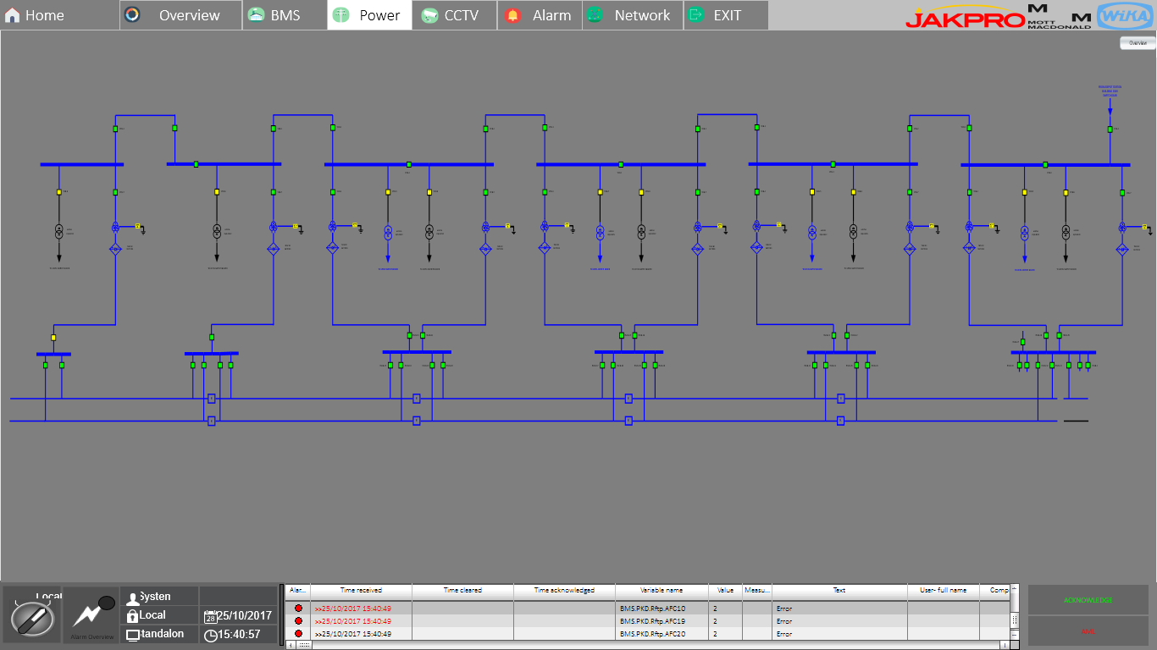

Figure 35 – Traction Power Substation Display sample

The SCADA graphical interface will present the information of connection or disconnection of circuit breaker, the status of Transformer and rectifier, etc. The operator will also be able to control the traction power system through clicking the circuit breaker symbol for connection or disconnection. Following show the HMI display of control for traction power operation.

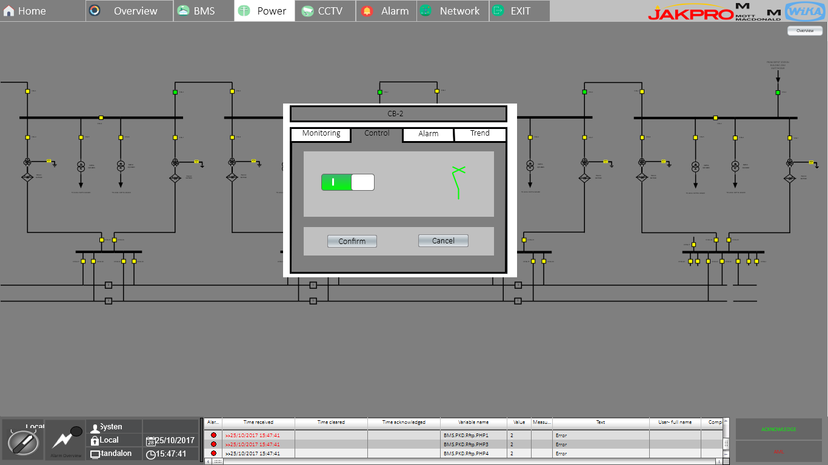

Figure 36 – Traction Power Control Display Sample

From the drawing above, shows that command to the circuit breaker of traction power substation will need a confirmation from operator. This shown on the confirm button of circuit breaker control dialog. So, the operator will be aware of the command he or she is intended to send to the system

Following shown block diagram of SCADA System and Traction Power System operational concept.



Figure 37 - SCADA System and Traction Power System Operational Concept

* 1. SCADA System will monitor status, alarm and measurement of but shall not be limited to following TPSS/APSS equipment:
* 20 kV Switchgear
* Transformer
* Rectifier
* DC Switchgear
* LV Switchgear
* Battery Charger

1. All status and alarm informed to SCADA operator
2. SCADA operator can give command to TPSS/APSS remote operation
3. SCADA System will send command to TPSS/APSS equipment
4. SCADA operator will give response and call technician to checking related alarm
5. Technician will follow up SCADA operator report and troubleshooting. If pickup relay activated, technician need to reset at switchgear locally
6. After checking the alarm, technician give troubleshooting status (solved, waiting spare part, etc) to SCADA operator

#### Emergency DC Mass Trip System

Refer to the document technical specification 362748-MMI-MVI1-XX-SP-000-0010 Technical Specification_RevA

Clause 7.12 in the Traction Power Substations (TSS)

* Emergency DC mass trip (based on SCADA signal or local push-button), to switch out all conductor rail sections and Transformer Rectifier Units (TRU5) at a given location (note this will require tripping of some DC CBs at adjacent sites)
* Emergency mainline mass-trip (all DC circuit breakers) at the Electrical Control Desk in the Operational Control Centre.

SCADA system will implement the emergency DC mass trip button in the all traction power SCADA console screen. Only authorized operator can access this authority with specific login. The Procedure to activateemergency trip button system are as follows:

1. OCC Operator with the authority access display the traction power SCADA console
2. If any emergency condition or special case which in turn need to shutdown all conductor rail sections, the operator can push the the emergency trip button
3. Message window confirmation will appear to confirm with yes or no choice
4. If operator confirm to shutdown, SCADA system through RTU will send opening command to all DC switchgear in each traction power substation. To prevent any closing command from local / remote, inhibit signal will also be activated.

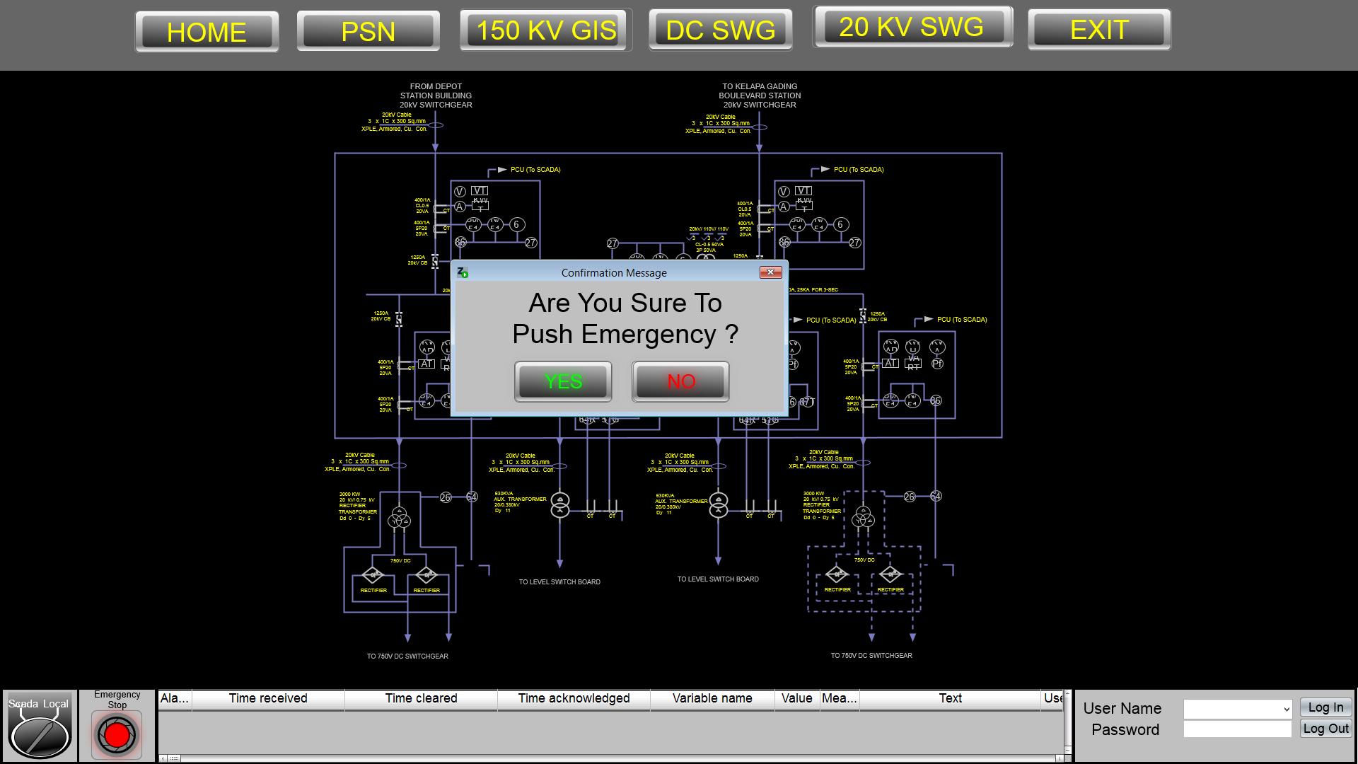

Confirmation windows

Emergency trip button

Figure 38 - Emergency trip button

After all condition has been check and conclude that there will be safe to operate the traction substation system normally, Operator than can release the emergency trip condition by operating emergency trip release button which are located on each circuit breaker symbol that affected by emergency trip condition. Procedure for releasingemergency trip button system are as follows:

1. After normal condition confirmed, OCC operator can push release button on each circuit breaker that affected by emergency trip condition.
2. Message window confirmation will appear to confirm with yes or no choice
3. If operator confirm to release, SCADA System through RTU will deactivate the inhibit signal.
4. Then OCC operator can give closing command to each DC switchgear by sequence.

### SCADA – BMS Screen Design and Funtionality

Building Management System (BMS) is a local control system which control all equipment for running service on building. Building Management System will consist of but not limited to BMS Processor Unit, analog and/or digital I/O unit, and BMS Workstation. All operator interface to control building equipment locally will be done by BMS Workstation and will be processed by BMS Processor Unit.

SCADA System will be interfaced and connected to Building Managemen System (BMS) in the form of Ethernet Communication to BMS Processor or Workstation. SCADA System will be connected to all Building Management System on each Station. Following are the drawing that shown connection diagram between SCADA System and Building Management System.



Figure 39 - SCADA System and Building Management System Connection Diagram

Building Management System (BMS) are controlling and monitoring but not be limited to the following subsystem:

|  |  |  |
| --- | --- | --- |
| **Equipment** | **BMS** | **SCADA** |
| MCFA | Monitor | Monitor |
| Fire Fighting Pump (Electric pump) | Monitor | Monitor |
| Fire Fighting Pump (Diesel pump) | Monitor | Monitor |
| Fire Fighting Pump (Jockey pump) | Monitor | Monitor |
| Water Pump (Filter pump) | Monitor | Monitor |
| Water Pump (Booster pump) | Monitor | Monitor |
| Domestic Water Tank | Monitor | Monitor |
| Rain Water Tank | Monitor | Monitor |
| Fire Water Tank | Monitor | Monitor |
| Lighting | Control & Monitor | Control & Monitor |
| ECS (Exhaust fan) | Control & Monitor | Monitor |
| ECS (VRV) | Control & Monitor | Control & Monitor |
| Generator | Monitor | Monitor |
| Weekly tank (Generator) | Monitor | Monitor |
| Power Meter (Transformer) | Monitor | Monitor |
| UPS | Control & Monitor | Monitor |
| Elevator | Monitor | Monitor |
| Escalator | Monitor | Monitor |
| LV Switchgear | Monitor | Monitor |

Table 21 - BMS and SCADA Controlling and Monitoring List

SCADA system will monitor and control all the subsystem above through Building Management System (BMS). SCADA system will control Building Management System on normal operation only.

If some subsystem or equipment need to be service, SCADA System will release the control authority to be taken by local workstation of BMS. In this mode, Control authority will be set locally through BMS Workstation and SCADA system will not be allowed to send control command to the BMS. In service mode, BMS will be allowed to control the subsystem or equipment individualy for service purposes. Following are the sample screen of SCADA system information presentation of Building Management System

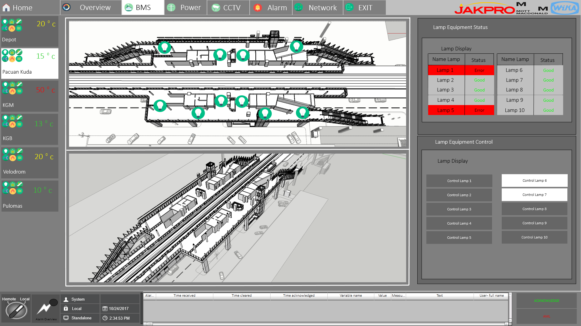

Figure 40 – BMS Ligthing HMI Display Sample

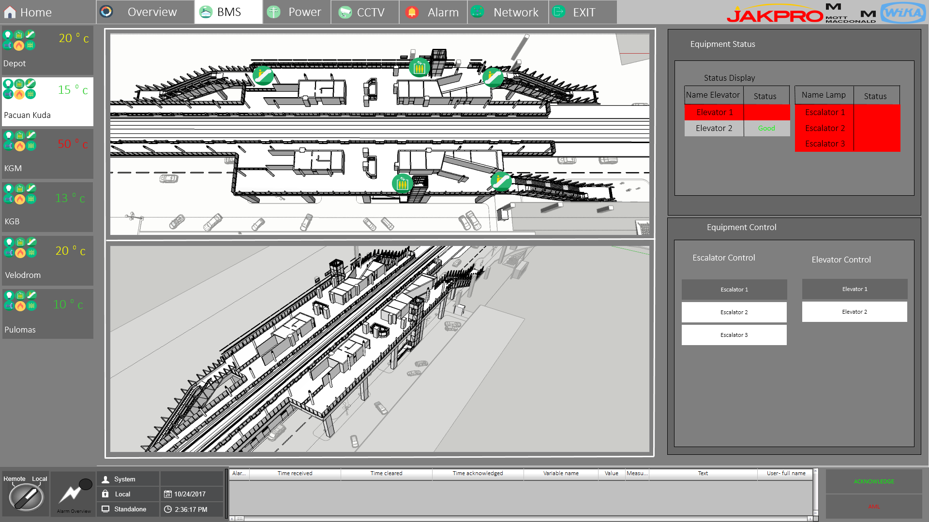

Figure 41 – Building equipment HMI Display sample

### SCADA – PA/PID/VoIP/PHP Screen Design and functionality

To Monitor and Control of PA/PID/VoIP/PHP System, SCADA System will have server to server connection with the PA/PID/VoIP/PHP system at the OCC. Following shown drawing of SCADA and PA/PID/VoIP/PHP System connection diagram.

**

PA/PID/VoIP/PHP

SCADA

Figure 42 - SCADA and PA/PID/VoIP/PHP System Connection Diagram

So, All of PA/PID/VoIP/PHP System will have an integrated server in redundant configuration for all subsystem to be connected with SCADA System.

#### SCADA – Public Announcement System.

Public Announcement (PA) System is system which handle of voice announcement to the passanger as well as to the operator and station authority according to the purposes of the announcement. Public Announcement (PA) system will be installed on each station and should have but not be limited to the following zoning for announcement:

* Platform Area
* Public Area
* Non-Public Area

Public Announcement system will also have server which located at the OCC to centralize all of the PA system. SCADA System will monitor for health status and alarm of the PA system through the above connection. SCADA System will also be allowed to control PA System in the form of the following command:

* Make Long Line Public Address (LLPA)
* Make Automatic Long Line Public Address (ALLPA) based on signaling system information
* Make Pre-Recorded announcement

Make LLPA means that the announcement operation process will be done manually by the operator. In LLPA, Operator can make live announcement as well as pre-recorded announcement. Also In LLPA, Operator should select manually for the station, zone, and also for the pre-recorded announcement if the operator decides to make pre-recorded announcement. This announcement also can be configured to be cyclical or just one-time announcement.

ALLPA command will only use pre-recorded announcement. the ALLPA command will be applied for the following operation:

* Train Information Announcement
* Pre-Configured Information on the particular station.

Train information Announcement consist of the following information:

* Next Train expected arrival time announcement
* Train Approaching and passanger warning according to the train approaching announcement.

Train Information Announcement will only announce at the zone platform to give information to the passanger at the related platform area.

Alarm information announcement will be categorize based on the alarm purpose. This can be based on alarm level, location, or intended actor (public or non-public).

Pre-Configured Information Announncement is the announcement on the particular station and zone that will be created by the operator and it will be synchronized with PIDS. Following show the sample screen of Public Announcement Display.

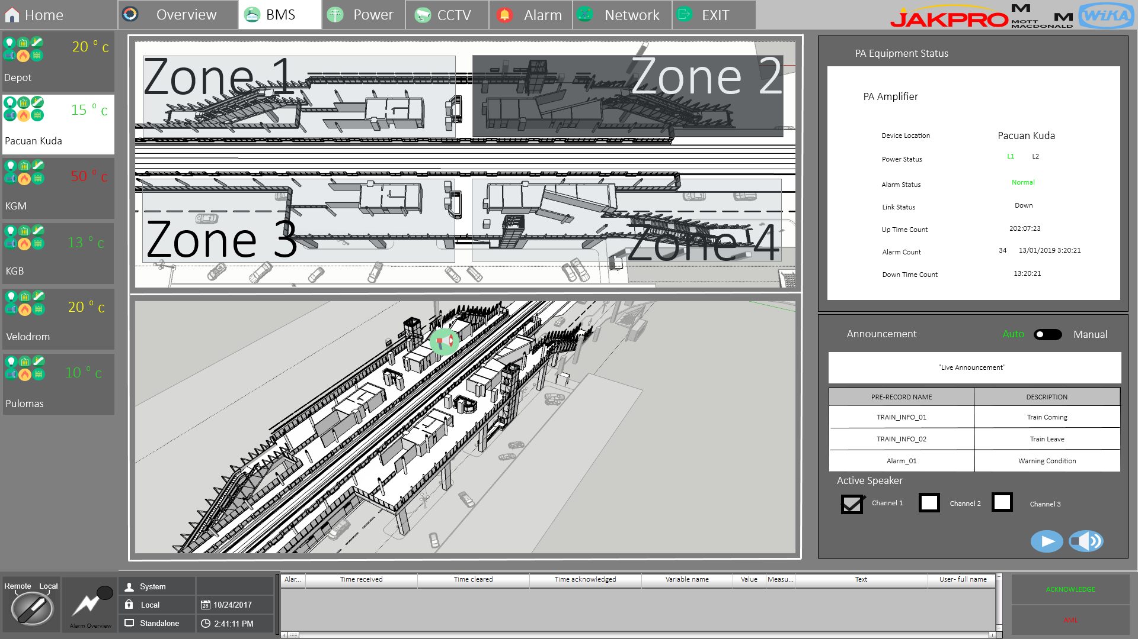

Figure 43 – Public Announcement HMI Display Sample

#### SCADA – Public Information Display (PID)

Public Information Display (PID) is a system or equipment that will be displayed a text message information. PID system should be integrated with the PA System, So SCADA System will automatically be interconnected with the PID system, because it has been connected with PA System at PA Server in the OCC.

The PID Display will be in the form of LED dot matrix display panels, so it will be mainly used to display real time train arrival information. SCADA System will monitor PID system equipment for health status and alarm. And also, SCADA system will be allowed to send command control to the PID system in the form of the following:

* Sending Text Message.

There will be two mode of messaging PID System by SCADA System, which are:

* Manual Messaging Mode
* Automatic Messaging Mode

Manual Messsaging Mode will be used for operator to display message on the PID display manually. In this mode, operator need to enter the message he or she want to display. The Message will also able to be configured cyclical in the specific time or just one time message.

Automatic Messaging Mode will be applied regarding of the following operation:

* Train information message

Train Information Message will be displayed but should not be limited to the following information:

* Next Train Expected Arrival Time
* Train Approaching.

Following are the sample screen of PID display on SCADA system

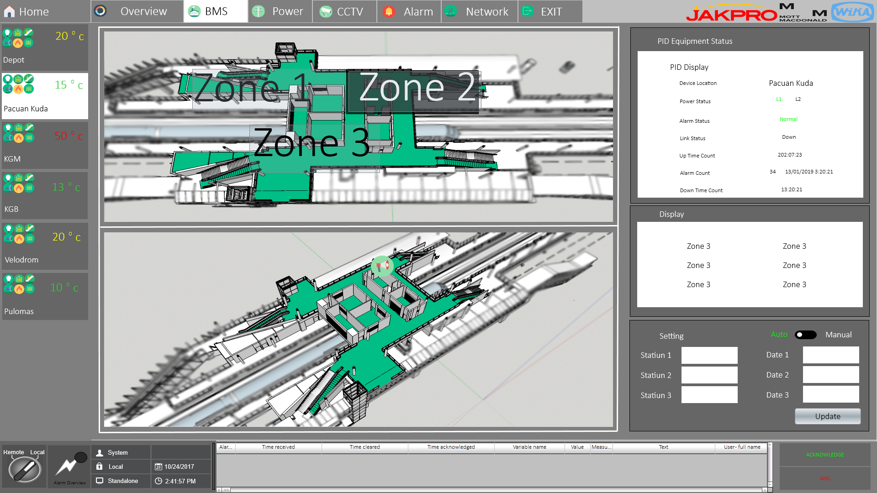

Figure 44 – PID HMI Display sample

#### SCADA - VoIP and Passanger Help Point (PHP)

For the Voice Over IP (VoIP) System, SCADA system will only monitor for equipment health status and alarm. So, there will be no command control from SCADA system to the VoIP System.

Passanger Help Point (PHP) System will consist of intercom like communication equipment which will be installed usually at the elevator to allow for the passenger to communicate with the operator.

Following shown block diagram of SCADA System and PHP system operational concept.



Figure 45 - SCADA System and PHP system Operational Concept

* 1. When a passanger initiate communication with the operator through PHP device,
  2. PHP system will pass to CXS Server which will further send the status of PHP to SCADA System.
  3. SCADA system will monitor this action, indication for the active PHP equipment in SCADA Workstation to inform the operator at OCC that there is a call from the passenger through PHP System.
  4. Send the information to the CCTV process to point particular camera to the active PHP equipment, and zoom in if necessary

### SCADA AMS/CCTV Screen Design and Funtionality

Following Shown drawing of SCADA – AMS/CCTV Connection diagram.



Figure 46 - SCADA – AMS/CCTV System Connection Diagram

For the Access Management System (AMS), SCADA system will only monitor for equipment health status and alarm. So, there will be no command control from SCADA system to the AMS. The status and alarm data will be gather from AMS/CCTV Server.

CCTV System will consist of IP Based Camera that can be accessed using TCP/IP communication. SCADA system will require to access CCTV camera for live streaming only. All recording will be done by CCTV Server..

Beside for realtime live streaming, SCADA system will also be able to control the PTZ camera to point of required position. When there is necessary alarm need to show for live streaming image or PHP Intercom active, SCADA System will detect such information and will access particular CCTV camera, point to appropriate location and zoom in if possible. Then SCADA Workstation will display the image from particular CCTV Camera.

SCADA System will also monitor CCTV System equipment for health status and alarm. The status and alarm data can be gather from AMS/CCTV Server, or from CCTV Camera device directly. Following show sample screen of CCTV monitoring display on SCADA system.

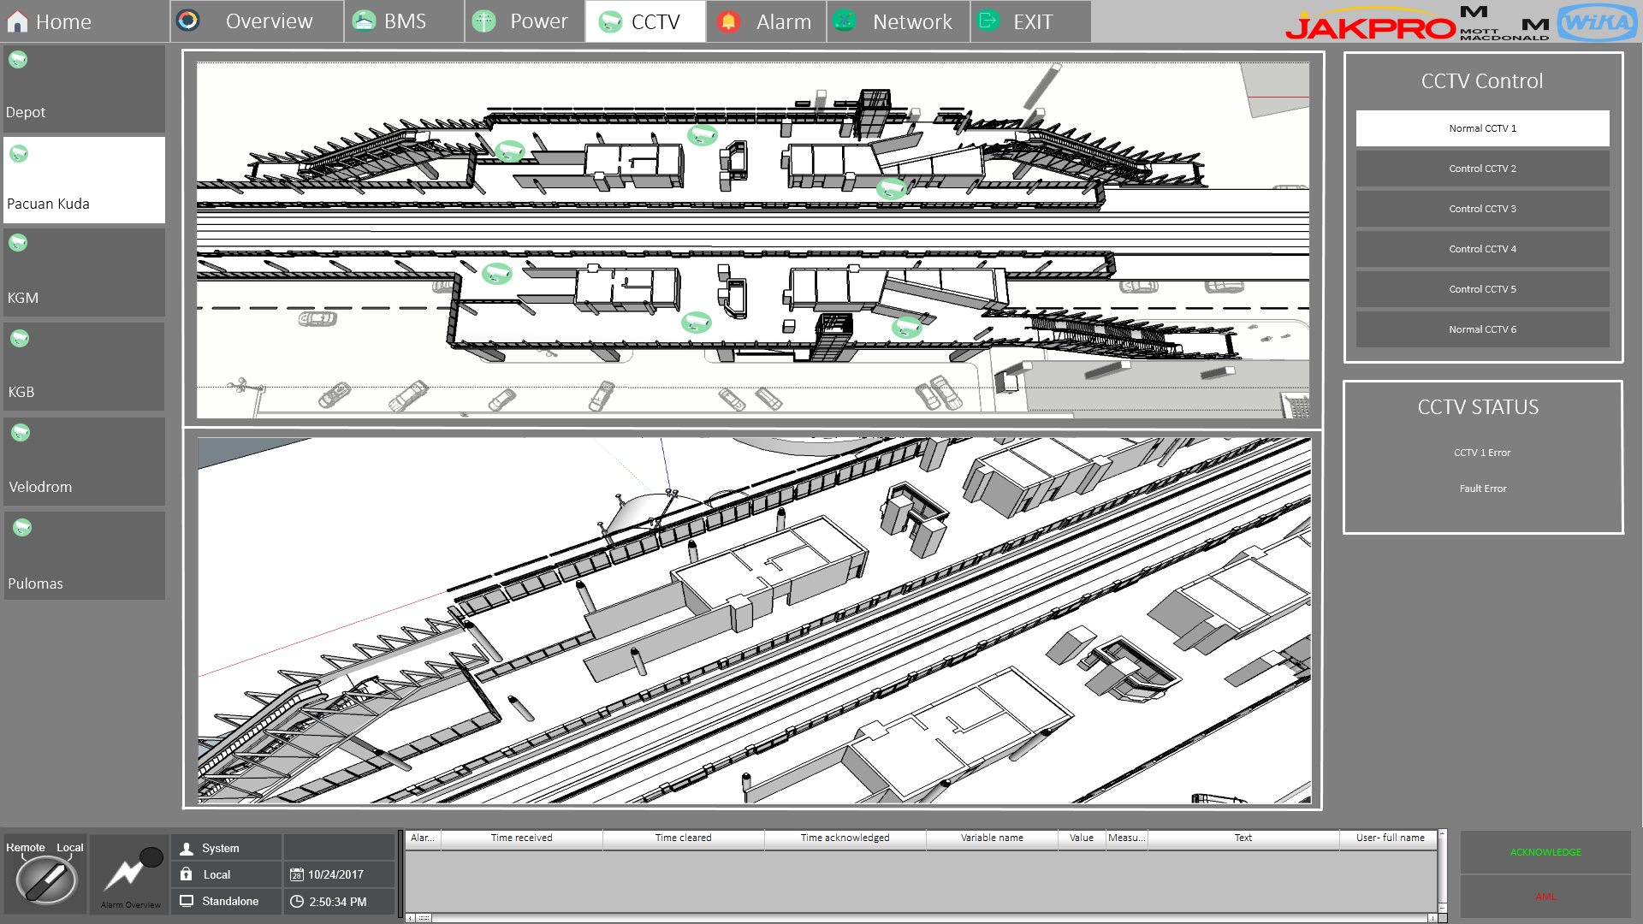

Figure 47 – CCTV Monitoring HMI Display Sample

### SCADA – Other System Screen Design and Funtionality

For other system, SCADA system will only monitor for health status and alarm of the equipment. There will be three kinds of connection between SCADA System and Other system, which are:

* Server to Server Connection
* SCADA Server to other controller
* SCADA Server to device directly.

Following are table of the other system connection type plan to scada server (this connection type can be changed based on the interface with other party).

|  |  |  |  |
| --- | --- | --- | --- |
| **No** | **System** | **Connection Type Plan** | **Protocol** |
| 1 | Radio Tetra | Server to Server | SNMP |
| 2 | Master Clock System | Server to Server | SNMP |
| 3 | Automatic Fair Collection (AFC) | Server to Server | SNMP |
| 4 | Fibre Optic Transmission System (FOTS) | Server to Server | SNMP |
| 5 | Platform Screen Door (PSD) | SCADA Server to PSD Controller | Modbus TCP |
| 6 | Wide Area Network (WAN) | SCADA Server to device directly | SNMP |

Table 22 - SCADA Interface with other Party

Following are drawing of the connection type between SCADA System and Other System, and the screen sample of PSD system monitoring display.



Figure 48 - SCADA Connection with Other Party

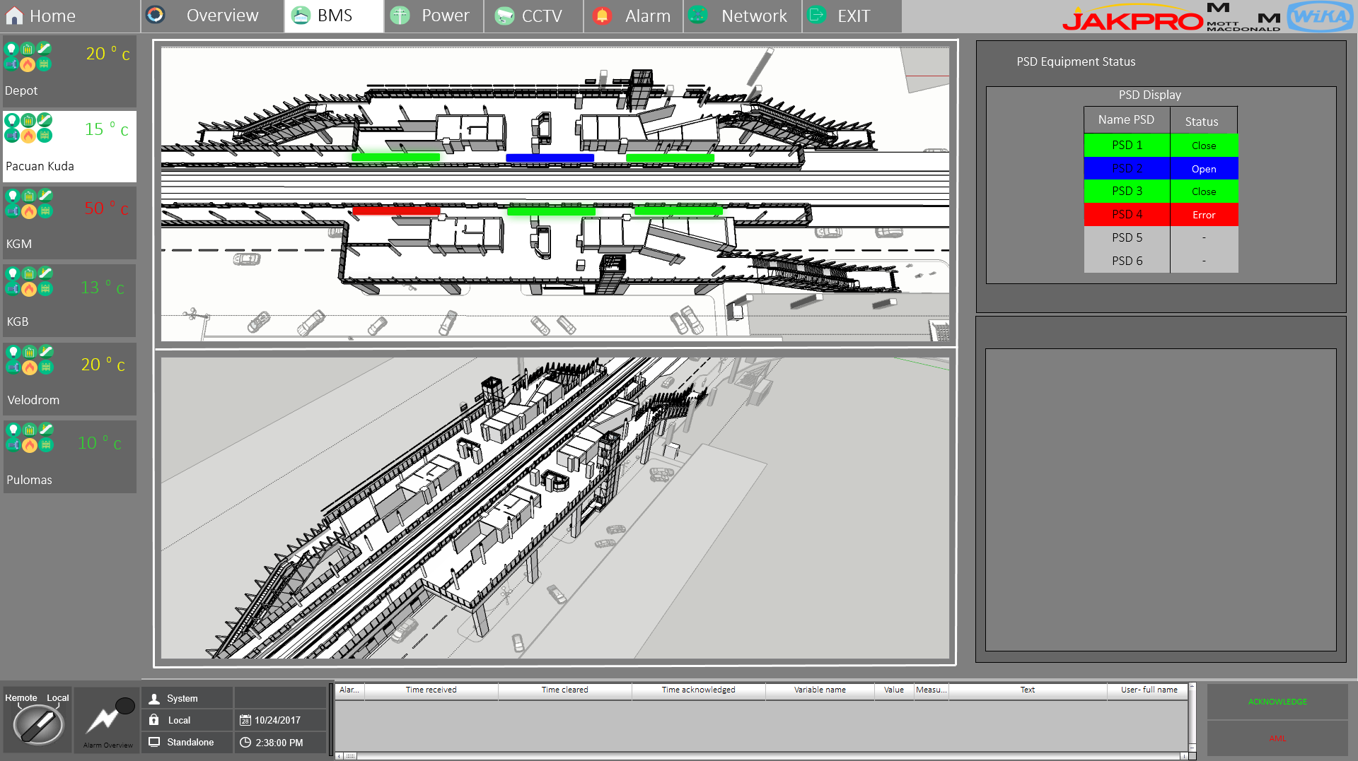

Figure 49 – PSD Monitoring HMI Display Sample

### SCADA – Wall Display Screen Design and Funtionality

SCADA System will be equipped with a computer that will be use as SCADA wall display controller. This SCADA wall display controller will organize the basic overall view of the subsystem being controlled by SCADA System. SCADA Wall Display Controller will be the client of SCADA Server. Following are the plan of the overall view that will be displayed by wall display controller:

* Traction Power Substation Overview
* Building and utility Overview

Following shown drawing of SCADA Wall Display Design Interface diagram.



Figure 50 - SCADA Wall Display Design Interface Diagram

## HMI SCADA Sytem BoQ

|  |  |  |  |  |  |  |  |  |  |  |  |  |  |  |  |  |  |
| --- | --- | --- | --- | --- | --- | --- | --- | --- | --- | --- | --- | --- | --- | --- | --- | --- | --- |
| **NO** | **DESCRIPTION** | **BRAND** | **PART #** | **QTY Need** | **QTY Spare** | **QTY Ordered** | **UNIT** |  |  |  |  |  |  |  |  |  |  |
|  |  |  |  |  |  |  |  | MAIN SERVER RACK | OCC WORKSTATION | OCC PRINTER | LARGE DISPLAY PNL | BACKUP SERVER RACK | BCC WORKSTATION | TYP. LOCAL WORKSTATION | DEPOT APSS RTU | DEPOT TPSS RTU | TYP. STATION TPSS RTU |
| **A** | **SERVER / WORKSTATION** |  |  |  |  |  |  |  |  |  |  |  |  |  |  |  |  |
| 1 | Server PC Processor Intel Xeon E5-2637v4 Windows Server 2016 x64 Memory 32 GB (2x HPE 16GB 1Rx4 PC4-2400T-R Kit) HP Smart Array P440ar/2G FIO Controller 2x HPE 300GB SAS 10k SFF SC HDD 12x HPE 600GB SAS 15K SFF SC HDD HP Embedded 1Gb Ethernet 4-port 331i Adapter 2x HPE 800W FS Plat Hot Plug Power Supply Kit HPE iLO Adv incl 3yr TSU 1-Server License HPE 5Y Proactive Care 24x7 Service | Hewlett Packard | ProLiant DL380 Gen9 | 2 |  | 2 | EA | 1 |  |  |  | 1 |  |  |  |  |  |
| 2 | Workstation PC Windows 10 Pro 64 - HP recommends Windows 10 Pro Intel® Xeon® E5-2620 v4 Processor (2.1 GHz, up to 3 GHz w/Turbo Boost, 20 MB cache, 2133 MHz, 8 core) HP Z840 850W 88 Percent Efficient Chassis 16GB DDR4-2400 (2x8GB) 1 CPU Registered RAM Operating System Load to SATA/SAS 1 TB 7200 RPM SATA HDD 1 TB 7200 RPM SATA 2nd HDD 1 TB 7200 RPM SATA 3rd HDD NVIDIA Quadro M4000 8GB 4xDP 1st No cable included Graphics HP Remote Graphics Software (RGS) for Z 9.5 mm Slim DVD-Writer Optical Disc Drive HP USB Keyboard HP USB Optical Mouse RAID 5 Parity Array Configuration HP DisplayPort To DVI-D Adapter (4-Pack) HP X520 10GbE Dual Port Adapter HP Single Processor Air Cooling Kit HP 3/3/3 Warranty HP Single Unit Packaging HP Z840 Country Kit | Hewlett Packard | Z840 Workstation | 3 |  | 3 | EA |  | 2 |  |  |  | 1 |  |  |  |  |
| 3 | Workstation PC Windows 10 Pro 64 - HP recommends Windows 10 Pro Intel® Xeon® E5-2640 v4 Processor (2.4 GHz, up to 3.4 GHz w/Turbo Boost, 25 MB cache, 2133 MHz, 10 core) HP Z840 850W 88 Percent Efficient Chassis 32GB DDR4-2400 (2x16GB) 1 CPU Registered RAM Operating System Load to SATA/SAS 1 TB 7200 RPM SATA HDD 1 TB 7200 RPM SATA 2nd HDD 1 TB 7200 RPM SATA 3rd HDD NVIDIA Quadro M4000 8GB 4xDP 1st No cable included Graphics HP Remote Graphics Software (RGS) for Z 9.5 mm Slim DVD-Writer Optical Disc Drive HP USB Keyboard HP USB Optical Mouse RAID 5 Parity Array Configuration HP DisplayPort To DVI-D Adapter (4-Pack) HP X520 10GbE Dual Port Adapter HP Single Processor Air Cooling Kit HP 3/3/3 Warranty HP Single Unit Packaging HP Z840 Country Kit | Hewlett Packard | Z840 Workstation | 6 |  | 6 | EA |  |  |  |  |  |  | 6 |  |  |  |
| 4 | Workstation PC Windows 10 Pro 64 - HP recommends Windows 10 Pro Intel® Xeon® E5-2640 v4 Processor (2.4 GHz, up to 3.4 GHz w/Turbo Boost, 25 MB cache, 2133 MHz, 10 core) HP Z840 1125W (1450W/200V) 90 Percent Efficient Chassis 16GB DDR4-2400 (2x8GB) 1 CPU Registered RAM Operating System Load to SATA/SAS 1 TB 7200 RPM SATA HDD 1 TB 7200 RPM SATA 2nd HDD 1 TB 7200 RPM SATA 3rd HDD NVIDIA Quadro M4000 8GB 4xDP 1st No cable included Graphics NVIDIA Quadro M4000 8GB 4xDP 2nd No cable included Graphics HP Remote Graphics Software (RGS) for Z 9.5 mm Slim DVD-Writer Optical Disc Drive HP USB Keyboard HP USB Optical Mouse RAID 5 Parity Array Configuration HP DisplayPort To DVI-D Adapter (6-Pack) HP X520 10GbE Dual Port Adapter HP Single Processor Air Cooling Kit HP 3/3/3 Warranty HP Single Unit Packaging HP Z840 Country Kit | Hewlett Packard | Z840 Workstation | 1 |  | 1 | EA |  |  |  | 1 |  |  |  |  |  |  |
| 5 | HP Z6/Z8 Rack Mount Kit | Hewlett Packard | B8S55AA | 1 |  | 1 | EA |  |  |  | 1 |  |  |  |  |  |  |
| 6 | LED Monitor 27-inch IPS LED Resolution 1920 x 1080 (16:9) Input DVI-D, DP, VGA & HDMI | Hewlett Packard | V272 | 30 |  | 30 | EA |  | 8 |  |  |  | 4 | 18 |  |  |  |
| 7 | Colour Printer | Hewlett Packard | Laserjet Pro M177fw | 1 |  | 1 | EA |  |  | 1 |  |  |  |  |  |  |  |
| 8 | Black / White Printer | Hewlett Packard | Officejet Pro 8210 | 2 |  | 2 | EA |  |  | 2 |  |  |  |  |  |  |  |

*Table*  23 *– SCADA BoQ*

## Cabling System

### CAT 6 Cable

SCADA equipments connected to the SCADA LAN as well as Ethernet cable willbe using Cat 6 cable.

|  |  |  |
| --- | --- | --- |
| **Actassi F2 Category 6 UTP Cable or Equivalent** | | |
| No | Description | Technical Spesifications |
| 1 | Conductor | Solid Bare Copper |
| 2 | Jacket | PVC |
| 3 | Separator | F2 Construction (PE) |
| 4 | Insulation | PE |
| 5 | AWG | 23 (0.58mm) |
| 6 | Reference Standard | TIA/EIA 568B.2-1 & ISO/IEC 11801, IEC61156-5 |
| 7 | Product Standard | UL |
| 8 | Certification | Flammability Test CM Fire rated |

Table 24 - CAT 6 Cable's Spesification

### AC Power Cable 4 Core

Copper Conductor PVC Insulated & PVC Sheathed Armoured Power Cable 41 A is used to connect the power source from existing electrical distribution board to the server, switch and workstation of SCADA.

| **Cu/PVC/SWA/PVC 0.6/1 kV (NYRGbY)** | | |
| --- | --- | --- |
| No | Description | Technical Spesifications |
| 1 | Spesification | SPLN 43-2 : 1994  IEC 60502-1 : 2004  SNI IEC 60502-1 : 2009 |
| 2 | Conductor | Annealed plain copper round circular stranded according to SPLN 41 - 1 ; IEC 60228 |
| 3 | Insulator | Extruded layer of Polyvinyl Chloride (PVC] complied with SPLN 41-2 :IEC 60502-1 |
| 4 | Armour Material | A layer of galvanized round steel wires with a counter helixlayer of galvanized steel tape |
| 5 | Outer Sheath | Extruded Polyvinyl Chloride [PVC] Black color |
| 6 | No. of cores and cross  secton area | 4 x 4 sq.mm |
| 7 | Current Rating | 41 A |
| 8 | Voltage Rating | 1kV |
| 9 | DC Resistance at 20C | 50 Ohm/Km |
| 10 | Temperature | 70C |
| 11 | Indentification | (SNI IEC) Yellow/Green Strip, Light Blue,Brown. |
| 12 | Special Feature | Low Smoke Zero Halogen |

Table 25 - Tehnical Cable's Spesification for AC Power

### Earthing Cable

Single Core Flexible Copper Conductor PVC Insulated used to connect the SCADA equipment needed earthing to earthing bar.

| **Cu/PVC/PVC 450/750 V (NYAF)** | | |
| --- | --- | --- |
| No | Description | Technical Spesifications |
| 1 | Spesificatio006E | SPLN 42-3 1992  IEC 227  SNI: 04-6629.5-2006 |
| 2 | Conductor | Annealed plain copper wires bunch stranded, according to SPLN 41-1; IEC 60228 |
| 3 | Insulator | Extruded layer of Polyvinyl Chloride [PVC] complied with SPLN 41-2 |
| 4 | Nominal Cross Section Area | 10 sq.mm |
| 5 | No. of wire and Diameter | 84./0.4 mm |
| 6 | Nominal thickness Insulation | 1.0 mm |
| 7 | Overall Diameter (approx) | 7.4 mm |
| 8 | Weight of Cable (approx] | 116 Kg/Km |
| 9 | Minimum Bending Radius | 133 mm |
| 10 | DC Resistance at 20C | 1.91 Ohm/Km |
| 11 | Temperature | 70C |
| 12 | Indentification | Yellow green strip |

Table 26 - Technical Cable's Spesification for Power and Chassis Grounding

## Earthing System

### Introduction

Earthing (grounding) is an important part of electrical design.

Earthing system is an electrical bond between agiven point in a network, installation or machine and anearth electrode.

The purpose of earthing systems is to:

* Prevent hazardous voltages due to system faults
* Prevent disturbances to electronics
* Minimise danger and damage due to lightning strikes
* Ensure the fast operation of protection devices

### Grounding of SCADA Equipment

All the electrical apparatus SCADA which required common ground will be bonded to theearth bar using the copper cable in PVC sheath. The method of the bonding will bebased on a crimped lug bolted at both end of the copper cable between the earth bar and theelectrical apparatus.

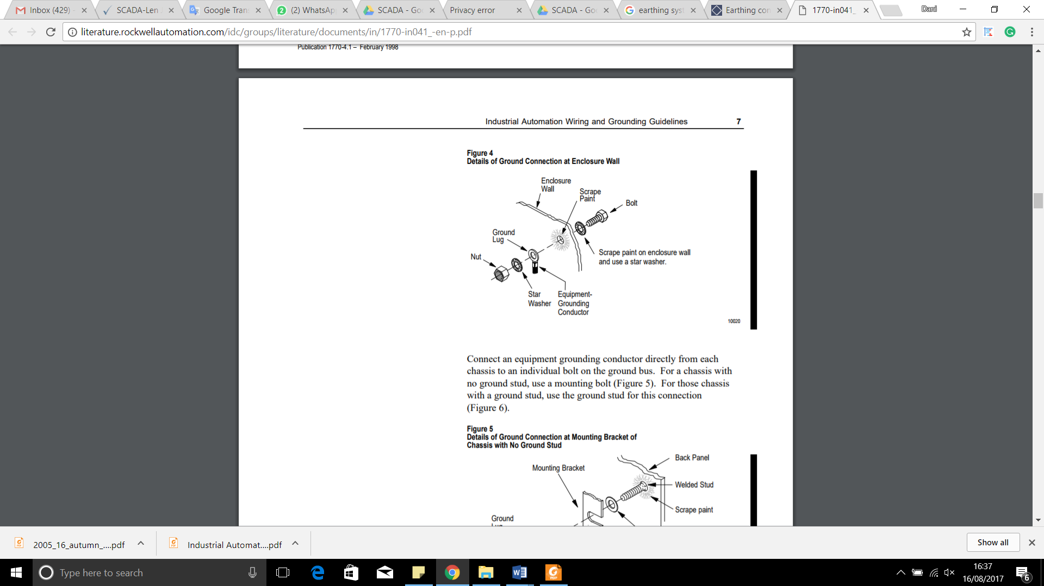

Figure 49 - Detail of Ground Connection

Besides bonding the electrical apparatus, the metallic chassis of the apparatus such as panel door mounting plate inside the panel will be bonded to the earth bus bar.

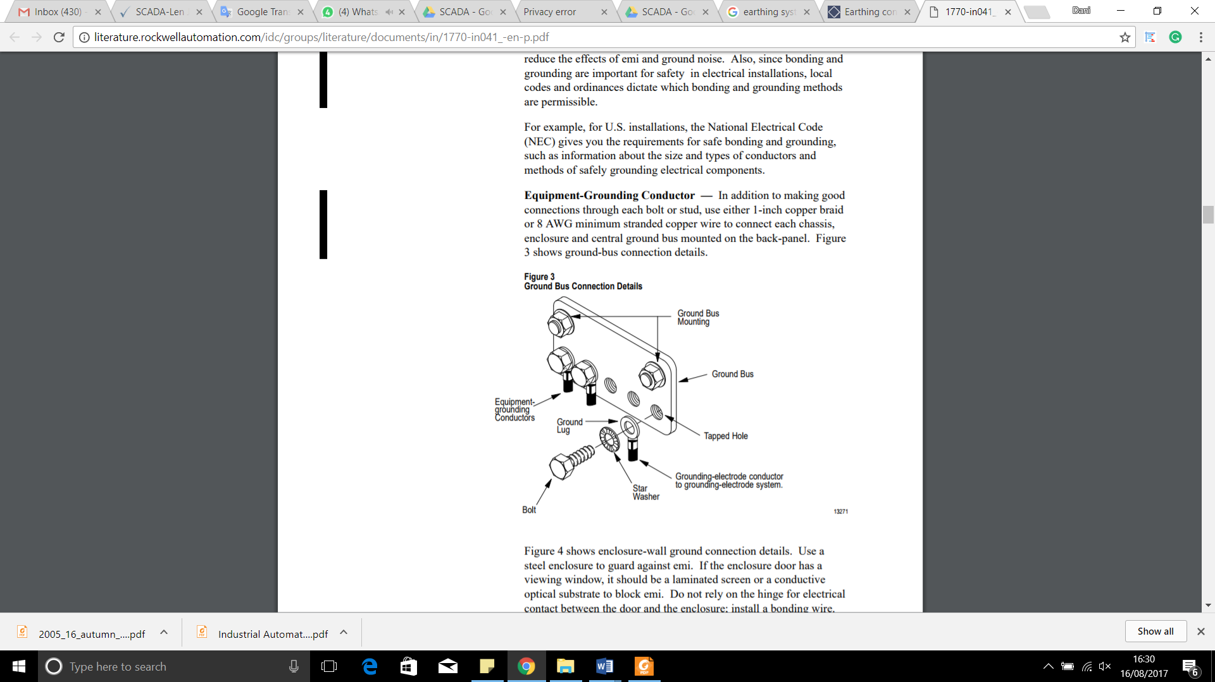

Figure 50 - Ground Bus Bar Connection Details

The ohmic requirement for the main earth bar terminal (provided by others) shall be not more than 1ohm.

# Electromagnetic compatibility

Electromagnetic compatibility is the condition that prevails when telecommunications equipment is performing its individually designed function in a common electromagnetic environment without causing or suffering unacceptable degradation due to unintentional electromagnetic interference to or from other equipment in the same environment.

The SCADA system equipment provided in the Jakarta LRT project will be electromagnetically compatible with their environments and in accordance to the EMC standards as stated in the contract. SCADA system in this project, regarding from compliance matrix in previous section, will be according to BS EN 61000 - Electromagnetic compatibility (EMC).

|  |  |  |  |
| --- | --- | --- | --- |
| **No.** | **Product** | **Part Number** | **EMC Standard** |
| 1 | Color Laserjet Printer | HP MFP M177fw | CISPR 22:2008/EN 55022:2010 - Class B, EN 61000-3-2:2006 +A1:2009 +A2:2009, EN 61000-3-3:2008, EN 55024:2010, FCC Title 47 CFR, Part 15 Class B / ICES-003, Issue 5, GB9254-2008, GB17625.1-2003, EMC Directive 2004/108/EC (Europe) |
| 2 | Black and White Printer | HP Officejet Pro 8210 | CISPR 32:2012 / EN55032:2012 Class B CISPR 24:2010 / EN55024:2010  EN 61000-3-2:2014, EN 61000-3-3:2013, FCC CFR 47 Part 15 Class B  ICES-003, Issue 6 Class B, EN 301 489-1 V2.1.1:2017,EN 301 489-17 V3.1.1:2017 |
| 3 | OCC and BCC Server | HP HPE ProLiant DL380 Generation 9 (Gen9) | FCC Rating Class A  CISPR 22; EN55022; EN55024; FCC CFR 47, Pt 15; ICES-003; CNS13438; GB9254; K22; K24; EN 61000-3-2; EN 61000-3-3; EN 60950-1; IEC 60950-1 |
| 4 | SCADA Workstation | HP Z840 Workstation | EN 55024:2010, EN 55032:2012 Class B, EN 61000-3-2:2014, EN 61000-3-3:2013, CISPR 22:2008 Class B, CISPR 32:2012 Class B, FCC CFR 47 Part 15, ICES-003, Issue 5 |
|  |  |  |  |

*Table*  27 *– Hardware Compatibility*

# RAMS Model

The SCADA System is targeted to meet the SIL 2 based on IEC 61508. This section describes the RAMs model and calculation for the SCADA System towards achieving the availability level.

The following picture depict the hardware configuration and SIL2 Boundary.



Figure 51 – SCADA System SIL 2 Boundary

The following table shows the MTBF and MTTR numbers of the SCADA system:

|  |  |  |  |
| --- | --- | --- | --- |
| **Equipment** | **MTBF (Hr)** | **MTTR (Hr)** | **Availability** |
| **OCC SCADA Server** | 50,000 | 0.5 | 0,9999999999 |
| **OCC HMI Workstation** | 50,000 | 0.5 | 0,9999999999 |
| **Local HMI Workstation** | 50,000 | 0.5 | 0,99999 |
| **RTU** | 120,000 | 0.5 | 0,999999999983 |

Table 28 - Equipment MTBF, MTTR and Availability Summary

The MTBF is the number of hours before an occurrence of a failure in the SCADA system device. The MTTR is the mean time to repair of the SCADA system. The MTTR specified is the time that is only relevant to the SCADA system and does not take into account any time that is consumed outside of the troubleshooting and repair time of the SCADA system. The following diagram shows the interconnections of the SCADA setup and the availability calculation with assumption that all other subsystems are in ideal conditions.



Figure 52 – SCADA System Configuration



Figure 52 – SCADA System Availability calculation

Based on the above figures, the Availability of the SCADA System can be calculated as below:

* Availability of Parallel OCC SCADA Server = 1-(0,00001) (0,00001)
* Availability of Parallel OCC SCADA Server = 0,9999999999
* Availability of Parallel OCC HMI Workstation= 1-(0,00001) (0,00001)
* Availability of Parallel OCC HMI Workstation = 0,9999999999
* Availability of Local HMI Workstation = 1-0,00001
* Availability of Local HMI Workstation = 0,99999
* Availability of Parallel RTU = 1-(4,167E-06) (4,167E-06)
* Availability of Parallel RTU = 0,999999999982639
* Availability of SCADA system = 1 – Unavailability {Parallel OCC SCADA Server + Parallel OCC HMI Workstation + Local HMI Workstation + Parallel RTU}
* Availability of SCADA system = 1- [(0.00001) (0.00001) + (0.00001) (0.0001) + (0.00001) + (4,167E-06) (4,167E-06)]
* Availability of SCADA System = 1 - 0.000010001217364
* Availability of SCADA System = 0,999989998782636
* Availability of SCADA System = 99,9989998782636 %

# Appendix

Appendix A: Compliance List Matrix

Appendix B: List of Drawings

Appendix C: SIL 2 Certificate

Appendix D: Technical Spesification of SCADA

Appendix E: IO List (not confirm)

APPENDIX A:

Compliance List Matrix

| **NO** | **REQUIREMENTS** | **COMPLIANCE** | | | | **CONTENT TYPE** | | **Requirement's Evidence (Document Reference)** | **NOTE** |
| --- | --- | --- | --- | --- | --- | --- | --- | --- | --- |
| **Compliant** | **Partially-Compliant** | **Non-Compliant** | **Discrepancy** | **Requirement** | **Information** |
|  | **Standards for SCADA** | | | | | | | | |
| 1 | BS 7430 - Code of practice for protective earthing of electrical installations | √ |  |  |  |  |  | Section 1.2.2 Standard References |  |
| 2 | BS 7671 - Requirements for electrical installations. IET Wiring Regulations. 17th edition | √ |  |  |  |  |  | Section 1.2.2 Standard References |  |
| 3 | BS EN 50121 - Railway applications. Electromagnetic compatibility | √ |  |  |  |  |  | Section 1.2.2 Standard References |  |
| 4 | BS EN 50122 - Railway applications. Fixed installations. Electrical safety, earthing and the return circuit | √ |  |  |  |  |  | Section 1.2.2 Standard References |  |
| 5 | BS EN 50125 - Railway applications. Environmental conditions for equipment | √ |  |  |  |  |  | Section 1.2.2 Standard References |  |
| 6 | BS EN 50126 - Railway applications. The specification and demonstration of reliability, availability, maintainability and safety (RAMS) | √ |  |  |  |  |  | Section 1.2.2 Standard References |  |
| 7 | BS EN 50128 - Railway applications. Communication, signalling and processing systems. Software for railway control and protection systems | √ |  |  |  |  |  | Section 1.2.2 Standard References |  |
| 8 | BS EN 50129 - Railway applications. Communication, signalling and processing systems. | √ |  |  |  |  |  | Section 1.2.2 Standard References |  |
| 9 | BS EN 50174 - Information Technology. Cabling installation | √ |  |  |  |  |  | Section 1.2.2 Standard References |  |
| 10 | BS EN 50288-7 - Multi-element metallic cables used in analogue and digital communication and control | √ |  |  |  |  |  | Section 1.2.2 Standard References |  |
| 11 | BS EN 50310 - Application of equipotential bonding and earthing in buildings with information technology equipment | √ |  |  |  |  |  | Section 1.2.2 Standard References |  |
| 12 | BS EN 60073 - Basic and safety principles for man-machine interface, marking and identification. Coding principles for indication devices and actuators | √ |  |  |  |  |  | Section 1.2.2 Standard References |  |
| 13 | BS EN 60529 - Degrees of protection provided by enclosures (IP code) | √ |  |  |  |  |  | Section 1.2.2 Standard References |  |
| 14 | BS EN 60617 - Graphical symbols for diagrams | √ |  |  |  |  |  | Section 1.2.2 Standard References |  |
| 15 | BS EN 60870 - Tele-control equipment and systems | √ |  |  |  |  |  | Section 1.2.2 Standard References |  |
| 16 | BS EN 60950 - Information Technology Equipment. Safety | √ |  |  |  |  |  | Section 1.2.2 Standard References |  |
| 17 | BS EN 61000 - Electromagnetic compatibility (EMC) | √ |  |  |  |  |  | Section 1.2.2 Standard References |  |
| 18 | BS EN 61131 - Programmable controllers | √ |  |  |  |  |  | Section 1.2.2 Standard References |  |
| 19 | BS EN 61508 - Functional Safety of Electrical/Electronic/programmable electronic safety-related systems | √ |  |  |  |  |  | Section 1.2.2 Standard References |  |
| 20 | BS EN 62305 - Protection against lightning | √ |  |  |  |  |  | Section 1.2.2 Standard References |  |
| 21 | BS EN 62491 - Industrial systems, Installations and equipment and industrial products – labelling of cables and cores | √ |  |  |  |  |  | Section 1.2.2 Standard References |  |
| 22 | ISO 11801:2012 - Information technology - Generic cabling for customer premises - Amendment 2 | √ |  |  |  |  |  | Section 1.2.2 Standard References |  |
| 23 | All Indonesia National and Municipal Codes, Acts and Regulations that are related to the SCADA system | √ |  |  |  |  |  | Section 1.2.2 Standard References |  |
|  | **Functional Requirements for SCADA** | | | | | | | | |
| 1 | The SCADA system shall provide a centralised control function with appropriate SCADA facilities to provide theOperators with an efficient means of real-time monitoring and controlling the M&E plant and subsystemsthroughout the stations through the SCADA workstations. | √ |  |  |  |  |  | Section 2 System Description  Appendix A: SCADA Design Architecture |  |
| 2 | The core of the SCADA system shall comprise a pair of redundant servers, configured in a hot-standbyconfiguration to provide resilience and secondary recovery control positions. The detailed designs andconfiguration of the SCADA system shall be considered to maximise system reliability and availability which will minimise operational risk. | √ |  |  |  |  |  | Section 5.1 Redudancy  Appendix A: SCADA Design Architecture |  |
| 3 | The SCADA system shall continuously monitor the status of M&E plant and subsystems. Equipment failures of M&E plant and subsystems shall generate alarms to the SCADA workstations which shall be automatically recorded and printed. The system shall provide comprehensive management information in the form of historical trends to enable the efficiency of station operation. | √ |  |  |  |  |  | Section 6.4.2 Alarm |  |
| 4 | The SCADA workstations shall provide high quality data presentation using the latest Graphic User Interface (GUI) techniques showing the operational status of M&E plant and subsystems by means of dynamic plan layouts, single-line diagrams and icons. | √ |  |  |  |  |  | Section 6.4.3 Screen Display Design |  |
| 5 | The SCADA system shall interface with the M&E plant and subsystems at the following locations:   * All stations * Depot * Traction power substations | √ |  |  |  |  |  | Section 6. General |  |
| 6 | The SCADA system shall be constructed in accordance with internationally recognised standards and designed for safe and efficient operation. All hardware and software of SCADA system shall be of a proven design and the major core components of the SCADA system shall have a service life of at least 15 years. | √ |  |  |  |  |  | Section 4.1 Zenon Product Family |  |
| 7 | The SCADA system shall be certified to a high and continuous demand SIL2 standard in accordance with BS EN 61508. | √ |  |  |  |  |  | Appendix B - SIL 2 Zenon Certificate  Appendix B - SIL 2 Allen - Bradley Certificate |  |
| 8 | The SCADA system shall meet, but not limited to the following requirements:   * Commercial-off-the-shelf (COTS) and modular construction solution. * Open proprietary system. * IP based and interfacing seamlessly with the M&E plant and subsystems. * Industrial grade with proven high quality and reliability, suitable for railway environment. * Supplied by proven system integrator with proven track record on rail systems. * Powered from UPS supplies to protect against failure of the incoming mains supplies. | √ |  |  |  |  |  | Section 2.2.5 Power Requirements  Section 4.1 Zenon Product Family  Section 8 RAMS Model |  |
| 9 | SCADA Servers / Workstations | | | | | | | | |
| 9.1 The OCC shall be installed with redundant SCADA servers; each console shall be installed with a SCADA workstation for the operation of the M&E plant and subsystems. | √ |  |  |  |  |  | Section 5.1 Redundancy  Appendix A: SCADA Design Architecture |  |
| 9.2 The SCADA servers and workstations shall use the most recent proven computer technology consisting of hardware and software. All system hardware and software shall be of a type already widely used for rail application with full service and support facilities available. | √ |  |  |  |  |  | Section 4.1 Zenon Product Family |  |
| 9.3 The SCADA servers shall be capable, in terms of processor and memory, to meet the performance requirements, including operator interface, database management, alarming and communication interfaces. The primary server shall handle communications with the RTUs, maintain the primary system database and interface with the SCADA workstations through the LAN in OCC or Fibre Optic Transmission System for those SCADA workstations that installed throughout the stations. | √ |  |  |  |  |  | Section 3 Hardware Description  Appendix A: SCADA Design Architecture |  |
| 9.4 The SCADA servers shall be configured in a hot-standby arrangement so that either server can immediately assume system mastership in the event of one server failure. Each server shall have two communication links to interconnect with two different network switches for receiving or transmitting I/O status from or to the fields RTUs, SCADA workstations or subsystems. | √ |  |  |  |  |  | Section 5.1 Redundancy  Appendix A: SCADA Design Architecture |  |
| 9.5 The SCADA servers shall utilise the LAN connection to monitor and control of other subsystems including CCTV System, Public Address (PA) System, Help Points System, Passenger Information Display (PID) System, etc. through the IP protocol. consistent at all times with the primary server’s database under normal conditions. | √ |  |  |  |  |  | Section Appendix A - SCADA Architecture Diagram System with Other System |  |
| 9.6 A real-time database duplication mechanism shall be implemented. The database duplication shall be performedon a per transaction basis to ensure that the secondary server’s database is consistent at all times with the primary server’s database under normal conditions. | √ |  |  |  |  |  | Section 2. System Description  Section2.1.1 Functional Role  Section5.1 Redundancy |  |
| 9.7 The secondary server shall provide identical functions as primary server, including data storage and data printing. Furthermore, the secondary server can take over the primary server’s function immediately without re-booting when a primary server failure occurs. The secondary server shall update the primary server’s database and handover the supervisory and control function back to the primary server once it has recovered. | √ |  |  |  |  |  | Section 5.1 Redundancy |  |
| 9.8 It shall be possible to remove one server for maintenance without interrupting system operation and, upon its reinstatement, re-synchronize the database without interruption to system operations. The Operator shall designate either server as the primary or secondary server through the SCADA workstations. | √ |  |  |  |  |  | Section 5.1 Redundancy |  |
| 9.9 Each SCADA workstation at OCC shall accommodate with four monitors. One monitor shall be dedicated to display CCTV images (spot monitor), and three monitors shall be used to display GUI graphics for overview stations display, overview traction power substations display and alarm status display for control and monitoring. | √ |  |  |  |  |  | Section 6.4.3 Screen Display Design  Section Appendix A: SCADA Design Architecture |  |
| 9.10 The design of the SCADA system shall be based on the concept that the operation from the OCC. However, the system design shall be such that control and backup of the system shall be possible from an alternate location. | √ |  |  |  |  |  | Section Appendix A: SCADA Design Architecture |  |
| 9.11 Each station shall be installed with a SCADA workstation that has the same basic system operations and functionality of the SCADA system. Each station SCADA workstation shall accommodate with three monitors. One monitor shall be dedicated to display CCTV images (spot monitor), and two monitor shall be used to display GUI graphics for overview station display and alarm status display of the particular station. |  |  |  | √ |  |  |  | SCADA Install two monitor typical in station. CCTV monitor provide by CCTV WPC |
| 9.12 All SCADA servers and workstations shall be configured with password access levels so that access to the operating control level is available only to Operator with the appropriate access rights. | √ |  |  |  |  |  | Section 2 SYSTEM DESCRIPTION  Section 4.1 Zenon Product Family  Section 4.4.5 User administration |  |
| 9.13 As a minimum, the SCADA workstations shall be comprised of colour monitors with a minimum size of 23.8”, diagonal non-glare flat LED screens and have a minimum resolution of 1920 X 1080 pixels. The SCADA workstations shall display with colour GUI diagrams the current status of the M&E plant and subsystems. | √ |  |  |  |  |  | Section 3.1.2 HMI Workstation Monitor |  |
| 9.14 Two black ink laser printers shall be provided. One printer shall be assigned for printing of recording alarms or event transactions, and the other printer shall be configured as standby. A colour laser printer that supports GUI graphics shall be provided and shall be assigned for printing of system reports and trending. | √ |  |  |  |  |  | Section 3.1.3 Color Printer  Section 3.1.4 Black and White Printer |  |
| 10 | **Remote Terminal Units** | | | | | | | | |
| 10.1 The SCADA system shall use the Remote Terminal Units (RTUs) to gather I/O status of M&E plant and subsystems from various stations. The RTU shall be of modular construction and proven reliability. | √ |  |  |  |  |  | Cover on Detail Design of RTU Document | Comply |
| 10.2 The RTUs shall be installed at stations, traction power substations and depot for control and monitoring of the various M&E plant and subsystems. Each location shall consist of redundant RTUs, install in different compartments within the local control panel. | √ |  |  |  |  |  | Cover on Detail Design of RTU Document | Comply |
| 10.3 The RTU for the traction power substations might need to be compatible with an IEC 61850 to provide parallel redundancy protocols for the Intelligent Electronic Device (IED) of switchgears. | √ |  |  |  |  |  | Cover on Detail Design of RTU Document | Comply |
| 10.4 The RTU shall use the most recent proven control technology consisting of hardware and software to implement complete functional systems. All system hardware and software shall be of a type already widely used for rail application with full service and support facilities available locally. | √ |  |  |  |  |  | Cover on Detail Design of RTU Document | Comply |
| 10.5 The RTUs shall be configured in a hot-standby arrangement so that either RTU can immediately assume system mastership in the event of equipment failure. | √ |  |  |  |  |  | Cover on Detail Design of RTU Document | Comply |
| 10.6 Each set of RTU shall be powered from dual power supply units to achieve system availability. | √ |  |  |  |  |  | Cover on Detail Design of RTU Document | Comply |
| 10.7 Each set of RTU shall comprise dual communication modules to interconnect with different network switches (diverse LAN route) for transmitting the received I/Os to the SCADA system. | √ |  |  |  |  |  | Cover on Detail Design of RTU Document | Comply |
| 10.8 The Fibre Optic Transmission System shall be used to link the RTUs at various locations back to the SCADA servers at depot. The RTUs for the substations shall be linked via a dedicated fibre optic cable to the nearby station for retransmission of I/Os back to the SCADA servers. | √ |  |  |  |  |  | Cover on Detail Design of RTU Document | Comply |
| 10.9 The RTU shall be intelligent, fully autonomous in operation and easily configurable to suit the status I/O requirements. Wherever possible, the status signal shall be derived from volt-free auxiliary contacts which are energised closed in the normal or healthy state to provide fail safe operation. | √ |  |  |  |  |  | Cover on Detail Design of RTU Document | Comply |
| 10.10 The RTU shall generate signals to implement the commands issued by the SCADA workstations for field devices or subsystems. These signals shall be a pulse whose length can be configured from the RTU to operate interposing control relays located remotely at M&E plant panels or electrical plant control panels at the substation. | √ |  |  |  |  |  | Cover on Detail Design of RTU Document | Comply |
| 10.11 Digital output modules shall incorporate relay contact channels or solid-state driver channels with a switching capability of at least 240VAC 5A, or 50 VDC 5A depending on the application. All digital modules shall provide LED status indication for each channel on the module front panel. | √ |  |  |  |  |  | Cover on Detail Design of RTU Document | Comply |
| 10.12 Analogue modules shall be electrically isolated. The signal standard shall be 4 to 20mA with high-resolution conversion to give an overall accuracy of +0.5% of full range. All field analogue cabling shall be twisted pair multicore with individual and overall screens. | √ |  |  |  |  |  | Cover on Detail Design of RTU Document | Comply |
| 10.13 The Contractor shall interpret the control philosophy of M&E plant and develop the RTU programming for automatic control sequence of the M&E equipment. | √ |  |  |  |  |  | Cover on Detail Design of RTU Document | Comply |
| 10.14 The RTU programming shall be developed using ladder logic application programmes for automatic sequence control of the M&E plant. The programmes shall be written to take due regard of the safety-related nature of each M&E equipment, and shall incorporate all necessary and sufficient checks and interlocks to implement the procedures in a hazard-free manner. | √ |  |  |  |  |  | Cover on Detail Design of RTU Document | Comply |
| 10.15 The marshalling panels shall be installed for the field I/O cables termination to the RTUs. The RTUs shall be connected to a single set of I/O modules to gather digital and analogue I/Os from various M&E plant. | √ |  |  |  |  |  | Cover on Detail Design of RTU Document | Comply |
| 10.16 The panels of M&E plant shall include a local selector switch to override any interlocks imposed by the RTUs. The SCADA system shall advise the Operator locally of the interlock override. The Operators action related to the SCADA system shall be recorded. | √ |  |  |  |  |  | Cover on Detail Design of RTU Document | Comply |
| 10.17 The RTU shall operate satisfactorily in very high electrical interference environments. The RTU shall be protected against the effects of conducted electrical interference, including interference from lightning and ac mains power supplies | √ |  |  |  |  |  | Cover on Detail Design of RTU Document | Comply |
| 10.18 The RTU shall perform continuous self-diagnostics to monitor its own operational status. Any detected fault or abnormality, which could affect the RTU performance or operational capability, shall be reported to the SCADA servers. | √ |  |  |  |  |  | Cover on Detail Design of RTU Document | Comply |
| 10.19 The RTU shall be allowed local independent operation in case there is a communications failure back to the SCADA servers in the OCC. | √ |  |  |  |  |  | Cover on Detail Design of RTU Document | Comply |
| 10.20 The RTU shall have adequate spare capacity and processing power to permit future system expansion. Each group of RTU I/O module shall have 25% spare installed capacity and sufficient memory and processing power to accommodate a 25% expansion. | √ |  |  |  |  |  | Cover on Detail Design of RTU Document | Comply |
| 10.21 The SCADA system shall automatically monitor the status of all RTUs and report on their operational status. The status shall include details of RTU and its internal devices such as the operational state of the processors and power supplies. This system shall be in addition to any fault reports and status indications of the devices monitored and controlled by the RTU. | √ |  |  |  |  |  | Cover on Detail Design of RTU Document | Comply |
| 11 | The functions of SCADA system shall include, but not limited to the following:   * Graphics – provide Operators with animated GUI graphics showing the current operation and control status of the M&E plant and subsystems. * Database manager – the database manager shall be capable of supporting records of the monitored and controlled points. The database manager shall allow the Operators to manage and print the records without affecting the normal operation of the SCADA system. * Logging and reporting – the logging and reporting features shall provide an alarm / event log and report log. The event log shall log all events alarms, system events and system error. Event logs shall be time stamped and shall include a description of the point. The report log shall log database reports on command from the Operators. * Alarm and event manager – alarms and events shall be displayed in order of assigned priority and sequence of events using a scrolled record. Alarms shall be conditioned, grouped and displayed with the most recent alarms at the top of alarm page. The most significant alarms that are required to be urgently responded to by the Operator shall be highlighted and flashing. Alarms shall be visually and/or audibly enunciated through the operator interface. * Historical trending – all measured variables shall be stored on database for at least 6 months. It shall be possible to select any variable for plotting against time on the screen to provide trending graphs, with start and duration times as Operator configurable parameters. | √ |  |  |  |  |  | Section 2. System Description  Section 2.1.1 Functional Role  Section 4.4.1 Historian  Section 4.4.5 User administration  Section 5.1 Redundancy  Section 6.4.2 Alarm  Section 6.4.3 Screen Display Design |  |
| 12 | The SCADA workstations shall function identically and independently, and shall allow the Operators to monitor and control the selected M&E plant or subsystems, provided they have the correct password security and access levels. | √ |  |  |  |  |  | Section 2 SYSTEM DESCRIPTION  Section 4.1 Zenon Product Family  Section 4.4.5 User administration |  |
| 13 | For maximum clarity, the information presented shall adopt colour GUI graphics, which shall be consistent for the animation symbols and display format presented on all SCADA workstations. The colour scheme philosophy shall utilise different colours for the symbols and displays to identify different levels of equipment status. This shall include equipment that is in an alarm state. | √ |  |  |  |  |  | Section 6.4.3 Screen Display Design |  |
| 14 | The graphic displays shall be categorised as either overview or details. Overview displays shall alert the Operators to the field M&E equipment or subsystems location, where an alarm or incident has occurred. From an overview display, the Operators shall be able to select another display for a specific interfaced subsystem or geographic section of the subsystem. Points to be controlled shall be selectable by cursor location through use of the keyboard or mouse. | √ |  |  |  |  |  | Section 6.4.3 Screen Display Design |  |
| 15 | The GUI graphics symbols and colour codes representing the status shall be agreed by the Employer’s Representative. The alarm and event lists reporting on the SCADA workstations shall be identical format as displayed on the SCADA workstations. The GUI graphics shall be able to display on the video wall. | √ |  |  |  |  |  | Section 6.2.5 Video Wall |  |
| 16 | The guideline of GUI graphics shall be, but not limited to the following:   * Distinct colours and display attributes (e.g. flashing) shall be used to draw attention to alarm or abnormal conditions. * Consistent use of colours, geographic orientation, labels, display attributes and symbols. * Label and message contents shall use Indonesian or English language consistent with operations terminology. | √ |  |  |  |  |  | Section 6.4.3 Screen Display Design  Section 6.4.2 Alarm |  |
| 17 | The GUI graphics shall use a toolbar for common operator commands. The Operators shall able to request commonly used displays and activate system functions via drop-down menus. Functions available through the GUI graphics shall include, but not limited to the following:   * Operator command confirmation * Display and control of field equipment * Acknowledgment of alarms on a priority basis * Initiate printing of reports * Archive and retrieve event logs * View historical information on predefined trend and chart windows * Change password * Configure system parameters * Online editing * Online help facility * Communications – communication software shall be provided to handle communications with the RTUs, SCADA workstations and with devices connected to the SCADA servers. | √ |  |  |  |  |  | Section 6.4.3 Screen Display Design  Section 6.4.2 Alarm |  |
| 18 | An alarm strategy shall be provided by the Contractor at detailed design stage to describe the presentation and prioritisation (including suppression) of alarm messages. This document shall be agreed with the Employer’s Representative during the detailed design stage and prior to system configuration works. | √ |  |  |  |  |  | Section 6.4.3 Screen Display Design  Section 6.4.2 Alarm |  |
| 19 | All alarms shall have a priority classification, indicating the importance of the detected condition. Typically, these alarms shall be allocated one of three priorities, as detailed below:   * Urgent – assigned to important alarms, primarily associated with life safety issues in the stations. Alarms with this priority may require rapid Operator response and rapid resolution to maintain safe conditions for passengers. * Alert – alert alarms are of lower priority, involving unusual conditions, which the Operator should be aware of and should act upon as soon as is convenient. * Record – this classification covers routine events that are not treated as alarms on the SCADA workstations and do not require acknowledgement. | √ |  |  |  |  |  | Section 6.4.3 Screen Display Design  Section 6.4.2 Alarm |  |
| 20 | The alarms shall be assigned one of four states according to their urgency status:   * Active – the condition generating the alarm is present and the alarm has not been acknowledged. * Acknowledged – the condition generating the alarm is still present but the Operators have acknowledged the alarm. * Reset – the condition generating the alarm no longer exists but the alarm has not yet been acknowledged. * Cleared – the condition generating the alarm no longer exists and the alarm has been acknowledged, in either order. A cleared alarm is automatically deleted from the alarm list. This state corresponds to the monitored signal being in an acceptable state with no outstanding operator actions required. Every alarm state with its date and time shall be archived in the historical list of alarms. | √ |  |  |  |  |  | Section 6.4.3 Screen Display Design  Section 6.4.2 Alarm |  |
| 21 | The following facilities, at a minimum, shall be provided for the SCADA workstations, interpretation and recording of alarms:   * The GUI graphics shall have at least one line reserved for displaying the most recent, unacknowledged alarm. The alarm classification shall be indicated by the background colour of the banner. * The alarm banner shall flash until acknowledged by the Operator. Once acknowledged, the previous unacknowledged alarm shall be displayed. * Upon initial receipt of an alarm with urgent classification, an audible chime shall sound until acknowledged by the Operator. This sound shall be distinctive and shall not be confused with audible alarms emanating from other equipment in the OCC. Other alarm classifications do not require an audible chime. * All alarms and events shall be displayed on separate monitor that allow the Operators to select current or historical alarms over a minimum period of 6 months. * When the Operators select the alarm pages for further detail, alarms of urgent (i.e. alarms of traction power substations) and alert categories shall be displayed in separate colours with the most recent alarm at the top. * Each alarm line shall contain the date and time at which the alarm condition was detected. • Unacknowledged alarms shall flash and change to steady upon acceptance. * Selected alarm pages shall be printed on the laser printer on operator demand. | √ |  |  |  |  |  | Section 6.4.3 Screen Display Design  Section 6.4.2 Alarm |  |
| 22 | The login authorisation level shall determine which functions the Operators are permitted to use. The SCADA system shall permit several Operators to be defined against the same login authorisation level. | √ |  |  |  |  |  | Section 5.3.5 User administration |  |
| 23 | The SCADA system shall be designed to support a minimum of 20 login authorisation levels. It shall support 6 default login authorisation levels to minimise configuration work. There shall be levels for all operators, which include station operator, station supervisor, station manager, engineer, maintainer and administrator. | √ |  |  |  |  |  | Section 5.3.5 User administration |  |
| 24 | Each login authorisation level shall be able to have defined, at a minimum, the following:   * Authorisation to view GUI graphics status only. * Authorisation to operate the subsystems, i.e. CCTV / PA / PHP / PID systems. * Authorisation to control the M&E plant through BMS. * Authorisation to acknowledge alarms. * Authorisation to edit the parameters setting. * Authorisation to edit graphics and I/O setting. * Authorisation to print. * Authorisation to install software updates. | √ |  |  |  |  |  | Section 5.3.5 User administration |  |
| 25 | Within each authorisation level, there shall be the ability, on an individual data field basis, to hide the field from view entirely or restrict the field to being read only or read and write. | √ |  |  |  |  |  | Section 4.4.5 User administration |  |
| 26 | The SCADA workstations shall display the name of the operator who is currently logged in. | √ |  |  |  |  |  | Section 4.4.5 User administration |  |
| 27 | The Operators login or logout for the SCADA servers / workstations shall be recorded. Access to maintenance functions and features such as alarm time adjustments shall be particularly safeguarded and, when accessed, the date, time and identification of the Operator shall be recorded in addition to any changes made or maintenance functions undertaken. |  |  |  |  |  |  | Section 4.4.1 Historian |  |
| 28 | User access rights shall be determined by use of a configuration table. Any changes to these rights shall be controlled and all changes recorded. | √ |  |  |  |  |  | Section 4.3.5 User administration |  |
|  | Performance Requirements for SCADA | | | | | | | | |
| 1 | The SCADA system shall incorporate redundancy and diversity techniques to minimise the effect of equipment failure. Access to equipment installed inside the station, in particular the substation, is normally restricted. It is therefore essential that the SCADA equipment installed within these areas shall survive failure of any single item of equipment without significant loss of function. | √ |  |  |  |  |  | Section 5.1 Redundancy |  |
| 2 | All monitoring and control signals of SCADA system shall be transmitted via the Fibre Optic Transmission system. The bandwidth required by the SCADA system shall depend on the functions of operation at that time. The bandwidth required for the SCADA system shall be a minimum of 1Mb/s. | √ |  |  |  |  |  | Section 2.2.7 Bandwidth Utilization |  |
| 3 | Ideally, the SCADA system shall provide continue real-time monitoring and a fine closed loop control of the M&E plant and subsystems to enhance the efficiency of operation. The response time of command signal sending from the SCADA workstations to the field equipment at any locations shall be within 1 second, while the response time of alarm signal sending to the SCADA workstations from the field equipment at any locations shall be within 1 second. |  |  |  |  |  |  | Response time can’t be considere now and will be report on FAT. |  |
| 4 | The response time of the SCADA system shall be as follows:   * SCADA GUI maximum scan time: < 500m seconds * SCADA servers duty changeover time: < 2 seconds * RTU program maximum scan time: < 500m seconds * RTU duty changeover time: < 2 seconds * Field alarm input to SCADA GUI: < 1 second * Command output from SCADA GUI to field: < 1 second * GUI navigation time: < 1.5 seconds |  | √ |  |  |  |  | RTU Response time  Cover on Detail Design of RTU Document  GUI response time can’t be considere now and will be report on FAT. | Comply |
| 5 | The allocation of spare capacity for the SCADA system shall be as follows:   * SCADA I/O spare capacity – wired: >= 25% * SCADA I/O spare capacity – space: >= 25% * RTU memory spare capacity: >= 25% | √ |  |  |  |  |  | Cover on Detail Design of RTU Document | Comply |
| 6 | All SCADA cables shall be LSOH sheathed and those potentially exposed to mechanical damage shall also be armoured. Primary communication cables shall be run in enclosed cable routes. | √ |  |  |  |  |  | Section 6.13 Cabling System |  |
| 7 | The SCADA equipment shall be suitably protected against the effects of heat, vandalism and damage, and be located out of sight of the general public | √ |  |  |  |  |  | Equipment SCADA install in the room |  |
| 8 | All SCADA equipment shall operate in the following worst case environment:   * Temperature: up to at least 55°C. * Relative humidity: up to 100% RH. |  |  | √ |  |  |  | Section Appendix C – SCADA Product Technical spesification | Relative Humidity up to 100%RH not Complyand the server temperature max 35C. Need Change Request |
| 9 | The SCADA system shall be designed in such a way that no single point of failure shall cause in loss of a full SCADA system. All critical components shall be configured as follows:   * Each critical component shall consist of a pair of redundant hardware configured in a hot-standby configuration to provide resilience and secondary recovery control positions. These servers shall be located in separate buildings to offer the highest resilience. * Each critical component shall consist of a pair of network connections to separated network switches to provide comms link resilience. * Each critical component shall be powered from the UPS with at least two hours power backup. | √ |  |  |  |  |  | Section 5.1 Redundancy |  |

APPENDIX B:

LIST OF DRAWINGS

APPENDIX C:

SIL 2 CERTIFICATE

APPENDIX D:

TECHNICAL SPESIFICATION OF SCADA

APPENDIX E:

IO LIST (NOT CONFIRM)